Manhattan
The Land of Heart's Desire

Manhattan
The Land of Heart's Desire

Robert D. McCracken

Nye County Press
Tonopah, Nevada

Manhattan
The Land of Heart's Desire
by Robert D. McCracken

Published in 2008 by Nye County Press
P.O. Box 153
Tonopah, Nevada 89049

© Copyright 2008 by Nye County Press
All rights reserved. No part of this publication may be reproduced or transmitted in any form or by any means, electronic or mechanical, including photocopy, recording, or any information storage or retrieval system, without permission in writing from the publisher.

Book design by Stephanie Hamill, Loveland, Colorado

Printed in the United States of America

ISBN: 978-1-878138-00-2

To the memory of Norman Coombs, quintessential central Nevada mining man, and Bob Bottom, who is keeping the tradition alive

In appreciation for their unwavering support and encouragement for the production of this book:

Nye County Commissioners

Andrew Borasky
Roberta "Midge" Carver
Joni Eastley, Vice-Chair
Gary Hollis, Chair
Peter Liakopoulos

CONTENTS

PREFACE

ACKNOWLEDGMENTS

ONE EARLY INHABITANTS AND EXPLORATION
First Inhabitants of the Manhattan Area
Surviving the Archaic Period
The Western Shoshone
Jedediah Smith Crosses the Great Basin

TWO THE BOOM AT MANHATTAN
Early Mining in the Manhattan Area
Humphrey Discovers Gold
News Spreads Fast

THREE PORTRAITS OF MANHATTAN
DeWolf's "Vivid Word Picture"
The Town Grows

FOUR MANHATTAN MOVES FORWARD
Boosters vs. Knockers
Claim Jumping
Promoters Boost Manhattan
Utilities Reach Manhattan
The San Francisco Earthquake and the 1907 Panic
Towns Near Manhattan

FIVE THE IMPORTANT MINES AND MILLS
The April Fool, the Manhattan Consolidated, and the Manhattan Gold Mines
The Big Four, the White Caps, and the Reliance Mines

SIX PLACER MINING IN MANHATTAN GULCH
Placer Gravel
Flashes of Color
Good News from Manhattan
Production Record
Manhattan Placer Mining in the 1930s
Manhattan's Gold Dredge
Keeping the Tradition Alive

SEVEN LIFE IN MANHATTAN IN THE EARLY YEARS
The Toiyabe Literary Club
An Investment in the Future: Education
A Church for Manhattan
The Shooting of Sheriff Thomas W. Logan

EIGHT A HEAP OF LIVING — MANHATTAN REMINISCENCE
The Gold Bug Bites
Close Calls and Bad News
A Farewell to Manhattan

TOUR OF MANHATTAN

REFERENCES

ABOUT THE AUTHOR

PREFACE

This illustrated history of Manhattan, Nevada, is the twelfth in a series of volumes on the history of communities in Nye County, Nevada. It is companion to a non-illustrated, more detailed account of Smoky Valley and Manhattan history titled A History of Smoky Valley, Nevada, published in 1997 by the Central Nevada Historical Society as part of the Nye County Town History Project (NCTHP). The project was initiated in 1987 to systematically collect and preserve the history of Nye County. The centerpiece of the NCTHP is a large set of interviews conducted with individuals who had knowledge of local history. Each interview was recorded, transcribed, and then edited lightly to preserve the language and speech patterns of those interviewed. All oral history interviews have been printed on acid-free paper and bound and archived in Nye County libraries; in Special Collections in the James R. Dickinson Library at the University of Nevada, Las Vegas; in the Nevada State Historical Society, Reno; and in other archival sites in Nevada.
The early twentieth-century mining boomtown of Manhattan sits on the eastern edge of Smoky Valley (also known as Big Smoky Valley) in northern Nye County in south-central Nevada, about 45 miles north of Tonopah. Like so many communities west of the 100th meridian in America, Manhattan traces its roots to James Marshall's discovery of gold at Sutter's Fort in California in 1848. Word of Marshall's discovery drew gold-seekers from around the world. Those who did not make it big in California followed the chase to new discovery sites. The discovery of silver in 1859 at the Comstock Lode, south of present-day Reno, led to the founding of Virginia City. Many who were unable to cash in there chased the glitter of riches deeper into Nevada. In the 1860s, prospectors got lucky in the high mountains on either side of Smoky Valley, the Toiyabe and Toquima ranges. The town of Belmont, Nevada, in Nye County was founded in 1865. But by the 1880s, boom conditions in Nevada had dissipated.
In 1900, the area's fortune took a favorable turn when Jim Butler discovered a huge deposit of silver and gold at what became Tonopah, followed in 1902 with the discovery of gold at Goldfield. Goldfield and Tonopah were soon the two largest cities in Nevada. They triggered a new wave of interest in finding precious metals at other sites in central Nevada. In 1905, a Smoky Valley cowboy by the name of John C. Humphrey got lucky when he found gold in Manhattan Gulch, located in low hills on the west side of the Toquima Range. The big Manhattan gold rush was on.
Manhattan was a glorious little boomtown, and no flash in the pan; it survives today. Along with Tonopah, Goldfield, and Rhyolite to the south and Round Mountain to the north, it was an exemplar for a new rush for riches. Together, these towns and the dozens of smaller, more ephemeral camps that the rush spawned, represented the last flowering of the Western frontier in America, a time when common men of limited means could rush to the site of a precious metal discovery with the hope of a chance to make it big. The California Gold Rush, beginning in 1848, started it all, and it ended 70 some years later on the desert in central Nevada.
Nature did not bless Manhattan with a huge deposit of gold or silver; none of the finds there matched Tonopah or Goldfield, and certainly not Round Mountain, but there was enough to feed the passions of any man (or woman) who was looking for a chance at a better life. All the color, passion, hard work, optimism, love of life, self-delusion, greed, crime, and disappointment that made the Old West what it was could be found in Manhattan. Manhattan was, from the day of its founding, a microcosm, a metaphor for all boomtowns in the mining West from 1848 until the 1920s. All that characterized the Western frontier existed in Manhattan.
There were two ways to obtain gold in Manhattan, and both were obvious from the beginning. The first was that gold could be dug from veins and small bodies of ore found in the solid rock of the nearby mountains. To get this gold, the rock in which it was found had to be drilled and blasted and transported to the surface, where it could be separated from the waste.
With the second method, nature had already done much of the miner's work. Over a vast period of time, water, ice, and wind had done the hard work of separating the gold from the native rock and washed it, along with all the eroded detritus, down Manhattan Gulch toward the center of Smoky Valley. In doing so, it concentrated the gold, depositing it in the wash, typically just above bedrock. To obtain this gold, a miner needed to remove the overburden, dig gold-bearing gravel out of the wash, then separate the gold from the gravel. It was hard work, but in some ways preferable to digging the gold-bearing rock out of the mountains. Both means of obtaining gold played vital roles in Manhattan's economy and history. Though Manhattan's boom days have long since passed, both types of mining activity are still extant there today.
This illustrated book begins with the first human inhabitants of the Manhattan area some 12,000 years ago and traces Native American occupation of the area up to about 1900. John Humphrey's discovery in 1905 is discussed. From there, the focus is on Manhattan's development and characteristics of life in the boomtown. An overview of underground and placer mining in the district is provided. The book concludes with a picture tour of Manhattan, starting at State Highway 376 in Smoky Valley and wending up Manhattan Gulch to the east end of town. The book is richly illustrated with more than 100 of the finest historical photographs, maps, and newspaper clips available.
This volume is the product of a community effort. Present and past Manhattan area residents have contributed to it through their recollections. Present community and area residents reviewed drafts of the manuscript and gave generously of their time in helping to determine what material was included and its accuracy. The tommyknockers, mischievous gnome-like entities thought by miners to dwell in the mines, are, of course, responsible for any errors.
Robert D. McCracken

ACKNOWLEDGMENTS

This book is the product of a group effort and could not have been produced without the enthusiastic assistance of many individuals.
Participants of the Nye County Town History Project from about 1987 to 1995 provided much of the information on Manhattan history that appears in this book, including Jim Boni, Norman Coombs, and Jim Larson. Additionally, residents of the Smoky Valley area and throughout northern Nye County provided historical information on a more informal basis. A very special thank you is extended to Bob Bottom for giving so generously of his time and knowledge. Mr. Bottom provided several guided interview tours of the town of Manhattan and its mines as well as his own gold placer operation. He enthusiastically reviewed several drafts of this book, tirelessly weeding out inaccuracies. Thanks also to Val Boni, who answered questions from Bob Bottom on Manhattan history on the author's behalf. Dr. Kevin Rafferty, Professor of Anthropology, Community College of Southern Nevada, critiqued and provided excellent suggestions on the archaeology of Smoky Valley.
Jean Charney transcribed the manuscript. Lynn Cox, Valerie Brown, and Julie Lancaster provided additional manuscript transcription. Julie Lancaster and Joni Eastley assisted in this effort with proofreading and editing. Teresa Madsen scanned a large number of the photos used in this volume. Midge Carver critiqued multiple drafts, and Julie Lancaster, Jeanne Sharp Howerton, Deborah Fryer, Michelle Welsh-Horst, and Alice Levine offered editorial advice in the later stages. Stephanie Hamill designed the book and cover and entered corrections throughout the production process. Jane Raese prepared the final files for press.
The Central Nevada Historical Society provided most of the pictures that appear in this book. Additional historical photos were provided from the Nye County Town History Project—Lofthouse, Boni, and Zaval Collections; University of Nevada, Las Vegas—Dickinson Library Special Collections; and from Rene Rogers Zaval and Jim Berg. Jeanne Sharp Howerton and Charles Rodewald provided the photographs used in the Manhattan tour section of the book and in other sections as well.
Eva La Rue, Curator of the Central Nevada Museum and Treasurer of the Central Nevada Historical Society, served as the guide to the historical society's photographic and written resources and gave generously of her expertise on regional history when frequently called upon by the author to research topics, locate relevant pictures, and verify references, texts, and photographic acknowledgments.
This book would not have been possible without the help of these people. The author will always be grateful.
R.D.M.

Manhattan

The Land of Heart's Desire

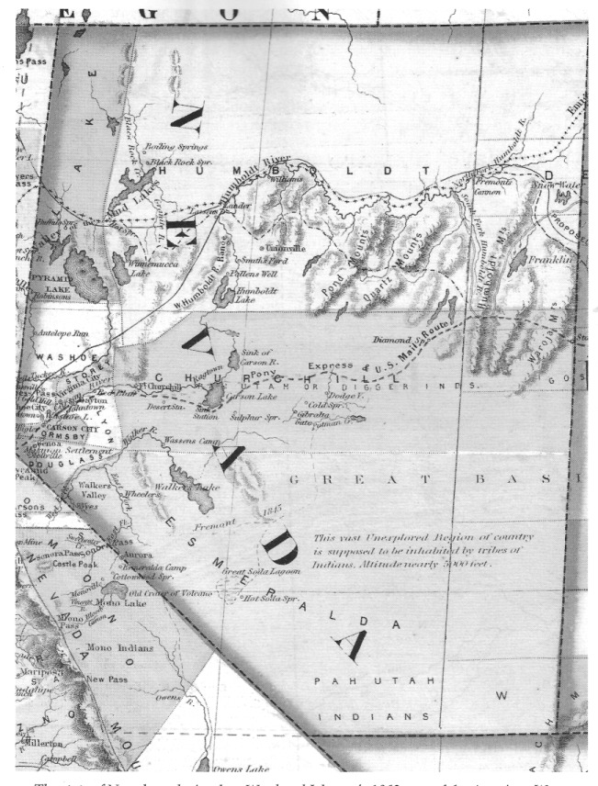
The state of Nevada as depicted on Ward and Johnson's 1863 map of the American West. Note John C. Fremont's route, which would have taken him down Smoky Valley and through central Nevada, characterized as a "vast unexplored region of country ... inhabited by tribes of Indians." Author's Collection

CHAPTER ONE
Early Inhabitant
and Exploration

Manhattan, along with Tonopah, Goldfield, Rhyolite, and Round Mountain, was one of the great central Nevada turn-of-the-century mining boomtowns—the last flowering of the Western American frontier.
Manhattan and its underground diggings lie at the head of Manhattan Gulch, a shallow wash that stretches for several miles along the western flank of the Toquima Range on the edge of the Smoky Valley, about 45 miles north of Tonopah in Nye County.

First Inhabitants of the Manhattan Area

The Clovis people were the first human beings known to have occupied the Manhattan area. When they arrived in the region approximately 12,000 to 11,000 years ago, the climate was somewhat colder and wetter than it is today. Two large shallow lakes were present in Smoky Valley at that time. A variety of edible plants grew in abundance in the vicinity of the lakes and along the streams that fed them. Numerous species of animals were present, including mountain sheep, deer, and rabbits, as well as many that are now extinct, such as the mammoth, camel, giant ground sloth, American lion, and the giant short-faced bear. The Clovis people must have enjoyed a relatively abundant life, subsisting off the plants and game found near the lakes at that time.
Beginning about 11,000 years ago, a worldwide climate change occurred, and the Northern Hemisphere became increasingly dry. Decreased precipitation in central Nevada ushered in what archaeologists call the pre-Archaic archaeological period, which began about 11,000 years ago and lasted for 4000 years. During that time, the two large lakes in Smoky Valley gradually shrank. Food sources became relatively less abundant.
The Clovis people likely only lasted a few hundred years. Their successors, known as the people of the pre-Archaic, or Western Pluvial Lakes tradition, probably began moving away from the shrinking lakes and developed an increased reliance on a generalized hunting and gathering subsistence for survival. A lifestyle based on relatively larger social groups that the lush lakeshore environment had earlier made possible gave way during pre-Archaic times to smaller groups, perhaps even single families, at times fending for themselves.

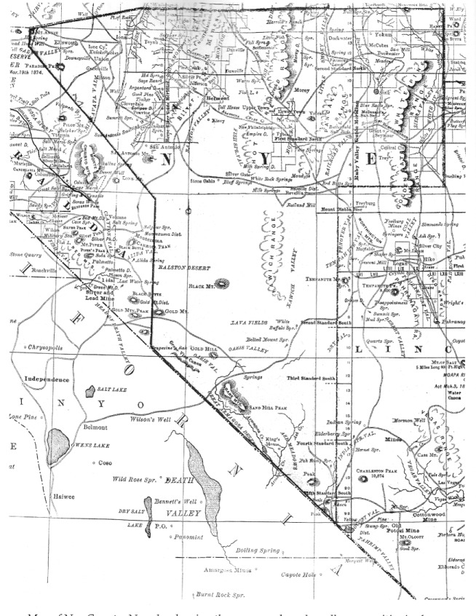
Map of Nye County, Nevada, showing the many roads and small communities in the Smoky Valley area in the northwestern part of the county in 1881. Manhattan would be located approximately where the "1" is in the word "Silver," southwest of Belmont (to the right above the "N" in "Nye"). University of Nevada, Las Vegas—Dickinson Library Special
Collections

Surviving the Archaic Period

The Archaic period began about 7000 years ago and lasted until the arrival of Europeans in central Nevada in the early nineteenth century. The Archaic involved a gradual shift toward a way of life in the Great Basin that more closely resembled the survival methods used by the Shoshone Indians when European explorers entered the region in the 1820s. Instead of relying heavily on one resource area, the Archaic people adopted what archaeologists call a broad-spectrum subsistence strategy. They became more nomadic, moving from one food source to another, following the cycle of the seasons as plants ripened and game became available. This changing way of life involved spending spring and early summer in the valley, then traveling to the mountains as food at higher elevations came into season.
Several important advances occurred during the Archaic period. Strange as it now may seem, prior to about 6500 years ago, there were no pinion pines growing in central Nevada. By about 6000 years ago, the pinon pine had become established in the area and within a few hundred years, pine nuts became an important new food source for area residents.
The atlatl, or spear thrower, was definitely in place in the technological repertoire of Central Great Basin people by 6000 years ago. It enabled a hunter to hurl his spear farther and with more force and accuracy than was possible with the larger javelin.
By about 5000 years ago, residents of the Smoky Valley area began to occupy caves in central Nevada for the first time, including the Gatecliff Shelter, located high in the mountains on the north side of Mill Canyon in Monitor Valley.
During the later part of the Archaic, Great Basin residents benefited from the introduction of the bow and arrow, which first entered the area about 1700 years ago. Within 400 years it had replaced the atlatl. The bow and arrow enabled a hunter to reduce the size of his dart, tip it with smaller points, and fire more arrows with greater accuracy and force. Pottery was introduced to the Archaic people in the early part of the twelfth century.
The later stages of the Archaic also witnessed an increased focus on gathering of plant foods and a more intensive exploitation of pine nuts. Dwellings increased in size and settlements grew larger as populations became increasingly sedentary for part of the year. This trend led to the establishment of the villages on the floors of many central Nevada valleys, including Smoky Valley, when Euro-Americans first entered the area.

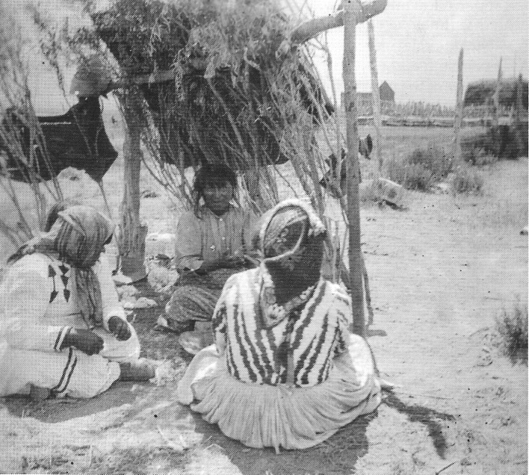

The Western Shoshone Western Shoshone women, Smoky Valley, Nevada. Circa 1920s. Rene Rogers naval and Jim Berg

The Western Shoshone

Western Shoshone Indians occupied the Smoky Valley and much of the Great Basin when Euro-Americans first arrived in the American West. The Shoshone were hunters and gatherers and skillfully used natural resources to sustain their relatively small populations. They were seminomadic, moving from one part of their territory to another as foods became available.
Men were largely responsible for hunting, women for the collection of plant foods, which provided the bulk of the diet. Bighorn sheep, which were hunted with the assistance of dogs, were the most important large game animal. Annual drives for antelope and rabbit took place in the fall. Deer were hunted in both summer and fall but were fatter in fall. Birds of many species and trout from mountain streams supplemented the diet.
Pine nuts, the most important food to the Western Shoshone, were collected in the late fall. The Smoky Valley Shoshone collected pine nuts on the east side of the Toiyabe Range as far up as the summit line; they also collected in the Toquima Range. Most pine nuts were stored for winter use.
Women collected wild onions, watercress, morning glory roots, sago roots, cattail roots, young cattail stems, wild carrots, and wild asparagus. They gathered fruits and berries, including buffaloberries, serviceberries, chokecherries, gooseberries, buckberries, and wild currants. Seeds were collected from sand bunchgrass, wild rye, and sunflower plants.
The Shoshone would usually winter over at a campsite most often positioned near water and in the low foothills, off the valley floors where the temperature was cooler. Several families would stay at the same campsite, creating a small village with a fairly stable population. Winter dwellings were constructed of juniper branches and insulated with leaves and other dry materials. Camp residents slept under rabbit-skin blankets, with heated stones at their feet. Food supplies were usually cached at sites within one or two hours' walk from a winter camp. When warm weather returned and harvest time approached, families dispersed to food-collecting areas, where temporary camps were set up.

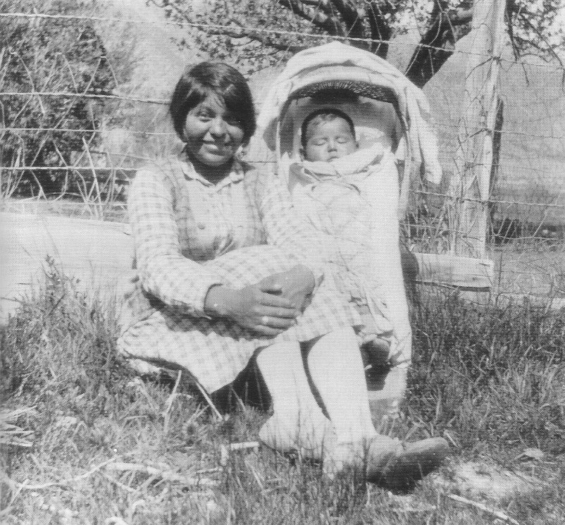

Eva Johnson, a Western Shoshone resident of Smoky Valley, with her baby, in the 1930s. Eva Johnson attended school with Pete and Irene "Rene" Rogers at the Rogers Ranch north of Carvers in Smoky Valley in the 1920s. Nye County Town History Project—Zaval Collection

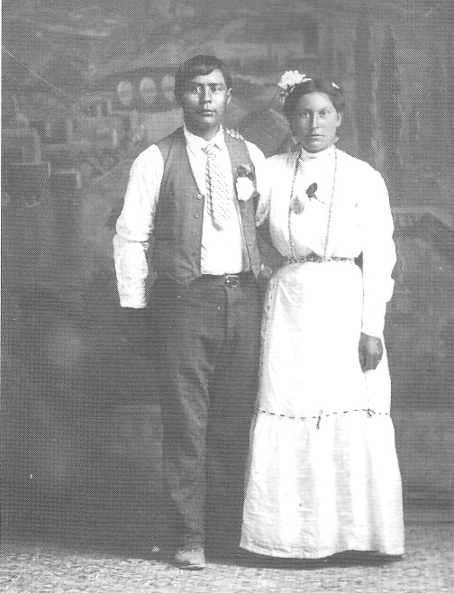

Handsome Native American couple, probably Western Shoshone, photographed by well-known Tonopah photographer E. W. Smith around 1910 in Tonopah. this photo is from the original glass negative. - Central Nevada Historical Society

The nuclear family was the basic social unit of the Western Shoshone, and family members developed strong bonds. Families belonged to small local districts, frequently centered in a valley or a cluster of winter villages. Groups were named after prominent geographical features or food resources in their territory. For example, the Smoky Valley Shoshone were called Wiyumbitiihanti (wee-yum-bi-tuh-hawn-tee), "eaters of buffaloberry," by the other Shoshone. Smoky Valley was called Wiyumbahunovi (wee-yum-ba-hu-no-vee), "buffaloberry and water valley" (Steward, 1970:100).

Jedediah Smith Crosses the Great Basin

Jedediah Strong Smith was one of the greatest explorers of all time and a most remarkable figure in the history of the American West. Born in Jericho (now Bainbridge), New York, in 1799, he is credited with being the first white man to reach California by an overland route, to cross the Sierra Nevada, and to cross the entire Great Basin and what is now the state of Nevada. According to Dale L. Morgan (1953), Smith's biographer, Smith saw more of the West than any other man of his time.
On August 7, 1826, Smith began a journey that took him in a great circle across the West. From a rendezvous in southeastern Idaho at the bend of the Bear River north of the Great Salt Lake, Smith and his men headed south to Utah Lake, south to the Virgin River, and on to the Colorado River. They turned west at the Mojave villages north of Needles, California, and journeyed across the Mojave Desert to San Pedro, California. From there, they headed east out of the Los Angeles Basin to Victorville, north to the Central Valley, and turned eastward at the Stanislaus River.
Smith and two companions, Robert Evans and Silas Goble, crossed the Sierra Nevada at Ebbetts Pass in May 1827. They descended the east side of the Sierra Nevada and made their way to Walker Lake. From Walker Lake, they headed east and crossed the Shoshone Mountains in the vicinity of Willow Springs, and then crossed the south end of the Toiyabes near Barrel and Mud Springs. They camped at Peavine Creek on June 6.
Smith's entry for June 7 describes his course across the Smoky Valley: "E 15 miles crossing a plain and at the foot of a hill found water where I stopped for dinner. [T]hen crossing the range of hills and following an [Indian trail N 10 miles found water and good grass and encamped. [Slaw an [I]ndian today" (Brooks, 1977:178). Authorities believe Smith had stopped for lunch just west of present-day Manhattan, then crossed the Toquima Range directly east of Manhattan on a route approximating that of today's Nevada Route 377.
On June 7 and 8, the three men are believed to have camped near what is now Belmont. From there, the party traveled northeast across Monitor Valley, then on to Hot Creek Valley, and entered the Pancake Range about where U.S. Route 6 does today. They crossed Railroad Valley and continued on to the vicinity of present-day Lund, crossing Connors Pass and Sacramento Pass on their way to the south shores of the Great Salt Lake.
Although Smith's firsthand accounts of his arduous travels across Nevada are not graphic, they are valuable in that they provide the first written description of the Great Basin and northern Nye County.

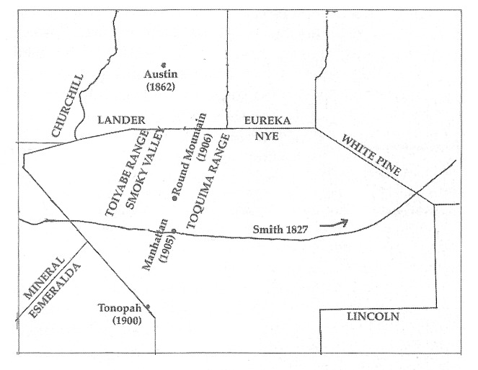
Map of route Jedediah Smith took across Central Nevada in 1827 from Walker Lake, up Manhattan Wash to Connors Pass, east of present-day Ely. After George R. Brooks, ed., 1977.

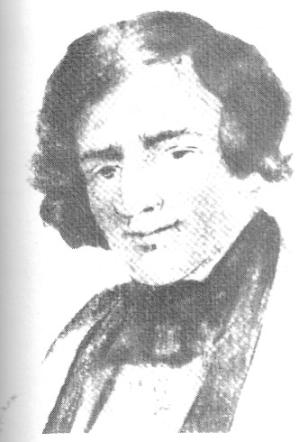

A likeness of Jedediah Smith, the first white man to cross the Great Basin and the Sierra Nevada. He was the first Euro-American known to set foot in the Smoky Valley when he and two companions journeyed from the Central Valley in California to the Great Salt Lake in spring and summer 1827. - University of Nevada, Las Vegas—Dickinson Library Special Collections

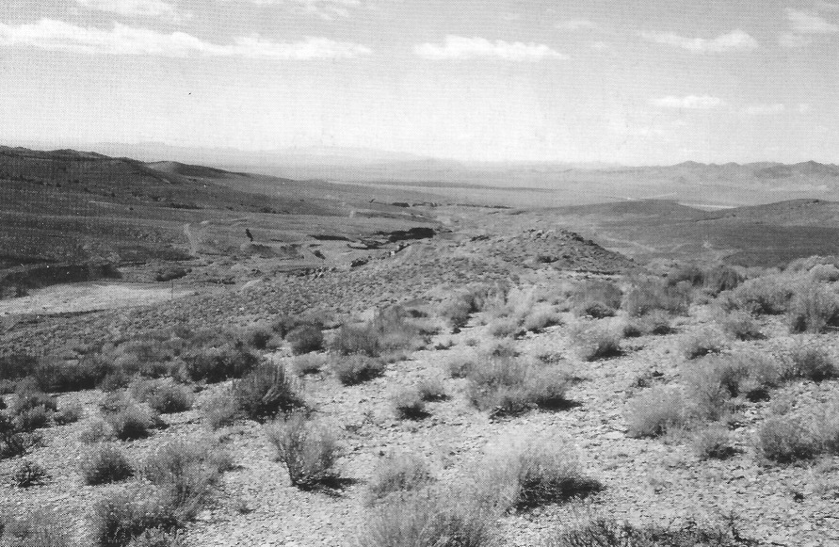

Manhattan Wash, looking southwest to Smoky Valley at the south end of the Toiyabe Range. Jedediah Smith is thought to have ridden up this wash when he crossed central Nevada in 1827. Note the placer diggings. Photo taken in 1995. Author's Collection

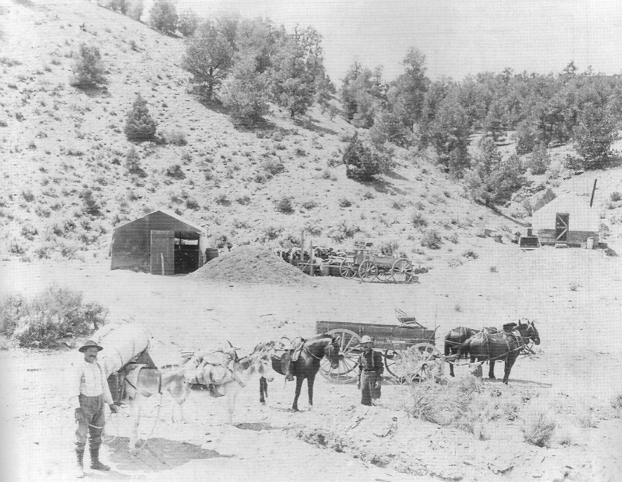

When Jedediah Smith crossed landscapes like the one in this photo, he probably had no idea that by 1905 prospectors would be setting up tents and looking for gold. A Manhattan prospector with his two burros prepares to head for the hills in search of the golden glitter. Notice across the gulch, a miner's tent house, consisting of a wooden floor and walls made of- boards halfway up the sides, and a canvas roof. See p. 18 for inside view of such a dwelling. Central Nevada Historical Society

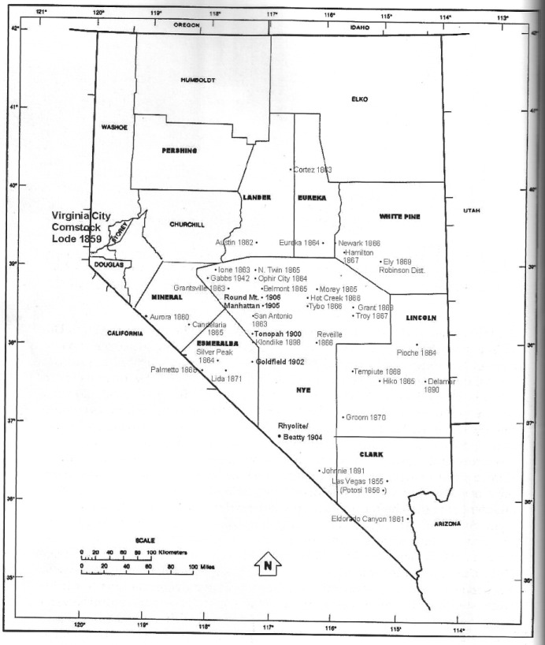

Ore deposits leading to principal mining camps in central Nevada. Sometimes the year of discovery of a mineral deposit and the founding of a camp at the site do not always correspond. Dates given are our best estimate. Virginia City was the mother camp of frontier mining in Nevada. Robert McCracken and Jeanne Sharp Howerton—various sources

CHAPTER TWO
The Boom at Manhattan

In 1859, a tremendous deposit of silver and gold was discovered at Mount Davidson in western Nevada at the foot of the Sierra Nevada. This discovery, known as the Comstock Lode, attracted large numbers of miners who had missed out on making it big in the gold camps of California. Unfortunately, there were not many opportunities at the Comstock for most prospectors and miners to truly prosper, so many who still yearned for another chance to strike it rich ventured Into the desert east of the Sierra Nevada. Within three years, two big strikes occurred in Nevada—the first at Aurora in 1860, the second at Austin in 1862.
Aurora and Austin were spectacular. They were followed in short order by Eureka (1864), Pioche (1864), and Hamilton (1867), and scores of smaller, more ephemeral camps. But after the discovery at Hamilton, it would be more than another generation before another very large strike was found in Nevada.
In 1900, Jim Butler discovered a huge deposit of silver in Nye County, and the town of Tonopah was born. Butler's strike was quickly followed by the discoveries of gold at Goldfield in 1902 and at Rhyolite in 1904. As a result of these strikes, the eyes of the mining world were focused squarely on central Nevada. For the next two decades, the mines of Nevada were the object of intense world¬-wide interest. The turn-of-the-century boomtowns on the remote central Nevada desert were the last places in America where a person of limited means and pioneering spirit could, through good fortune, find a bonanza and set off a rush to which boomers by the thousands would converge for the sole purpose of getting rich—either by making their own discoveries of gold and silver or by mining the Dockets of those also seeking their fortunes. Manhattan was an important part of this enormous wild stampede.

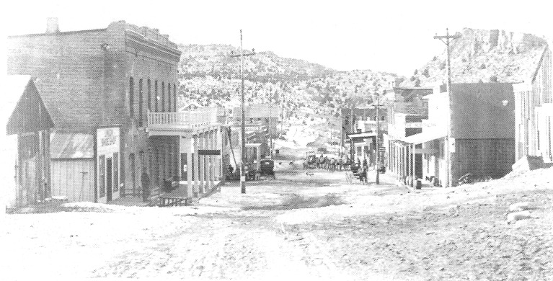

Following the discovery of the Comstock in 1859 and the founding of the town of Virginia City, the next big bonanza discovery in Nevada came at Aurora in 1860. Aurora was located about 125 miles south of Virginia City. Within two years of its founding, it had a population of more than 5000. Aurora's glory days only lasted a few years. This photo of the town is from about 1905. Central Nevada Historical Society

Early Mining in the Manhattan Area

The first recorded mining in the Manhattan area began in 1866, when George Nicholl discovered ore about 16 miles southwest of Belmont near Timber Mountain. The Manhattan District was organized the following year. There were about 50 locations in the district, and the principal mines were the Mohawk and the Black Hawk. Very little work was done after 1869, and the district was abandoned.
In 1877, a rich prospect of lead and silver was found in the vicinity, and the Eagle District was organized. Silver values in the ore from the district ran as high as $2500 per ton. A town, now known as Old Manhattan, was established near Manhattan Spring in a gulch running toward Timber Mountain. In an interview published in the Tonopah Bonanza in 1906, a former resident of Old Manhattan said that in the early 1870s the community had three working mines and a population of perhaps 250. Old Manhattan is said to have produced $200,000 in its time. As of 1942, several stone cabins still stood at the site of Old Manhattan.

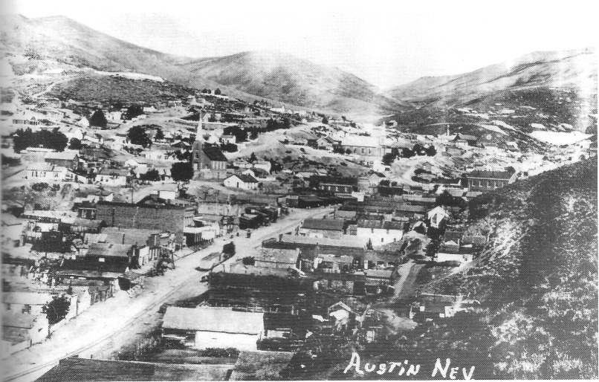

Austin, Nevada, probably in the 1870s. The Austin boom began in 1862. Those who got to Austin late spread out looking for other occurrences of gold and silver, first in the Toiyabe Toquima ranges, then farther to the east. Such prospecting efforts led to the founding of number of important mining camps in central Nevada during the 1860s and 1870s and laid the basis for the future development of central Nevada. Central Nevada Historical Society

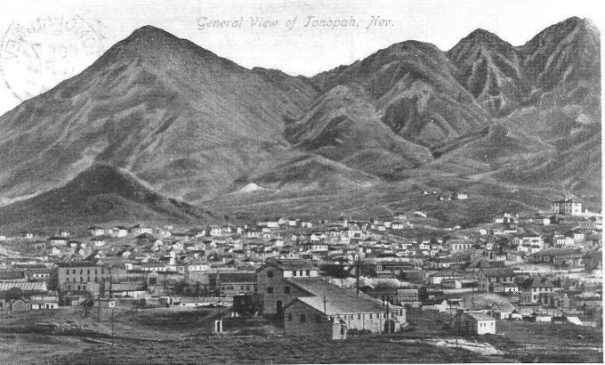

Jim Butler discovered a huge deposit of silver in Tonopah in 1900 that triggered a prospecting and mining boom in central Nevada, much as the discovery of silver had done in Austin 38 years earlier. Tonopah became the mother camp to a new generation of boomtowns. In this old postcard, we see Tonopah as it looked in 1912, seven years after the founding of Manhattan. Nye County Town History Project—Lofthouse Collection

Humphrey Discovers Gold

It is typical for accounts of how a precious metal deposit was found to vary somewhat, especially in minor details. A credible version of Manhattan's discovery states that on a spring day in 1905, John C. Humphrey, whose family owned a ranch at Peavine, was looking for cattle not far from the road that ran from Belmont to Peavine and Cloverdale by way of Manhattan Gulch. He found some rock that looked as though it might carry gold values and staked five claims about three miles up from Old Manhattan. Humphrey gave E. E. Seyler, another local rancher, one-half interest for having the sample assayed. In June, Humphrey and his brother Frank, along with Seyler and George "Shorty" Maute, the owners of the property, returned to the site to do some location work. While eating lunch, Humphrey examined a nearby ledge and broke off a piece; it was covered with gold. An assay ran 1000 ounces in silver and $10 per ton in gold; another sample, taken from a 12-foot ledge nearby, yielded 68 percent lead, $50 per ton in silver, and $8 in gold. These finds were made on the April Fool claim, so-named because it was found on April 1.

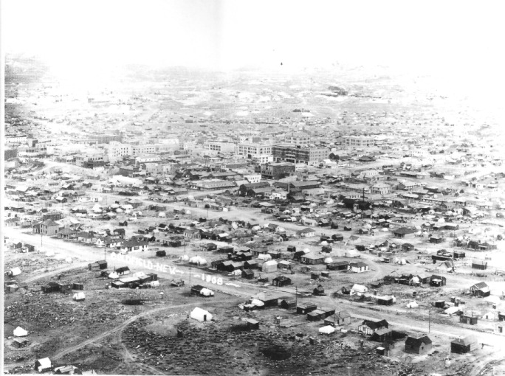

Following Jim Butler's discovery of silver at Tonopah in 1900, prospectors fanned out into the central Nevada desert, looking for other bonanzas. They didn't have to wait long, for in 1902 a large deposit of gold was found 26 miles south of Tonopah, and the town of Goldfield was born. By 1910 Goldfield was Nevada's largest community, with a population of more than 10,000; Tonopah was the state's second largest town. Photo shows Goldfield in 1908. - Central Nevada Historical Society

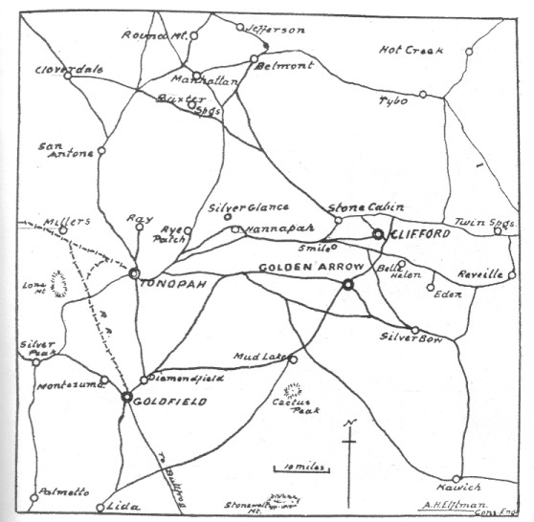

This hand-drawn map of the camps and roads in the Tonopah-Goldfield area appeared in the Tonopah Daily Sun, April 4, 1906. Manhattan is near the top of the map, west of Belmont. Central Nevada Historical Society

News Spreads Fast

News of Humphrey's discovery spread throughout the region. By late summer 1905, roughly 3000 claims had been staked out in the vicinity. By August 1905, there were about 500 people in the district, and 50 tents had been pitched. As many as eight townsites were planned. The first settlement in the immediate area was Palo Alto, near Bull Spring on the edge of Smoky Valley. The water there was of poor quality, so a better location for a town was soon found up the This location became the permanent site for Manhattan, which was also :ailed Pine-Tree Camp for a time.
The town of Manhattan was located in a canyon between the mountains that formed the Manhattan Mining District; it became the boss camp for the area. Manhattan sits at an elevation of 7200 feet, which provides a cooler, moister climate than is found farther south. Manhattan was platted on a site "immediately and adjacent to the Humphrey and Seyler claim." According to the Tonopah Daily Sun, the Manhattan Townsite Company, promoter of the townsite, had offices in both Manhattan and Tonopah.
By October, the fledgling town featured a number of lodging establishments, a general store, three boardinghouses, and five saloons—a total of 70 tents and four wooden buildings. By December, there were 75 frame buildings in town. A four-horse stage negotiated the 45-mile trip to Tonopah. Huge wagons pulled by 14 or more horses or mules transported lumber, which was in great demand, from the railhead at Tonopah to Manhattan—where a load of the valuable building material would sell out in a few minutes.
By late December, Manhattan's population had grown to about 800. One of Humphrey brothers and a man named Harris established an addition to the original townsite; lots there sold rapidly
On a typical day in early January 1906, 40 people could be found camped at Antonio on their way to Manhattan, with an additional 20 stage passengers bound for the new town. The small post office at San Antonio, the nearest one Manhattan, was doing a bustling business. The Tonopah Bonanza reported that "the road between Tonopah and Manhattan is literally lined with burros, teams, broncos, freight teams and automobiles. It is a wonderful sight. The people of Manhattan are the most happy, prosperous, confident lot of people on the face of the earth and they have the gold to show" ("Headed for Great Manhattan," 1906)
Residents of Tonopah and Goldfield saw opportunities for new businesses in Manhattan. Two former employees of Tonopah's Mizpah Cafe moved to Manhattan and built their own restaurant. A Goldfield entrepreneur, Charles Cussin, headed for Sacramento, California, to buy goods to stock his new store in Manhattan. James Fowlie of Tonopah opened a saloon in Manhattan. "Ikey" Knudson a popular barber in Tonopah, moved to Manhattan and set up shop.
In 1907, Manhattan miners refused to join the Goldfield IWW (International Workers of the World). There wasn't much labor trouble in Manhattan, but in 1907 a committee did form to keep Slavs and other foreigners out of the mines.
By February 1906, most of the mining development was being done on hills adjoining the town. At the west end were Mustang Hill and Gold Hill across the gulch from Mustang Hill, and in the middle of town was April Fool Hill. East of April Fool Hill was Litigation, or Injunction, Hill, where claims had been tied up litigation since the year before. By early 1906, the Stray Dog was considered a great mine of the Manhattan camp, according to the Goldfield News.
By early 1907, more than 50 mining operations could be found along a 10-mile line running east and west of Manhattan. The most developed properties included the Consolidated, Stray Dog, Indian Camp, Jumping Jack, Pine Nut, Dexter, Consolidated Extension, Seyler-Humphrey, Little Grey, Paymaster, Manhattan Butler, Gold Wedge, Giant, Original Manhattan, Mustang, Mustang Extension, and Buffalo. Some of the other mines being worked were the Mammoth, Red Top, Bronco, Amethyst, Desert Queen, Cash Rock, Happy Hooligan, Joker, As-You-Like-It, Granny, Cat Bird, and Hindocraft.

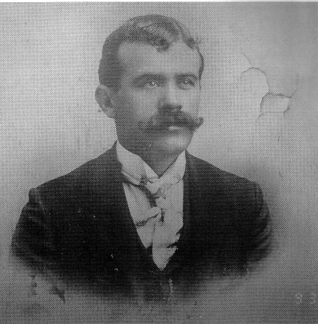

John C. Humphrey made the initial discovery of gold on the April Fool claim in April 1905, which immediately led to the founding of the frontier boomtown of Manhattan. Photo on display at the Central Nevada Museum, Tonopah

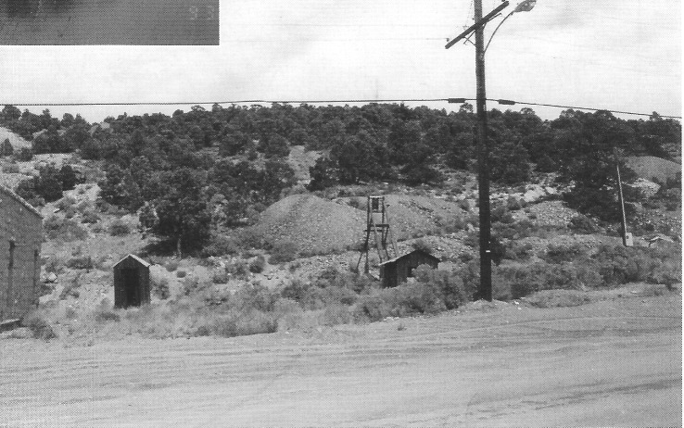

April Fool Hill and the site where John Humphrey male is discovery of gold in 1905. The site is located on the north side of Main Street in the middle of what became the town of Manhattan. The gold in April Fool Hill occurred in small, rich veins. Photo taken in 1995. Author's Collection

Stay Dog Bob

Western miners were strong believers in the power of luck. If a man s going to make it big in the mining game, he had to be lucky. Without t good luck, a miner would always be : poor; and if his luck was bad, there was no limit to the misfortune he might experience. But an absence of good luck need not be blindly accepted - sometimes opportunities arose that might help a miner improve his luck.
Take the case of Sway Dog Bob, who showed up in Manhattan in the summer of 1905. Stray Dog wasn't much to look at: a medium-sized collie mix with a short tail and sharp ears. Nobody seemed to know where he'd come from. Rumor was that he had belonged to an old Indian who had been turned out by his tribe to die and had remained with his master until the old man passed on. A group of prospectors was thought to have given the man a decent burial and the dog took up with them.
Stray Dog hadn't been in Manhattan long before he proved his worth. He was present when Clark Davis made the richest discoveries on the April Fool lease in August 1905. He was at the Annie Laurie lease when miners discovered rock so infused with gold that it was used for jewelry. He was at the Nellie Gray claim when rich ore was discovered, and within days of Stray Dog paying a visit to the Iron King and the Iron Queen placer diggings, miners there were into good gravel. Word spread quickly in Manhattan that Stray Dog brought good luck. When a new discovery was made, people asked, "Was the dog there?"
Missing no chance to boost their luck, miners tried any number of strategies to lure Stray Dog to their claims. They set out hearts of tenderloin and boxes of candy to tempt him. They made beds of soft cotton in front of their tents and shanties, hoping Stray Dog would favor them with his presence. Mostly, these efforts didn't work, Nevada historian Phillip I. Earl reports. Like luck itself, Stray Dog was difficult to predict; he seemed to come and go at random.
In late February 1906, Stray Dog Bob disappeared from Manhattan and wasn't seen there again. Miners hoped that he had not experienced misfortune; perhaps he had rejoined an Indian group. Then word reached town that he was at Millers, a milling and mining camp about 40 miles south of Manhattan and west of Tonopah. Again, within a week of his arrival at Millers, leasers hit good ore. However, as Earl notes, Stray Dog Bob didn't stay long at Millers; he was last seen headed toward Goldfield.

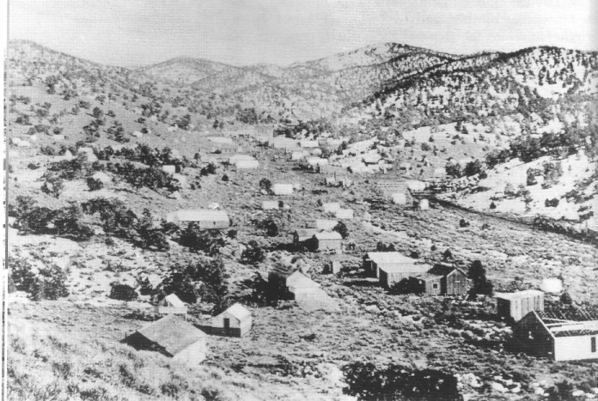

View up Manhattan Gulch not long after the town of Manhattan was founded in 1905.
Central Nevada Historical Society

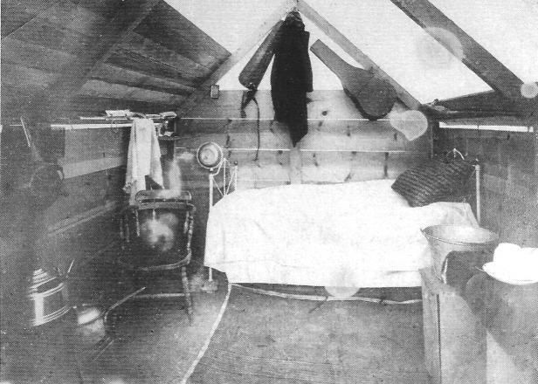

The interior of a miner's tent house in a turn-of-the-century central Nevada boomtown. Such structures, while simple, functioned surprisingly well, providing shelter from the summer's sun and winter's howling winds and cold. Note the old crates being used as tables on the right. - Central Nevada Historical Society

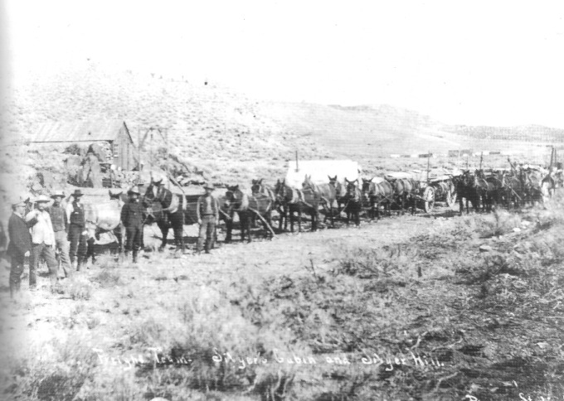

Mules, horses, and freight wagons, Manhattan, 1906. Central Nevada Historical Society

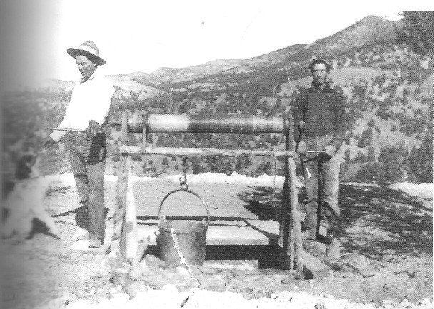

Two miners operating a hand-powered hoist known as a windlass near Manhattan, 1905. The windlass was the least-expensive method for removing ore and waste rock from a mine shaft.- Central Nevada Historical Society

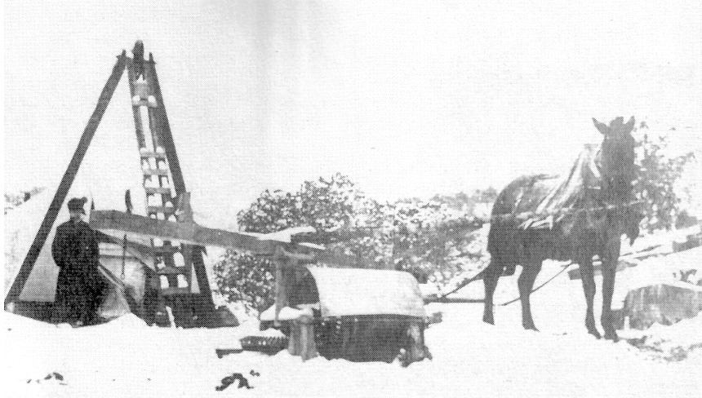

Shaft and hoist, Manhattan, 1905. The hoist pictured is known as a whim, which represents an advance in mine hoists over the hand-operated windlass. A horse pulls a beam at one end to a pivot in a circular motion, which turns gears that operate a drum on which a cable is wound. Through a tripod or head frame, the bucket containing ore or waste moves up and down the shaft. Although the whim requires less human labor than the it was more expensive to acquire—and you have to feed the horse. - Central Nevada Historical Society

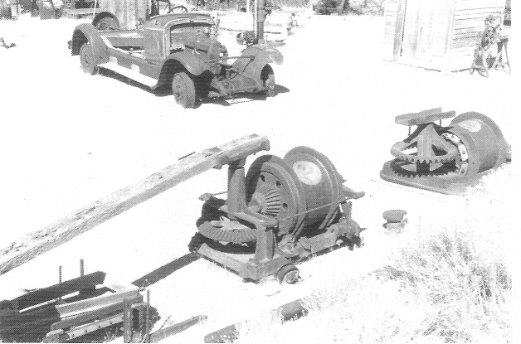

Two whims used in turn-of-the-century mining camps in central Nevada on display at the Central Nevada Museum, Tonopah, 1995. - Author's Collection

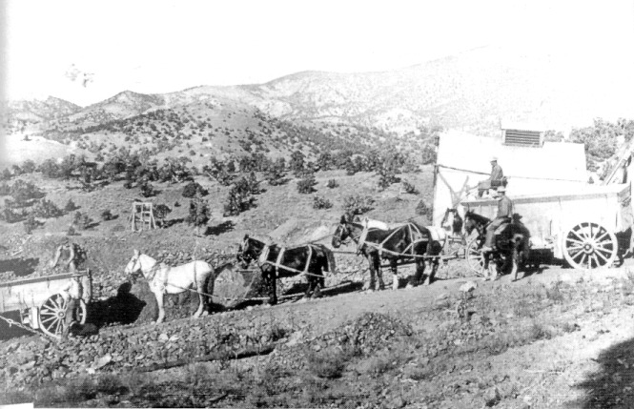

Ore wagons and teams, Manhattan, circa 1908. Central Nevada Historical Society

The Last Robbery of a -Wells Fargo
Horse-Drawn Stage

Few images symbolic of the American western frontier are more in-grained in our imaginations than that of a horse-drawn Concord stage making its way across a picturesque open landscape, and no image of frontier lawbreaking stands out more than that of a stagecoach being robbed by masked gun-toting thieves. Such an event happened to a stage headed for Manhattan.
The last armed robbery of a Wells Fargo horse-drawn stagecoach occurred in 1908 on the high road between the boomtowns of Rawhide, located in Mineral County, with an estimated population of 10,000, and Manhattan. Both Manhattan and Rawhide had Wells Fargo agencies.
At Rawhide, a Wells Fargo strong-box carrying $72,000 in mine payrolls, including $7,000 for the Manhattan Consolidated Company, was loaded onto a six-horse stage. The stage left town in late morning but didn't get far before there was trouble. About six miles out of town, the stage was stopped by two masked men. As often portrayed in the movies, the stage was swinging around a curve when a command to halt rang out from behind an outcropping. Before those on board realized what was happening, one of the robbers took hold of the reins and pointed his .44-caliber pistol at the stage; the second thief drew a bead on the driver with his .44. Both crooks quickly moved in closer. The taller of the two ordered the driver to throw down the Wells Fargo box and the driver complied. No passengers were harmed. The thieves were last seen attempting to get the lid off the box with a chisel.
It took two hours for word of the robbery to reach Rawhide. A posse under the direction of the state police rushed to the scene of the holdup in automobiles. Sources do not say whether the road agents were ever apprehended or if any of the money was recovered (Beebe and Clegg, 1949).

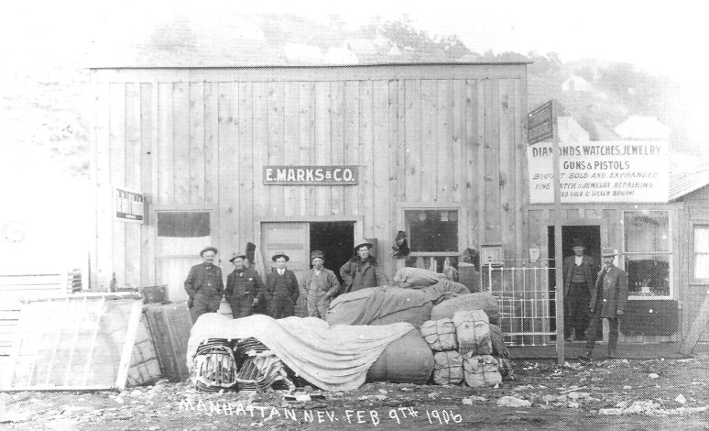

Newly constructed businesses on Manhattan's Main Street, February 9, 1906. The sign ,above the door on the left reads "The Bank of Nevada." Goods appear to have been recently unloaded and include what looks like bedsprings on the left. - Central Nevada Historical Society

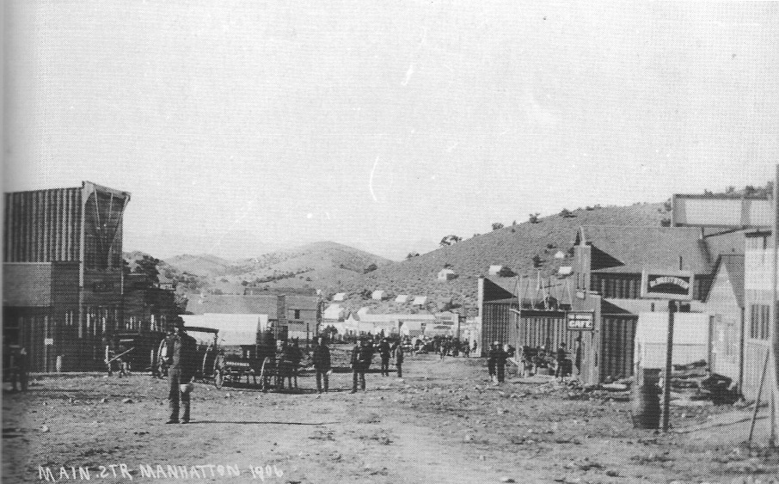

Street, Manhattan, 1906. Central Nevada Historical Society

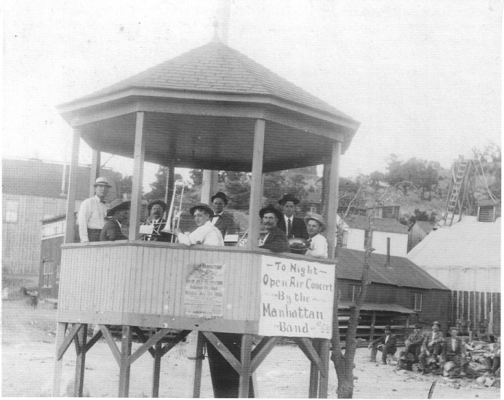

A bandstand located on Main Street in Manhattan, 1906. - Central Nevada Historical Society

CHAPTER THREE
Portrait8 of Manhattan

Nelson Rounsevell, a newspaper publisher and writer who had worked in Panama and Peru, was living in Oakland, California, in December 1905 when a telegram came from Tonopah, Nevada, with this message: "BIG STRIKE IN MANHATTAN COME AT ONCE." Rounsevell borrowed $100, got together an outfit of carpenter tools, bought some food and three quarts of whiskey, and started on the 24-hour railroad trip to Nevada to join, as he characterized it, "one of the most spectacular gold rushes since the Klondike."
He arrived in Tonopah on New Year's morning 1906. Conveyance of any Kind to Manhattan was difficult to obtain in Tonopah. Rounsevell and five other would-be travelers teamed up to hire mules and a spring wagon at a "fabulous price," loaded their tents, food, trunks, and prospecting outfits, and headed for Manhattan at dawn on January 2. Rounsevell and his companions arrived in Manhattan at 11:00 p.m., after what he called "as cold, dreary and tiresome a trip as I have ever made" (Rounsevell, 1933:47-49). But his initial impression was favorable.
Manhattan was the prettiest and most picturesquely situated camp in all Nevada. It was squeezed into a narrow winding gulch with its main street meandering up the canyon, following the twists and bends. There was scarcely room for a row of buildings on either side of the street, and the narrow shacks were scattered among tents and cabins. The rocky hill-sides were covered with scraggly nut-pines—almost the only patch of green in the entire stretch of southern Nevada desert. The mouth of the canyon opened onto the broad expanse of Smoky Valley and led up into the Toyabe [sic] Range (p. 48).
In the following colorful prose, Rounsevell described his first meal in Manhattan:

Unloading my carpenter tools in the snow just before midnight, I dragged the box into a corner of "The Horseshoe," then the leading saloon and gambling house in the camp. The place, a large half-board, half-tent affair, was packed to overflowing with a noisy, drinking, gambling crowd of boom followers of every type.
On one side of the room was a long bar built of pine boards, behind which a corps of bartenders served bottled beer and straight whiskey to a line-up of customers which filled the place 24 hours a day. On the opposite side of the room were crap tables, roulette wheels, twenty-one tables and faro bank lay-outs, all surrounded with as many players as could elbow their way close enough to lay a bet. In between this swarm of drinkers on one side and gamblers on the other, a motley crowd milled up and down, in and out, back and forth from game to game and from the bar to a restaurant counter at the rear.
There, behind a plain board counter, greasy, fast-working cooks with sleeves rolled up fried steaks and ham and eggs for customers perched on tall stools. Strong coffee, pork and beans, hot cakes, bread and canned peaches made up the remainder of the bill of fare. No napkins, finger bowls, silverware or frills here. Cans of evaporated milk were opened with one blow of a cleaver and the contents poured into a dozen smoking cups of coffee. No waiters, no cashier, no overhead—just an abundance of good food at a high, boom-camp price, and Lord, it tasted good after a 16 hour trip across the snow-covered desert (pp. 48-49).

DeWolf's "Vivid Word Picture"

Lester W. Haworth founded Manhattan's first newspaper, the Manhattan Mail, on January 10, 1906. The paper was issued as a 12-page weekly every Wednesday; a subscription cost $5 per year. In 1907, Haworth leased the paper to Frank F. Garside. After changing hands several more times, the Manhattan Mail folded on June 24, 1911.
The most vivid surviving descriptions of life in Manhattan appeared in the Manhattan Mail in articles by W. P. DeWolf. DeWolf was a keen observer of Manhattan life and a skilled wordsmith, no stranger to the hyperbole and flowery language that marked the journalistic style of the time. On June 20, 1906, under the headline "Vivid Word Picture of People and their Activities," DeWolf de-scribed the great variety of "types" drawn to Manhattan.

Adventurers . . . men who have followed the blazed trail for the prospector over icy wastes and across sun-scorched desert sands that they might garner the golden fruit of his arduous toil. . . . Feminine fraility [sic], trailing the gift of God given beauty through the hell of a life of shame. . . . Grizzled old prospectors, with the humor as biting as a winter's blast, . . . possessed of an honesty as rugged as the eternal hills in which they delve. . . .
Ministers of the gospel, bearing the message of the Son of God over sun-shriveled alkali plains and snow-capped peaks. . . . Mothers, living amid the solitude and grandeur of tree clad slopes, in teaching little children the lesson of gentleness that the south wind breathes to the whispering pines. School teachers starting tiny feet aright at the outset of the trail of knowledge.
Miners, bluff, deep chested, iron muscled. Hard workers and some-times rough in their hours of recreation. . . . Capitalists from the money centers of the world; dignified in bearing, cautious in investing (DeWolf, 1906).

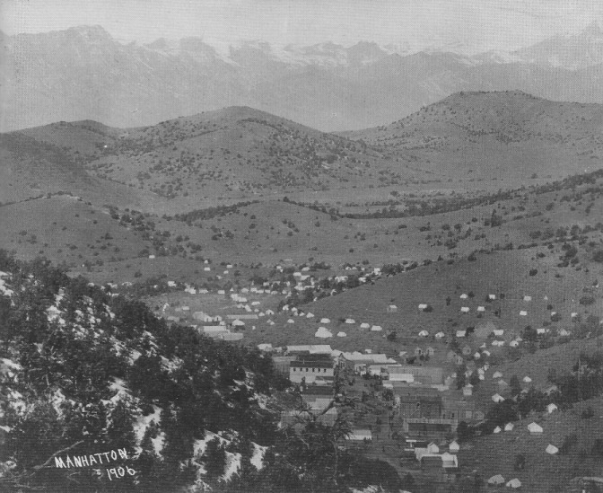

View west to Manhattan as it appeared when Nelson Rounsevell arrived and W. P. DeWolf described it in 1906. Manhattan's Main Street snakes along Manhattan Gulch. Several substantial two-story structures are visible, and numerous tents dot the hillside. In the distance the magnificent crest of the Toiyabe Range is visible.- Central Nevada Historical Society

DeWolf described the crowds:

Merchants, mule skinners, mine promoters, wildcatters, professional men, panderers, newspaper men, millionaires, hobos—the entire gamut from . . . every walk in life—jostle each other along the sinuous length of the main street of the camp. On the sidewalks, in the roadway, they crowd and press, each bent upon some errand of moment to himself. From every class and every clime they came, all drawn hitherward by the beckoning finger of the Goddess of Fortune (DeWolf, 1906).

DeWolf observed that life in a gold camp was unlike that in any other type of community. The social environment was open and without prejudgment. "Socially," DeWolf wrote, "Manhattan has not passed from the khaki of everyday life to the pretentious dignity of a dress suit standard." In Manhattan, there were no "preconceived ideas of social status" (DeWolf, 1906).

Each man is measured at his true worth or lack of worth, and in making its estimate the community plays no favorites. . . . The "busted" prospector of today may be the millionaire of tomorrow, so it is not wise to draw too fine a distinction. The waiter you tip at dinner may strike it rich and may be cracking champagne within the week, and the hoboe [sic] who "bones" you for four bits may wander into the hills and find a pay crack (DeWolf, 1906).

They all had one thing in common, DeWolf observed:

All dreamers, this heterogeneous Manhattan crowd; and 'tis the most fascinating of all dreams that has lured them into the Nevada wilderness—the dream of fortune (DeWolf, 1906).

With scarcely a year gone by since the first gold discovery in 1905, DeWolf concluded his portrait of Manhattan: "Since the days—but a few months ago—when the first band of pioneers pitched their tents on the present townsite, Manhattan has outgrown its swaddling clothes." Nestled "comfortably in an amphitheater formed by low-lying, rolling hills . . . a veritable oasis in the desert," it was "the land of Heart's Desire" (DeWolf, 1906).

The Town Grows

By summer 1906, people said—with some exaggeration, no doubt—the Manhattan boom was the biggest in Nevada since the Bodie boom in 1879. (Bodie, now securely in California, was once considered to be in Nevada.) Every class of mercantile pursuit could be found along Manhattan's meandering Main Street. There was a score of hotels and rooming houses. There were stores and restaurants, and several two-story buildings were under construction. The town had two banks: the Tonopah Banking Corporation, and the Nye and Ormsby County Bank, which occupied Manhattan's first stone building. By March 1906, two clerks were needed to handle business at the post office. Main Street was lined on either side with busy brokerage offices, and stock price quotations were received from exchanges at Goldfield, Oakland, and San Francisco within ten minutes following the close of a call. What is more, as DeWolf noted, the typical Manhattanite was willing to take a chance. "There are no more zealous speculators in Manhattan securities than are the residents of Manhattan themselves," he wrote (DeWolf, 1906).
Manhattan took pride in having at least six attorneys, four physicians, a real estate broker, an assayer, a druggist, and even a funeral director who could pro-vide embalming. Manhattan had a cemetery—named Mount Moriah by William Carol Humphrey, who had assisted in laying it out. Humphrey, whose son made the first strike at Manhattan, loaded his house at Crow Springs on a wagon and moved it to Manhattan in the first days of the boom.
By 1907, Manhattan seemed important enough for Father James Butler to move there and establish the Sacred Heart Mission. Father Butler, who had been at St. Brendan's Parish in Eureka, followed the boom to Tonopah, where he was given permission to settle and construct a frame church for St. Patrick's Parish.
Manhattanites were proud of their new jail, a stone building measuring 18 x 26 feet with two steel cells that had come from Belmont. Formerly, when a man had become rowdy during a celebration, he had been handcuffed to a pine tree located at a conspicuous spot on Main Street. However, a vengeful transgressor had chopped down the tree after spending a night cuffed to it. Manhattan had only a single deputy sheriff to preserve the public peace.
A variety of conveyances were available to travelers going to and from Manhattan in summer 1906. Automobiles dashed between Manhattan and Tonopah over dusty dirt roads. There were travelers on horseback and prospectors with their burros along the way; the automobiles' noxious smells and noisy horns made the burros act up. An old Concord coach, which was pulled by horses and carried a strongbox stowed behind the driver, arrived from Tonopah at the Wells Fargo office every afternoon. Its passengers usually arrived coated with an inch of alkali dust.
Manhattan had an active nightlife. Gambling was in progress at all hours, with the ceiling the limit. The games, DeWolf felt, were "on the square"—an opinion one must question, as many, if not most, games throughout the state of Nevada during that period, as skilled observers knew, were crooked. Throughout the night, a crier hoarsely shouted, "Well, come on, boys; free ride to the dance hall!" There was a band at the dance hall, and girls in abbreviated skirts and bodices urged visitors to dance. Tunes such as "Mule Skinner's Delight" set feet tapping.
Nearby were the brothels where "reside the women of the half-world. Frail Magdalena beneath whose robes of scarlet often beats an aching heart," as DeWolf colorfully described the ladies of the evening (1906).
Regarding the presence of vice in Manhattan, DeWolf commented wryly that a particular feature of the community was the…

remarkable thirst with which a considerable percentage of the population is afflicted, or blessed. . . . There are as sincere drinkers in Manhattan as ever brushed the bloom from a cocktail or took an observation through the bottom of a glass; and the frequency with which they line up at the bar is only equaled by the facility with which they stow a cargo (De Wolf, 1906).

There was another side of Manhattan life, one that centered on families, love, and children. "Clustering amid the pines on the hill slopes which mark the boundaries of the main street of the camp," DeWolf wrote, "are hundreds of happy homes; none of them pretentious, but each the abiding place of peace and deep content" (DeWolf, 1906). Neighbors gathered at each others' homes in the evenings to pass the time singing or playing cards. The Cotillion Club held a weekly youth dance. The Toquima Club, which became a Manhattan institution, was founded in spring 1906; it had an initial membership in excess of 100, with the name of nearly every prominent female resident on its roster. The Masonic Fraternity and the Aerie of Eagles were also present by 1906. DeWolf, perhaps stretching the truth to a considerable degree, suggested that Manhattan had a population of 3500 in summer 1906. In the town that seemed to sprout from the tree-covered hills so quickly, the cost of living was high, but so were wages, and there was always the possibility of striking it rich.

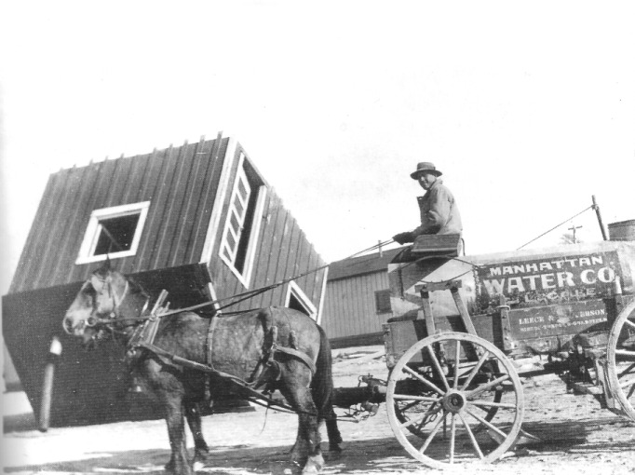

The availability of water was always a problem in Nevada's desert boomtowns. In most towns, water was initially delivered by horse and wagon. As the town matured, water was eventually piped in from springs or other sources lying at some distance. A horse-drawn water wagon is pictured in Manhattan in 1905. We do not know why the cabin is upside-down; perhaps it has just been moved in from some other locality. - Central Nevada Historical Society

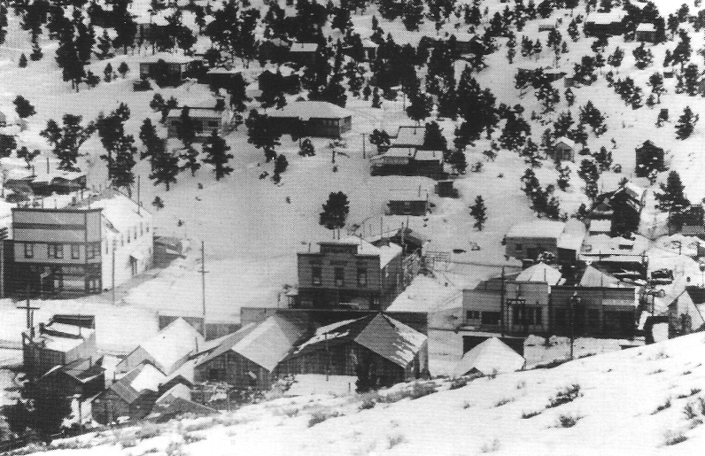

Portion of the central business district of Manhattan in winter 1906. - Central Nevada Historical Society

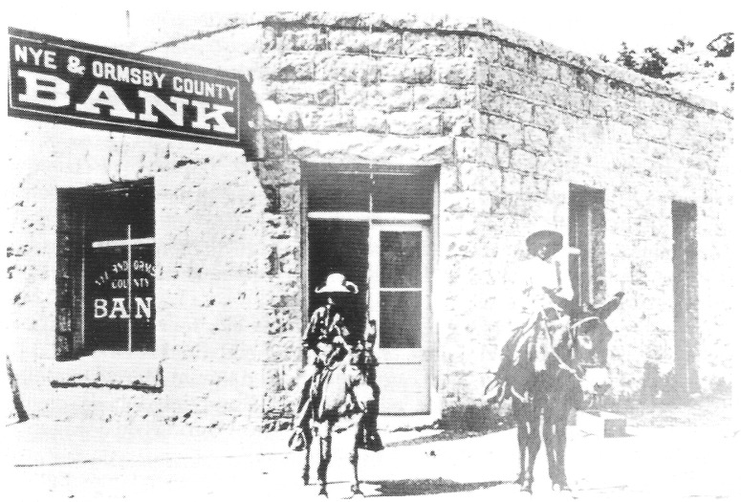

Nye and Ormsby County Bank, Manhattan, circa 1906. One of two banks in Manhattan, it was established in spring 1906 and occupied Manhattan's first stone building. The bank failed, in part because of the financial Panic of 1907. See this structure as it appeared in 2007 on page 106. - Central Nevada Historical Society

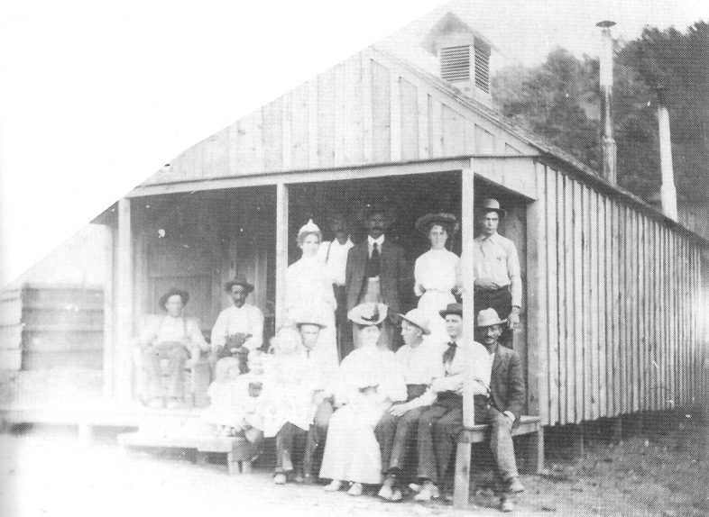

Manhattan Hospital, circa 1906. The availability of quality health care in the turn-of-the-century Nevada boomcamps was a hit-and-miss affair. Services provided in this facility were likely better than no care or many home health remedies. - Central Nevada Historical Society

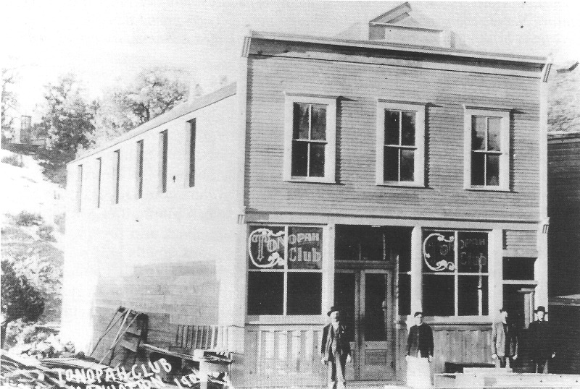

Main Street, Manhattan, 1906. One of the many establishments where, as W. P. DeWolf wrote in his remarkable description of Manhattan in its rambunctious first days, a thirsty patron "took an observation through the bottom of a glass" (1906). - Central Nevada Historical Society

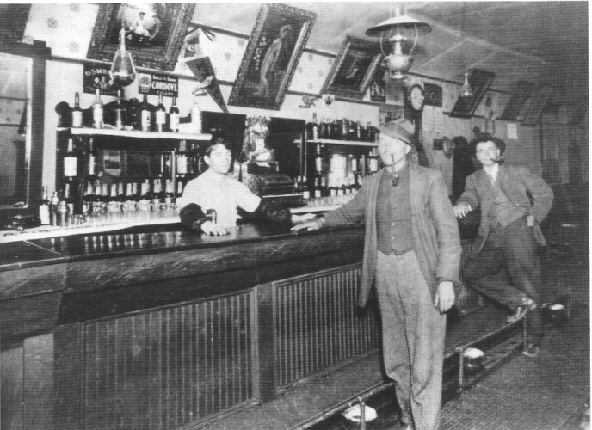

The bar of the Manhattan Red Front Saloon, 1905. The owner, Martin H. Bertolino, is tending bar. - Central Nevada Historical Society

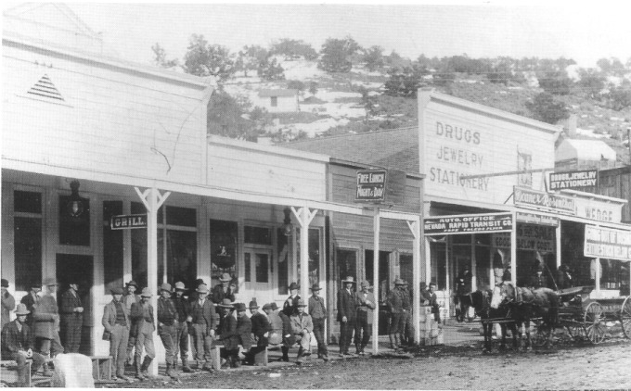

A crowded Main Street, Manhattan, 1907. - Central Nevada Historical Society

CHAPTER FOUR
Manhattan Moves forward

Isolated as the camp was, news of Manhattan's promise reached the outside world through visitors who came there, looked over its mines and undeveloped claims, assessed their potential, and then reported the findings in more established towns like Tonopah and Goldfield. All through summer and fall 1905, the Tonopah papers were filled with reports by respected mining men who had visited Manhattan.

Boosters vs. Knockers

Many of the enthusiastic accounts would have pleased any advocate of the power of positive thinking. In early August 1905, for example, J. Gross returned to Tonopah from Manhattan and told the Tonopah Daily Sun that "as yet, there is nothing done on any of the claims beyond the location work, but the showing eclipses anything I ever saw. . . . I think the district will prove to be among the best, if not the very best. . . . [T]he surface indications are as good and perhaps better than the other camps of Tonopah, Bull Frog [sic], and Goldfield" ("Placer and Quartz at Manhattan," 1905). In December, Harry Sheldon, a well-known broker, visited Manhattan and returned pleased with what he had seen, reporting that he had made "fully a hundred pannings from all parts of the camp, with splendid results" ("Manhattan," December 22, 1905).
"Diamondfield Jack" Davis was among those in the first rush to Manhattan. He returned in January, saying he felt optimistic about the town's future. In early 1906, Sol Camp, superintendent of the January Mine in Goldfield, visited Manhattan and returned convinced it would "become one of the great mining districts of the world" ("The Land of Heart's Desire," 1906). Some boosters even went so far as to assert that Manhattan was another Johannesburg, South Africa.
Still, not everyone was as optimistic. As early as September 1905, the Goldfield News commented that most Goldfield prospectors and investors who had gone to Manhattan to investigate the district had returned home. Although none condemned the camp, most agreed that there was little chance of staking a good claim because "the territory had been staked for miles around the original discovery" ("Manhattan Mining District," 1905). In December, the Tonopah Daily Sun ran a cautionary article. In the story, C. A. Humphrey—brother of John C. Humphrey, the locator of the Seyler-Humphrey claims at Manhattan—tempered his enthusiasm for Manhattan's future with a word of advice for those who got there too late to cash in on a good claim: "Keep yourself ready for a rush when a new strike is made and try and get in in time to get a good lease" ("Manhattan Leasers into the Money," 1905).
Others questioned the extravagant claims made about Manhattan and its future. For example, Martin Herff, who had mined in Leadville, Colorado, in 1878 and had worked in British Columbia, in Mexico, and throughout the Southwest, visited Manhattan in August 1905. He returned to Tonopah, and was quoted in the paper as saying, "People are expecting too much from Manhattan and Palo Alto for the time that they have worked. They are young and it is just as hard to say what kind of a camp a young camp is going to make as it is to figure out what kind of a man a child will become" ("Straight Talk on Manhattan," 1905).
Herff discussed Manhattan's problems, noting that the district had been handicapped from the beginning because the area had been staked out for the most part by wildcat speculators who had no interest in developing a mine but who were intent on selling their claims for a profit. He felt that "the promoter of this class, who rides for ten miles through the country with a pencil and pad of paper locating a bunch of claims can only do the district harm. It is the very com-mon custom to give away one claim for doing the work on two or three others, then when the work is done the place lies fallow until a possible sale is made, and real mining interests are kept out." A bogus claim locator, he said, would dig his location hole in the soft ground on the claim—where there was no hope of finding minerals: "Such location work is a bluff and shows on the very face of it that the locator is simply a dog in the manger and does not mean business" ("Straight Talk on Manhattan," 1905).
In spring 1906, A. H. Halloran, a writer for the Mining and Scientific Press, a leading mining trade periodical of the day, prepared a report on Manhattan. Halloran was unusually critical of the promotional activities taking place in the camp. He noted that there were good indications of ore in many localities in the area but that their economic value remained to be proven. Halloran criticized the boom atmosphere that had caused the camp to mushroom from 100 to 3000 people in six months' time. Stockbroker and "real estate boomer" alike, he said, had realized how attractive the Manhattan site was to investors who had missed the chance to get in on "the ground floor of other Nevada excitements." Manhattan, he observed, was "the best-advertised camp in America." In the preceding six months, little mining had been done. "Claims have been located, other claims have been re-located over them, and still other claims staked on the snowing pre-existing claims, all blanketed with claims newly recorded since the snow has melted. Yet to many companies merely mining on paper this is as satisfactory as though they actually did own a few square feet of ground." The situation offered, he suggested, "a pleasing prospect to an ambitious lawyer."
Halloran reported that some high-grade ore had been mined and sacked, "forming an imposing barricade around the whim or windlass." Much of the ore, however, had not been shipped but remained stacked at the mine. Pictures of sacked ore, Halloran contended, were worth more to "wildcat" companies than smelter returns; too many companies had been formed with the "only mining being confined to working possible investors, to precipitate money from the pockets of the unwary." There were a few legitimate companies in operation, but until the existence of mineral at depth was proved, Manhattan would remain "a precarious gamble." He recommended sinking a 1000-foot shaft to determine the continuous depth of the ore (Halloran, 1906:380-381).

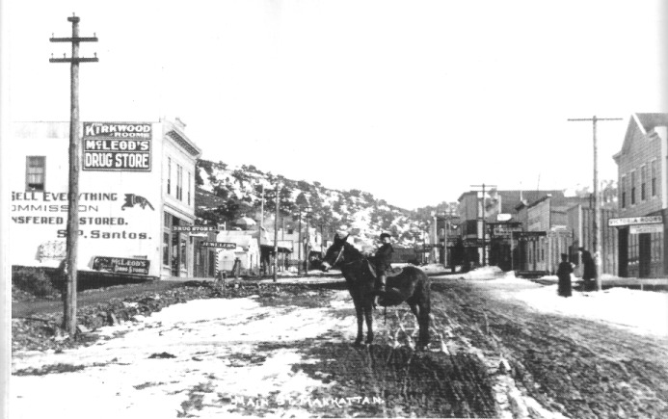

Looking east up Main Street, Manhattan, 1907. - Central Nevada Historical Society

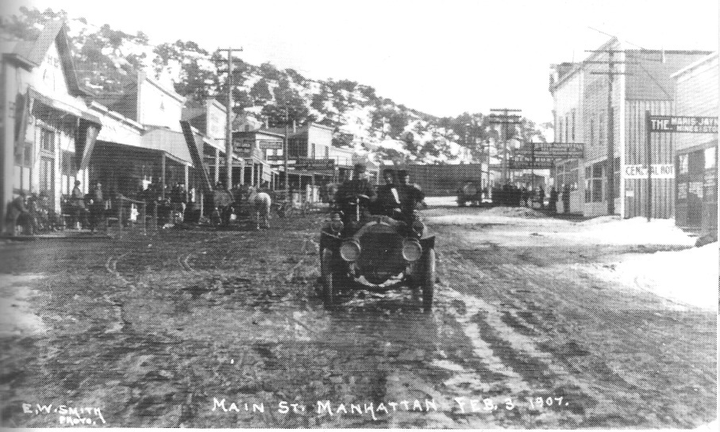

An early automobile on Main Street, Manhattan 1907. Photograph by E. W. Smith. - Central Nevada Historical Society

Claim Jumping

Claim jumping, as Halloran noted in his report, was a big problem in Manhattan. Often a miner or prospector who was interested in filing a legitimate mining claim in order to develop a mine would find that subsequent to his own locating of a claim, claim jumpers had filed claims that overlapped or completely included his own claims. In most instances, claim jumpers were not interested in mining; their purpose was to blackmail the rightful claimant by tying him up in court and preventing him from either working his property or selling it. By paying off the claim jumper, the legitimate miner could free up his property legally and proceed with his business.
In mid-December 1905, the Goldfield News reported on a series of meetings held in Manhattan to discuss what could be done about claim jumping, which many believed was giving the camp a bad name. Speeches were given by some of the community's most important citizens, including W. Humphrey, W. J. Clark, and S. E. Vermilyea, regarding methods of dealing with claim jumpers. Everyone agreed that uncertainty regarding title to property was keeping investors out of the camp, and many people held that claims were being jumped by an organized band of extortionists. A majority at the meeting advocated "more drastic and summary methods" to deal with the thieves. At a meeting attended by over 100 "determined men" packed into a hall "like sardines," the temper of the proceedings suggested that thereafter the man who jumped claims in Manhattan "not only jeopardizes his fortune, but takes his life in his hands," which referred to the willingness of some present to use "hemp" (that is, a hangman's noose) to solve the problem. No doubt Vermilyea's calling as an attorney influenced him to join those advocating peaceable methods, such as arbitration, to settle claim disputes. As if to foreshadow today's litigious society, under Nevada law on mining claims, Vermilyea pointed out, if a prospector wanted to make a truly legal and secure claim, an attorney and a civil engineer would have to be present on the property when the claim was made ("Manhattan," December 7, 1905; "Manhattan Miners Declare War Against Claim Jumpers," 1905).

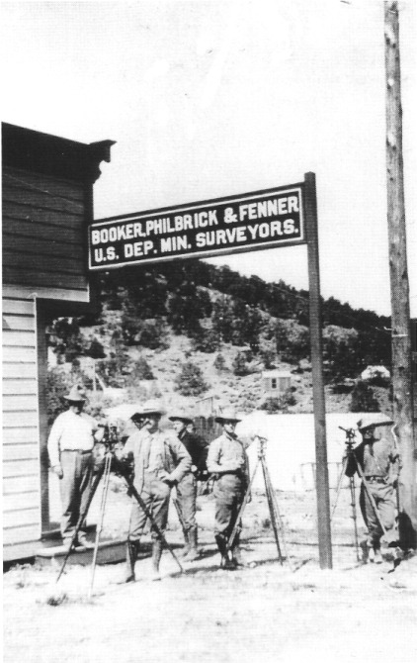

Surveyors in Manhattan, 1907-1908. Claim-jumping was a serious problem in Manhattan and damaged the community's economic development. Having a mine claim properly filed with the authorities and the mine legally surveyed was vital for a mine owner. Disputes over claim boundaries could cripple a miner's ability to either sell or attract investors for developing his property. - Central Nevada Historical Society

Promoters Boost Manhattan

Despite such cautionary statements, Manhattan did attract outside money. In January 1906, Patrick, Elliott & Camp, a Goldfield brokerage house, announced that it would act as agent for the Seyler-Humphrey Gold Mining Company and its famous April Fool property. Within five days the entire allotment of treasury stock was sold out, with offers for purchase of stock coming by telegraph from New York, Pittsburgh, and Chicago. That same month, the company sold 75,000 shares for the Manhattan Combination Mining Company within a few hours at 15 cents per share. By March, one Manhattan company, the Greater Manhattan Consolidated Mining Company, was controlled by Los Angeles capitalists. In February, the Jumping Jack, owned by J. T. Darrough and J. W. Power, the former Nye County sheriff, was sold for $90,000 and one-fifth of the stock in the new company, which was headed by a Tonopah banker; the sale price was a high-water mark for the new camp.
In February, the Goldfield News noted the beneficial association that could develop between a stock promoter and a mining camp—provided the stock promoter was honest. However, the newspaper cautioned that when enthusiasm and expectations rose above realistic levels concerning how much money could be made through stock investment, the possibility of fraud also rose, which was bad for the community. The newspaper appointed itself watchdog for fraudulent stock flotation—but with a disclaimer: Even though the Goldfield News carried an advertisement for flotation, that did not necessarily mean the paper endorsed it.
By late summer 1906, there was talk that mills would be built in Manhattan. It took one year, but by mid-October 1907, at least three mills were under construction in Manhattan.

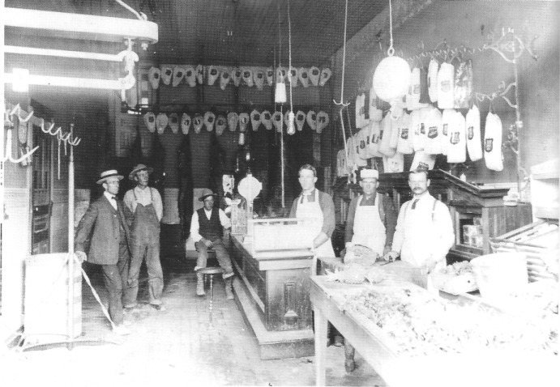

As this photograph of the butcher shop owned by John Moore and Clint Desmond indicates, businesses in Manhattan thrived despite the uncertainties of the mine claims. - Central Nevada Historical Society

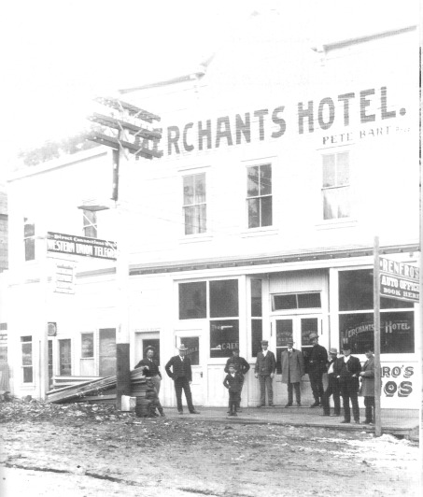

Merchants Hotel, Main Street, Manhattan, 1907. Note the Western Union office on the left and the sign on the right for booking autos, both of which attest to the robust economy of Manhattan. - Central Nevada Historical Society

Arthur Raycraft,
Father of Wireless Radio in Nevada

Arthur G. Raycraft, considered the father of wireless radio transmission in the state of Nevada, had strong ties to early Manhattan. Raycraft moved to Tonopah from Carson City some time prior to 1909 and was employed by the Nevada First National Bank in Tonopah. He had previously worked as a telegrapher.
As a banker in early Tonopah, he was, not unexpectedly, interested in mining and had investments in Manhattan mines. He became the president of the Dexter-Manhattan Mining Company.
Raycraft was also deeply interested in wireless communication technology and, by mid-1909, had made plans for a wireless communication setup between Tonopah and Manhattan.
Raycraft installed his wireless system in Manhattan on the second floor of the Dexter Building. In Tonopah, Raycrafts wireless system was housed in a room on the second floor of the beautiful home he designed and had constructed. It is known today as "The Castle House." Call letters for his Manhattan station were ARM; Tonopah's were NHM
By June 1910, Raycraft was receiving wireless messages from the West Coast and by early 1911, he provided the Tonopah Daily Bonanza with a wireless world news service. The Tonopah paper is said to have been the first newspaper in the state with such a luxury. Transmissions between Manhattan and Tonopah are thought to have been equally successful.
By 1919, there was interest in in-stalling wireless systems in other mining camps near Tonopah, including Spanish Belt (50 miles northeast of Tonopah), Arrowhead (40 miles to the east), and Tybo. Advancing radio technology, however, is thought to have bypassed Raycrafts Nevada Wireless Telegraph and Telephone Company after World War I. Raycraft died in 1944; his title of "Nevada's Father of Wireless" is well deserved.
Tonopah Daily Bonanza headline, May 21, 1909 "MANHATTAN HAS FIRST WIRELESS TELEGRAPHY IN STATE OF NEVADA".

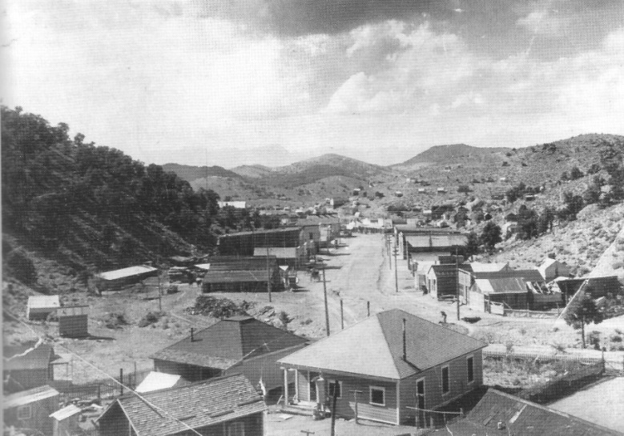
Looking west down Main Street, Manhattan, 1909. The Toiyabe Range is visible in the distance. In the foreground is the house of J. Frank Humphrey, brother of John C. Humphrey, who made the discovery of gold that set off the boom in Manhattan in 1905. - Central Nevada Historical Society

Utilities Reach Manhattan

The Manhattan Electric Light, Power, and Telephone Company was incorporated in January 1906; telephone service was established between Manhattan and Tonopah in March 1907. Some effort was made to obtain subscribers for electric service, but power from the outside did not reach Manhattan until 1909. In the interim period, some electricity was generated by locally based equipment.
Electric power produced outside Manhattan reached the town after a $25,000 advance was made by the Manhattan War Eagle Mining Company (representing Manhattan) and the Round Mountain Mining Company (representing Round Mountain), located 13 miles north of Manhattan. An agreement was reached with the California-Nevada Power Company in February 1909 that power would be turned on at the War Eagle Mill in May. The 37 miles of 50,000-volt, 3-phase lines connected Millers with Manhattan and used old poles from the Rhyolite Light, Heat and Power Company. Some 30 to 40 men were employed in construction of the line.

The San Francisco Earthquake and the 1907 Panic

Two disasters that occurred within two years of the town's founding set Manhattan back. The first was the earthquake that leveled San Francisco on April 18, 1906. Much of the boom in Manhattan had been financed by San Francisco money. Many of those owning property in Manhattan had San Francisco ties and those California investors rushed back to San Francisco when they heard the terrible news. Within two weeks, Manhattan was almost depopulated. By one account, in May 1906 there were only about 100 people left in town. With minimal capital, those who remained kept some of the best mines going, and even opened more mines. Several rich strikes were made at this time; one was at Monte Carlo at the foot of Timber Hill not far from the old Manhattan Mine. Those who stayed on helped disprove Manhattan's bad rap that the ore there did not go deeper than about 12 feet. Shallow depth of ore, of course, is one of the worst things that can be said about a hard-rock mining camp. During the summer and fall of 1906, people began to return to Manhattan.
Tests in fall 1906 also showed that Manhattan ore could be refined by cyanide processing, so mill construction began. The first mill in Manhattan (later called the War Eagle Mill, also known as Red Mill) was owned by the Manhattan Ore Reducing and Refining Company. The second, established by the Nevada Ore Processing Company, was sometimes called the Lemon Mill. Both mills were located below Manhattan, one on each side of the canyon. By 1907, Manhattan had 65 properties showing ore and three 10-stamp mills in operation with four on the drawing boards. In addition, the first placer mining had begun in 1906.
Because San Francisco banks owned about one-half of the property in Manhattan, the financial Panic of 1907 dealt another blow to the community. As banks in San Francisco folded during the Panic, many mining enterprises were forced to shut down. The Manhattan branch of the Nye and Ormsby County Bank failed, but the Manhattan Bank hung on, in no small part because James Darrough refused to withdraw his $10,000 from it in October—Darrough even sent word that he would deposit more money in the bank if needed. The town struggled to survive the earthquake and the Panic—and managed to do so. In 1908, Manhattan would claim 368 registered voters.
Lucile Rae Berg, daughter of Will and Lillian Berg from Round Mountain, had a deep interest in central Nevada history and, in 1942, wrote her master's thesis for the history department at the University of Nevada in Reno, titled "A History of the Tonopah Area and Adjacent Region of Central Nevada, 1827-1941." She summarizes Manhattan's recovery from its early troubles this way: "By 1909, things were picking up. . . .Whenever a big strike was made, a small boom occurred. After a time, it became customary to expect Manhattan to boom once a year or at least every two or three years. Manhattan has always been known as a 'boom town' and often there was nothing there but talk" (113).

Towns Near Manhattan

Other towns in the district competed with Manhattan. Those communities had their boosters, and people with vested economic interests touted the advantage of their towns over the others. Palo Alto was the first town in the district to spring to life after Humphrey's initial discovery. It was located west of Manhattan near the water at Bull Spring, on the edge of Smoky Valley. The spring was well known to local cattlemen. But its waters were not satisfactory, and the town was abandoned by August 1905; by 1917 only a few tin cans marked the site.
East Manhattan was located about 2 miles east of Manhattan. It sprang up in 1906 shortly after new discoveries were made in the district. There were a few promising ledges near the community, which at its height had two stores, two saloons, and a restaurant. With the exception of one wooden building, the town was composed of tents. The nearby veins of ore proved to be shallow, and the community was abandoned by the end of 1906.
Central (or Central City) was located about 21/2 miles west of Manhattan. There was an abundance of pure water at the site. At its peak in early 1906, the town featured two assay offices, five saloons, two stores, two hotels, a lumberyard, and a bakery; it probably had a population of about 100. Central had a post office from March to September 1906. Stage lines connecting Tonopah and Austin passed through Central, and large freight teams of 12 to 20 horses or mules pulling three wagons always stopped overnight for feed and water. With the revival of Manhattan in fall 1906, Central lost out and vanished from the map. Most of its buildings were moved to Manhattan.

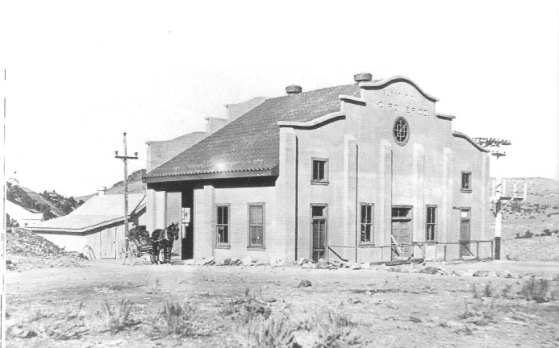

Substation for the Nevada Power Company at the lower end of Manhattan, 1910. Electric power generated outside the community reached Manhattan in 1909. The building site is now (2008) located in the northwest corner of the west pit at the lower west end of town. - Central Nevada Historical Society

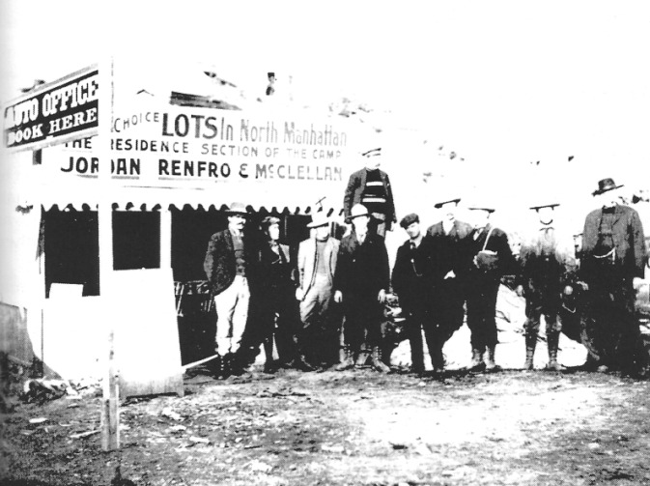

Real estate office on Main Street, Manhattan, .ca 1907. Money could usually be made selling real estate in and near Nevada's frontier boomtowns. In early 1906 lots were selling for $3,000 that had sold for $75 only a short time before. Note how the men in this photograph are dressed—all are wearing high lace-up boots, felt hats, and sport coats with sweaters or vests and ties. - Central Nevada Historical Society

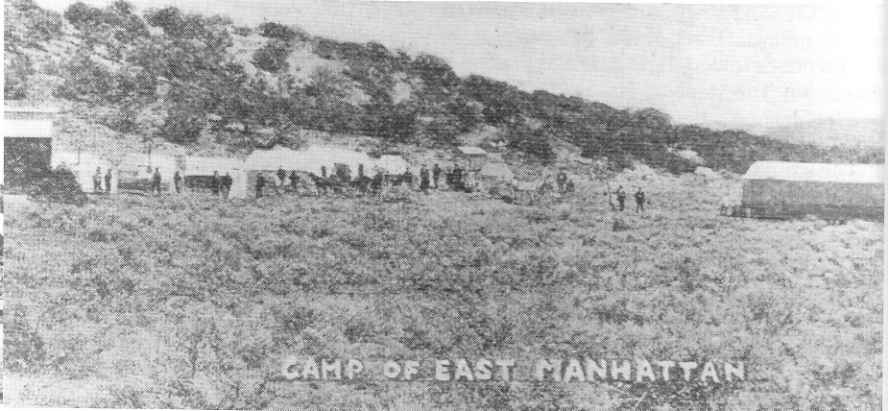

East Manhattan was founded in spring 1906. It was located about 2 miles east of Manhattan near some promising ledges that proved to be shallow; by the end of the year it was abandoned. - Central Nevada Historical Society

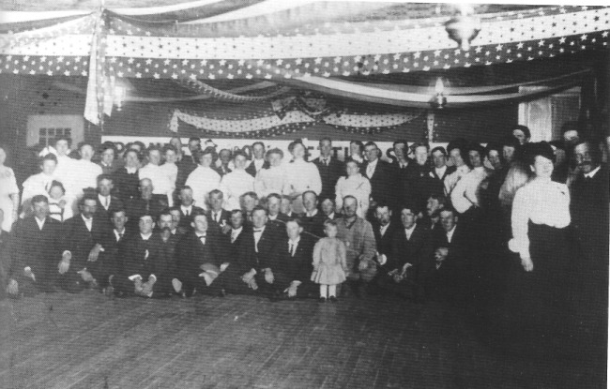

Grand ball given by the Pioneers of Manhattan, Nevada, February 28, 1906. - Central Nevada Historical Society

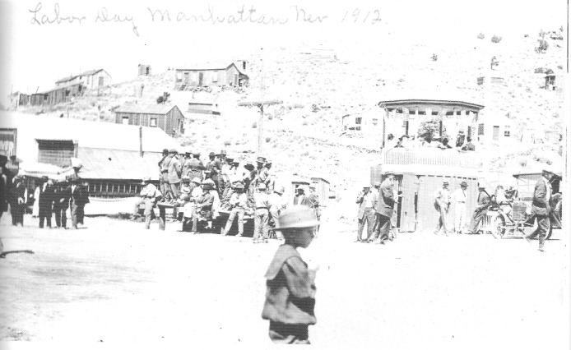

Residents gather for the Labor Day celebration in Manhattan, 1912. - Rene Rogers Zaval and Jim Berg

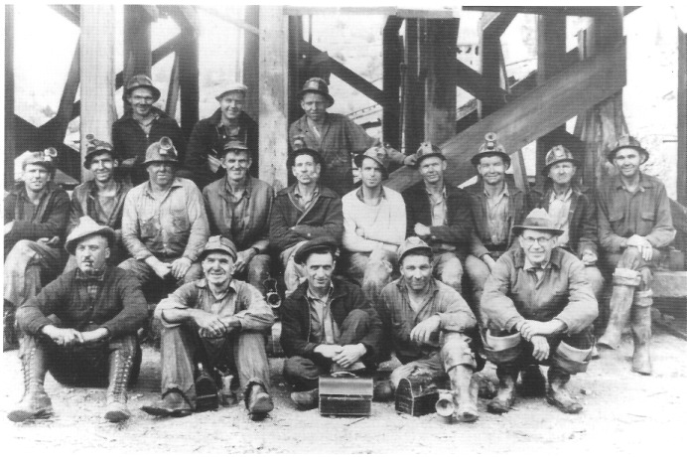

A crew at the White Caps Mine, 1940. - Central Nevada Historical Society

CHAPTER FIVE
The Important
Mines and Mills

Norman Coombs began working in the mines at Manhattan and Round Mountain in the late 1920s and continued to work in them periodically for more than 50 years. A native of Tonopah, he spent his career working underground, most of it in central Nevada. A quintessential miner, he was among the last of a breed. The following overview of the Manhattan District's principal mines and mills derives primarily from his recollections.

The April Fool, the Manhattan Consolidated, and the Manhattan Gold Mines

The April Fool, the first mine in Manhattan, began producing in 1905. April Fool ore tended to occur in high-grade streaks of milky quartz one-half to two inches wide; sometimes the streaks were wider than two inches, but when they were, their gold content was lower. A shaft about 60 to 70 feet deep can still be seen on the property, which is located behind the old post office, and part of the streak that first attracted attention can still be seen running up a hill from the shaft.
The Manhattan Consolidated Mine, located above town on the road to Belmont, had a 500-foot shaft. The ore occurred in veins in siliceous limestone, and mining was expensive because of the water in the lower depths of the shaft. In addition, the rock contained barite, which when drilled by the miners, produced a foul smell, something like feces. By 1938, the mine had been taken over by leasers. The Manhattan Consolidated Mine ground ore in a Chilean mill rather than in a stamp mill. (A stamp mill crushes ore by pounding it; a Chilean mill is a modification on the principle of an arrasta, in which in place of a stone being dragged in a circular motion around a pivot point, heavy metal wheels on axles connected to the pivot point turn in a circular motion, grinding the ore.)
The Manhattan Gold Mine was also located above town. It consisted mostly of several levels of tunnels, some of which were as long as 2000 feet. Much of the ore found in the Manhattan Gold was high-grade, with the gold having a silvery look and being only about 600 fine (60 percent gold). The veins ranged from two to six feet wide, but they were not uniform and were really two separate veins. One was on the footwall side, and the other was on the hanging wall side, with the material in between being mostly barren. As is usually the case, the footwall side of the split vein carried much higher values than did the hanging wall side. This mine was also associated with a stamp mill located below town.

The Big Four, the White Caps, and the Reliance Mines

The Big Four Mine, located on Big Four Hill at the lower edge of town, also consisted mostly of tunnels, with raises (vertical branches) coming off the tunnels. Some of the tunnels were up to 1000 feet long and went nearly all the way through the mountain. The ore in the Big Four tended to be very pockety. A pocket of ore could produce 15 or 20 tons that would run as high as $1000 per ton with gold at $20 per ounce—meaning about 50 ounces of Manhattan gold per ton. The gold from the Big Four often formed a dendritic pattern in rock, with the small seams of gold in a specimen branching out in a fanlike pattern. The gold was present in "blurred" or "drusy" (covered with crystals) quartz and at times was so rich that it sometimes clogged the screens at the mill. The Big Four Mine processed ore at Musket's Mill, named for the man who built it.
The White Caps Mine (part of the Manhattan Dexter holdings) was by far the biggest-producing "lode," or hardrock, mine in the Manhattan camp. It was one of the first in the camp and was discovered because of its outcrops. The mine was owned by the Tonopah Extension Mining Company, whose executives included John G. Kirchen and Homer Williams as well as many other prosperous Tonopah residents.
The White Caps primarily mined low-grade ore. The ore occurred in big veins from 5 to 14 feet wide and ran $30 to $40 per ton with gold at $35 per ounce. The White Caps shaft bottomed out at 1300 feet, and there were always serious problems with water in the mine. If water was not pumped from the shaft, it would rise up and flood the mine to the 500-foot level. In the bottom of the shaft, water came into the mine at the rate of 1000 gallons per minute; of course, pumping such large quantities of water was an added operational expense. Tonopah businessman John Connolly took over the mine in the mid-1930s (after it had been shut down because of the water-pumping expense), and he opened the mine to leasers.
The mill associated with the White Caps Mine had both stamp and ball mills and could process about 100 tons of ore in 24 hours. The mill also had a roaster for the ore concentrations. A considerable amount of arsenic in the rock and water in the White Caps created a constant health hazard for the miners. A miner who got a small cut or nick and was then exposed to water from the mine found that the wound would not heal, and even worse, the arsenic would cause it to form a large, open sore that would not heal until the miner stopped working in that mine. Treating the sore with a tarlike medicine kept it from getting worse, but it still would not heal. Miners in Butte, Montana, had similar problems with arsenic-caused sores.
The Reliance Mine, which opened in the mid-1930s, was the second biggest producer in the Manhattan District. The shaft at the Reliance, which eventually reached a depth of 600 feet, was also plagued by water. Reliance ore became lean below the 500-foot level, but the mine had both high-grade and low-grade ores, with the former running $1000 and the latter $20 to $30 per ton with gold at $35 per ounce. Coombs estimated that more than $1 million in gold was taken from the Reliance, whose ore occurred in veins that sometimes became very rich. In all, the Reliance Mine operated for no more than six or seven years. Interestingly, the Reliance was first located as a placer operation in the gravels in Manhattan Gulch below town, and subsequent discoveries led to the sinking of the big shaft. The War Eagle Mill, also known as the Red Mill, processed the Reliance Mine ore. Like all the mills in the Manhattan area, it used either groundwater from Manhattan Gulch or water pumped from the deep shafts.
Many years later, in the 1980s, the Echo Bay Mining Company, which had bought up the gold mines at Round Mountain, also acquired the Reliance property. Drilling proved that the entire area near the Reliance shaft could be mined using open-pit methods. At first Echo Bay tried to heap leach the ore from the open pit, but the company found that more gold could be recovered if the ore was run through a ball mill and then treated in cyanide tanks. The Reliance Mine sat on the right-hand side of the road going into Manhattan.

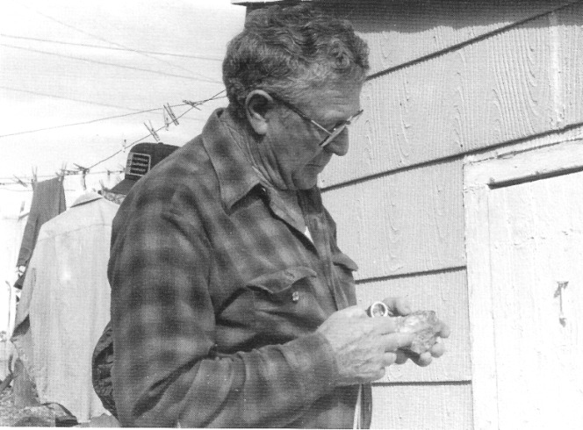

Norman Coombs examining a specimen of ore with a magnifying glass, 1990. - Author's Collection

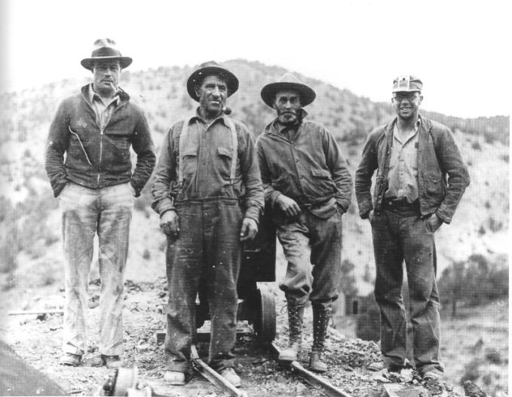

Four central Nevada residents, probably miners, circa 1930. - Central Nevada Historical Society

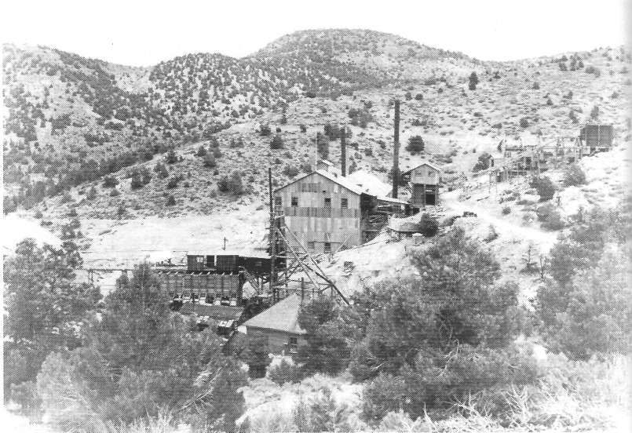

The White Caps Mine, Manhattan, 1939. - Central Nevada Historical Society

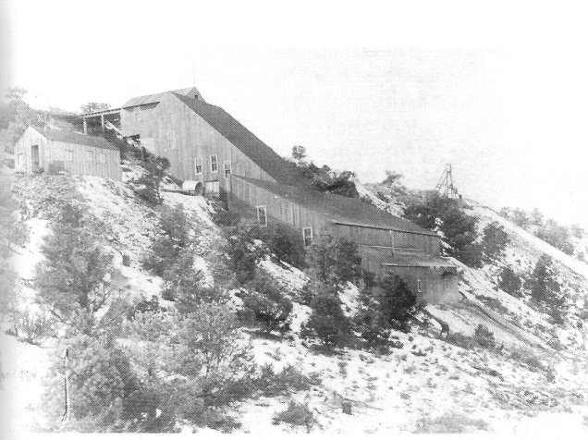

Manhattan Milling and Ore Company, Manhattan, circa 1909. One of Manhattan's largest mills, it was located west of town, on the south side of Manhattan Gulch. - Central Nevada Historical Society

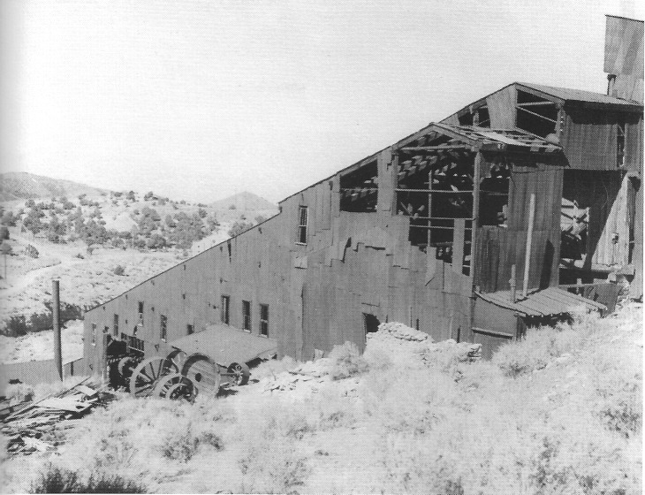

The Manhattan Milling and Ore Company was known to later generations as the Red Mill. Note the power station building just visible over the mill's roof edge. The last time the mill operated was just prior to World War II. By the late 1940s, when this photo was taken, much of the milling equipment had been scavenged or sold for scrap. - Nye County Town History Project—Boni Collection

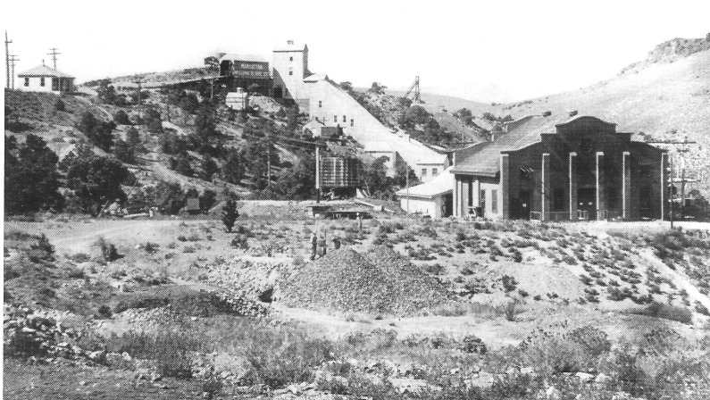

Lemon Mill, also known as the Wittenberg Mill, located on Wolftone Point, circa 1910. Note the power station, which was constructed near the mill in 1909. - Central Nevada Historical Society

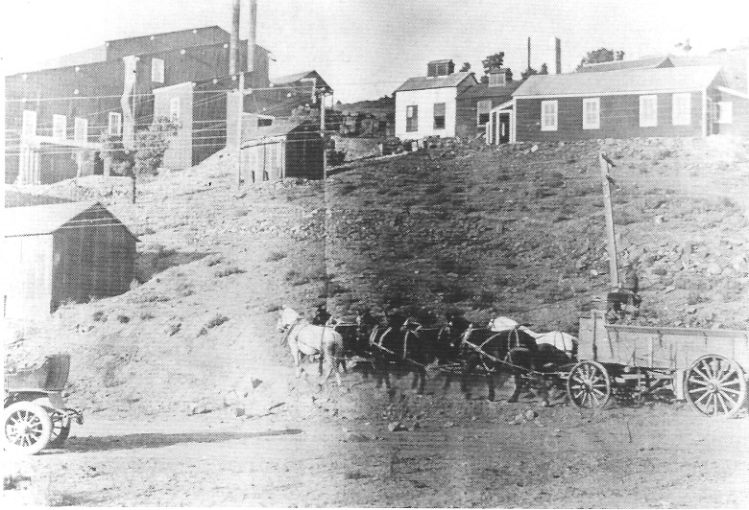

Ore being hauled in a wagon to War Eagle Mill, circa 1910. - Central Nevada Historical Society

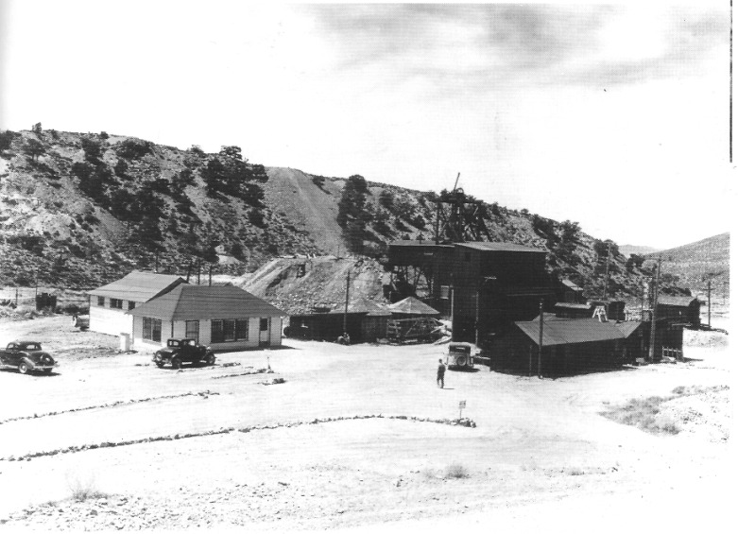

The Reliance Mine, 1939. - Central Nevada Historical Society

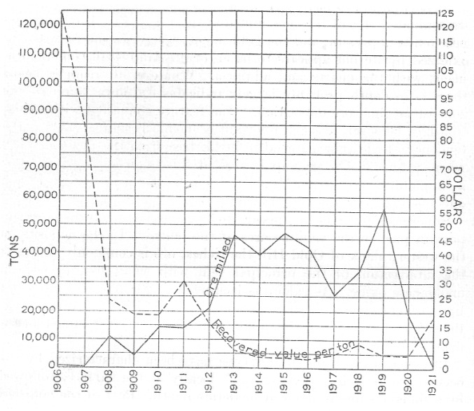

Curve showing tonnage of ore milled in the Manhattan district, 1906-1921, and average value per ton of bullion obtained. Henry G. Ferguson, 1924

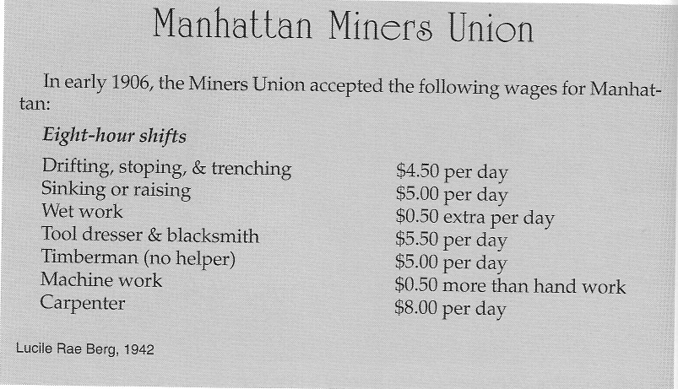

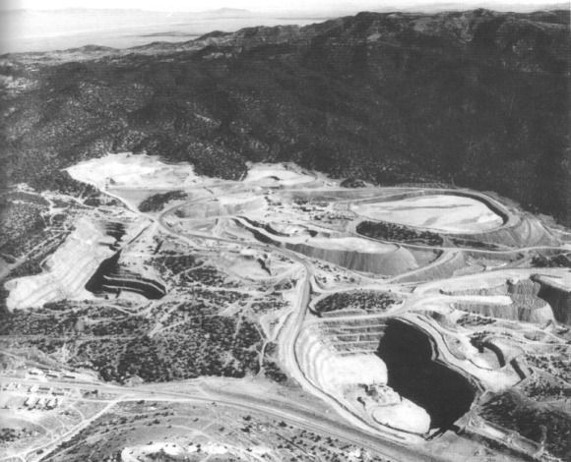

Beginning the 1970s, drillers for a accession of companies, including Hughes Tool, Houston Oil and Minerals, Summa, and Echo Bay Mining Company, discovered extensive gold reserves just below the lower end of town in Manhattan. Those reserves were removed from four open pits seen in this photo (two are relatively small), looking toward the southeast with Ralston Valley visible in the distance, 1989. In 2007, owner Round Mountain Gold Corporation was drilling on the property looking for previously unknown gold reserves. - Central Nevada Historical Society

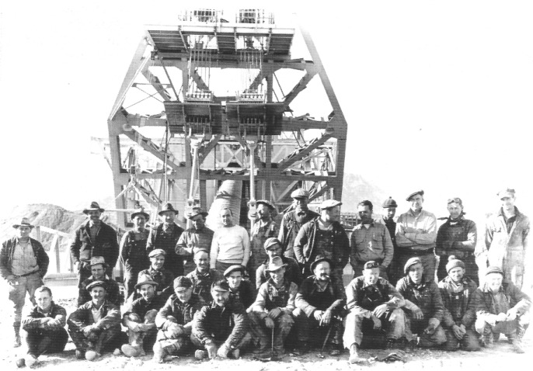

Crew of the Manhattan gold dredge in front of the boom at the dredge's bow, perhaps just prior to World War H. - Central Nevada Historical Society

CHAPTER SIX
Placer Mining
in Manhattan Gulch

By the time the last of America's frontiersmen began arriving in Manhattan in 1905, much of the gold that nature had deposited in the mountains on either side of Manhattan Gulch had eroded from the veins and pockets and washed several miles down the gulch. Although the hardrock mines at Manhattan were good producers, Manhattan placer was among the very best in Nevada.

Placer Gravel

Over the millennia in the geologic past, there were countless times when tremendous torrents of water came surging down Manhattan Gulch, in what we would call enormous flash floods. Such waters stirred up everything in their path, sending it all, including boulders, gravel, and gold that had eroded from the mountains at the head of Manhattan Gulch, rumbling down the wash. When the churning mass of mud, rocks, and gold mixed with water moved down the gulch, it polished the bedrock and concentrated the gold. As the water rushed toward the floor of Smoky Valley, the Manhattan Wash channel served as a huge natural sluice box. When the watery mass raced along, the gold, which was much heavier than the materials it was moving with, would tend to sink to the bottom of the channel, where natural crevices and humps in the bedrock would trap the gold like riffles in a sluice box. As the mass moved, it also lost some of its momentum on the inside turns of the channel and the downwater side of large boulders and hillocks, and gold was deposited there.
The average width of the gulch is about 300 feet, and its grade is approximately 4 percent. The depth of the gravel ranges from 20 to 100 feet, with an average of about 30 feet. Roughly 60 percent of the gravel is larger than one inch; the rest is sand and smaller pebbles. When placer miners worked the gulch—and eventually 5 to 6 miles of it was mined—the pay streak (the layer of gravel containing gold values), which lay directly on top of bedrock, was 2 to 4 feet thick in most of the shafts that were dug into the gravel. Shafts were usually sunk at intervals of about 300 feet, and drifts (tunnels) were constructed at bedrock level at the bottom of the shafts.

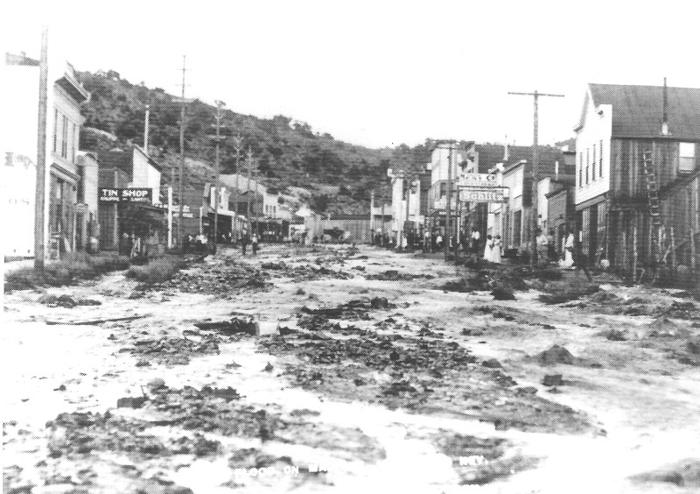

Because of its location in a gulch that drained water from rain and snow from nearby high mountains, Manhattan was subject to flash floods, which could send large volumes of water and debris coursing down Main Street. Water can be seen here flowing down Main Street following a summer flood in 1913. Material rushing down Manhattan Gulch, of course, was the basis of the Manhattan placer. Gold that had been eroded from the mountains surrounding Manhattan Gulch was moved downstream and concentrated by flood waters in a great natural sluice box. - Central Nevada Historical Society

Flashes of Color

In fall 1905, the Dexter Company found flashes of gold, called "colors" in mining terminology, in pannings while digging a well at the lower end of town in Manhattan Gulch, but no one paid attention to the find. Later, a miner named Burns discovered nuggets on the surface of a gravel bench above Manhattan Gulch in 1906.
In April 1908, William Alexander Donald, a placer miner from California, believed gravel in the gulch would produce good placer values, so he obtained a lease on the Nellie Gray claim. He sank a shaft and hit bedrock at 23 feet. The pay streak was from 5 to 7 feet thick and averaged $10 per cubic yard in value. Donald cleared several thousand dollars before his lease expired.
Placer gold had been found in the gravel of a 45-foot well dug at Central in 1905, but in the rush for lode claims it had been overlooked. After Donald's success, the owners of the well at Central sank a shaft and found a pay streak 3 feet thick. Observers at the time dated the real inception of placer mining at Manhattan to the sinking of this shaft at Central in 1908.
Thomas "Dry Wash" Wilson, who had been hugely successful with placer mining at Round Mountain beginning in 1906, became a local celebrity in the Round Mountain–Manhattan area. Wilson had heard about the good luck with placer at Central and immediately purchased an interest in several leases in the area. Naturally, Wilson's endorsement of Manhattan Gulch placer caused a great deal of excitement. The Manhattan Mail proclaimed in a headline on February 17, 1909: "Bucket of Gravel from Davis-Wilson Lease Washes Out $8 in Gold Nuggets. Each Day Brings Forth News of Rich Finds All Along the Gulch—Warmer Weather Causes Renewed Activity." The accompanying story was reassuring.

Interests in ground are being sold at big figures and general excitement prevails along the entire [Manhattan] gulch. "Dry-wash" Wilson is acquiring interests up and down the gulch and according to reports is paying big money for them. Mr. Wilson is one of the best posted placer men in the camp and the fact that he is putting his money so lavishly into the placer ground has had a magical effect on the doubting Thomas. Mr. Wilson made a fortune in placer at Round Mountain and has left that camp for the placers of Manhattan.

Although in April 1908 hard-rock mining was practically at a standstill in Manhattan, by May 24, a little more than a month after Donald made his discovery, there were 60 shafts sunk to bedrock in Manhattan Gulch that varied in depth from 35 to 90 feet. Some of the placer mines were worked for two, even three shifts, though some by only one or two men. Nearly all had 2- to 4-foot¬thick pay streaks, which ran from $5 to $30 per yard. In May 1909, there were 150 men working in Manhattan Gulch. A nugget obtained from one of the placers in May 1909 measured 21/2 x 31/2 inches and was 1/2-inch thick.

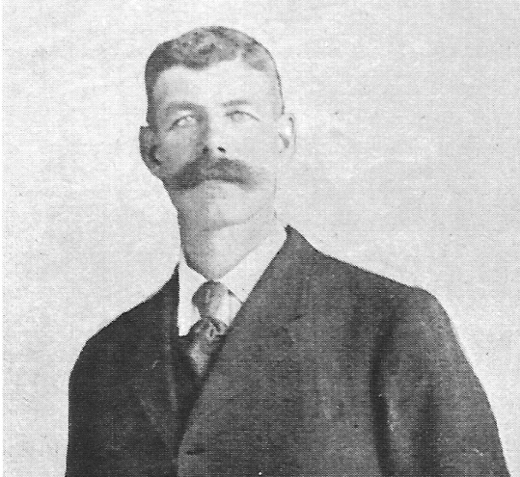

Thomas "Dry Wash" Wilson, circa 1909. His endorsement of the placer in Manhattan Gulch in 1909 generated considerable enthusiasm for those interested in placer mining in Manhattan. - Central Nevada Historical Society

Good News from Manhattan

There was a steady stream of favorable reports on placer activity at Manhattan in 1908 and 1909. At times it seemed as though each new report was obliged to top the previous one. In mid-October 1908 the Bullfrog Miner observed, "Placering has become quite the fad in the Manhattan district, and nearly every gulch in the camp has machinery on the surface, extracting gold from the rich placer deposits" ("Manhattan Building Three Stamp Mills," 1908). In June 1909, under the heading "Manhattan Placers Promise Great Gold Production," the Rhyolite Herald told readers that values recovered in the sluice boxes in Manhattan Gulch ranged in value from $4 to $22 per cubic yard, with an average of slightly above $12 per yard. One outfit broke into gravel reported to run from $2 to $10 per pan. That summer, "Happy Charlie" Birimisa encountered gravel that ran as high as $125 per yard, and as the Rhyolite Herald put it, "The entire populace sat up, rubbed their eyes and declared that the biggest thing had been struck" ("Placer Gold Runs $10 a Pan at Manhattan," 1909). Ninety percent of the holes dug in Manhattan Gulch produced pay dirt, and there were some spectacular finds. The Griffen nugget, the size of a deck of cards, was recovered only because it would not pass through the concentrating equipment. When a worker reached in to throw away what he thought was a rock, he recognized it as gold. It was solid gold and, at 11.13 ounces, may have been the largest nugget ever recovered in Manhattan.

Production Record

Between 1906 and 1915, the hardrock ore lode mines in Manhattan produced $2,065,072 in gold and silver. More than 12,000 ounces of gold were produced in both 1908 and 1910. The peak year was 1911, when just over 20,000 ounces were produced. Thereafter, production declined—by 1915, to under 8000 ounces. In contrast, the placer mines in Manhattan produced $924,906 between 1908 and 1915. The peak production years for placer at Manhattan during this period were 1912 and 1913, when over 8000 ounces per year in gold were being produced. However, the above figures are undoubtedly low because of both high-grading by miners and underreporting by leasers of the real amount of gold found. After 1913, placer mining in Manhattan Gulch declined slowly as the richer portions of the deposit that could be worked by hand became exhausted.

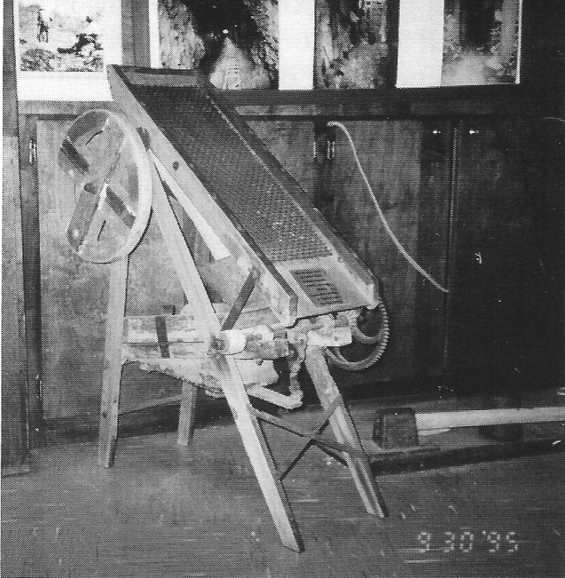

A dry-wash placer machine used in central Nevada around 1910 on display at the Central Nevada Museum in Tonopah. The gold-containing gravel is shoveled onto the screen at the top of the machine; the coarse gravel slides away, and particles small enough to go through the screen—including gold—fall down through the hopper onto a bed composed of heavy cloth. The bed is agitated by puffs of air from a bellows at the bottom, operated by hand labor, causing the lighter rock materials to slide away and trapping the heavier gold behind the riffles. - Author's Collection

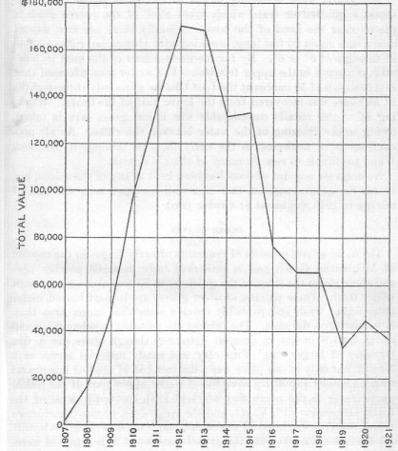

Curve showing placer production in the Manhattan District, 1907 - 1921. - Henry G. Ferguson, 1924.

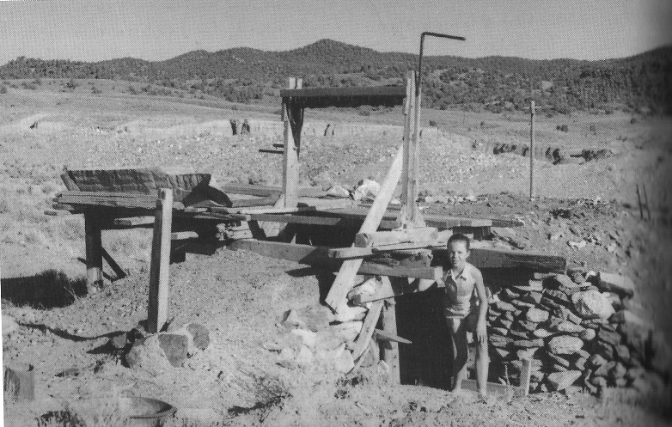
Small placer operation from the 1930s, as scam in 1960. - Central Nevada Historical Society

Manhattan Placer Mining in the 1930s

After Franklin Delano Roosevelt became president in 1933, one of the first acts of his Democratic administration was to raise the price of gold from $20 to $35 per ounce. The price increase produced a revival in placer mining at Manhattan Gulch. Central Nevada native Jim Larson, who worked the Manhattan placer mines as a young man, recalled that between 1934 and 1938 anyone in Manhattan who wanted to work in a placer operation was able to afford a new car. In the Great Depression years, a new pickup truck cost about $600 and a new car, under $1000.
Miners usually did not own the claims they worked but instead took six-month leases. Royalties paid by the leasers to the owners averaged 10 to 15 percent of gross returns. During that time period, there were as many as 25 sets of leasers working in Manhattan Gulch, employing essentially the same methods used a generation earlier. The size of a lease was commonly 300 x 300 feet. Because of the dangers in mining, men usually worked in pairs, although sometimes there were as many as four men working one lease.
On a typical day, a placer miner at Manhattan Gulch worked on his hands and knees in a tunnel normally less than 5 feet in height and 30 to 100 feet long, picking away at the gravel, loading it into a bucket on a dolly, and pulling the dolly out to the shaft. Some miners used a wheelbarrow instead of a dolly. The filled bucket was then raised to the surface by an electric hoist whose motor and drum sat to one side at the bottom of the shaft in a little alcove. That way the miner did not have to climb out of the shaft to operate the hoist. Hoists used a Model T Ford transmission driven by an electric motor. Dollies were made of four mine-car wheels with two 6 x 6-inch or 8 x 8-inch braces between them, arranged so that the bucket would not slip off. Eight-pound light mine track was used. The hoist cable had a mark on it, so the miner knew when the bucket had reached the top of the shaft. At that point, a mechanical attachment emptied the bucket automatically, and the miner then let the bucket back down the shaft. A placer shaft was usually 5 x 7 or 7 x 7 feet wide, although company-owned shafts were sometimes larger.
Once a shaft reached bedrock, workers tunneled out. Two men working underground could dig out about seven yards of gravel per day if everything went just right, as Larson recalled. It took about 30 minutes at the end of the shift to run the day's diggings through the sluices and obtain the gold. In the 1930s, Larson and a partner could sink a 40-foot shaft in about one week. Larson remembered that there were amazingly few accidents in the shafts. "When a man went out and earned his own keep, he was a pretty sharp cookie; very few of them got killed that way" (Larson, 1990:15).
Picking all day in the gravel was hard on a miner's hands. Larson said, "I'm telling you, your hands get . . . you can't even move them, when you wake up in the morning, your hands feel like they'll fit a pick handle. You've got to knead them" (Larson, 1990:8). Most miners were forced to kneel while working, which caused constant circulation problems in their legs. Larson's knees would not take that stress, so he worked sitting on a 6 x 6-inch block, swinging his pick from that position.

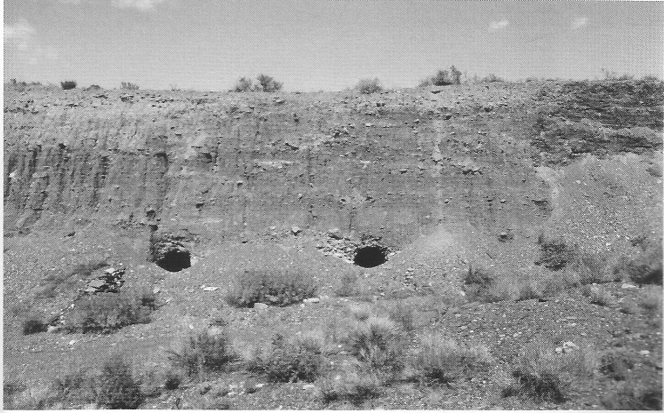

Between 1910 and the late 1940s, Manhattan miners sunk shafts into the gravel in Manhattan Wash and tunneled out from the bottoms of the shafts looking for gold-bearing gravel that had been deposited in the wash on top of bedrock. Beginning in 1938, a dredge mechanically processed much of the gravel in the wash, uncovering many old tunnels the miners had dug earlier. Photo shows two such tunnels in 1995. - Author's Collection

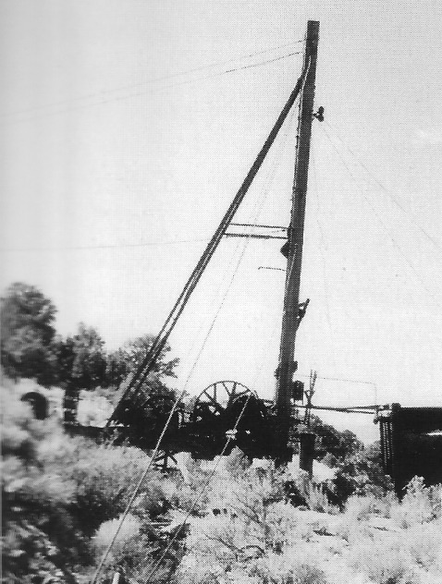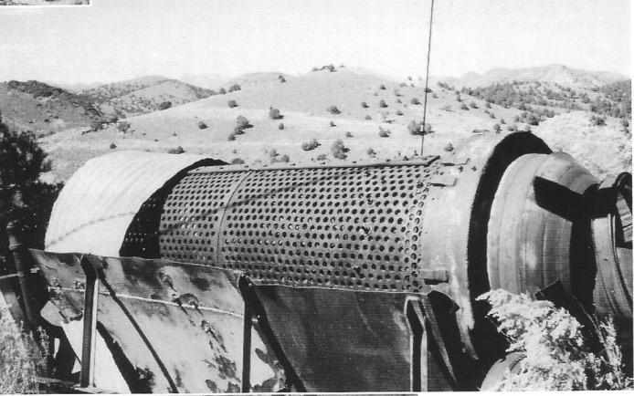

Remains of a drag line, trommel screen, and sluice box at an old placer workings dating from the 1930s located just above Main Street on Gold Hill in Manhattan. Photos taken in 1995. - Author's Collection

Manhattan's Gold Dredge

It became clear early in Manhattan's development that the placer gravels stretching for miles below town in Manhattan Gulch could be mined using mechanized equipment. It took three decades before this happened, however. During the mid-1930s, drilling and test holes made by the Natomas Company, headquartered in Sacramento, California, revealed that approximately 25 million yards of auriferous gravel, not including the high benches above the main channel, could be removed by a floating bucket-line dredge.
The Natomas Company was experienced in gold-dredging operations. The company handled nearly 19 million cubic yards of gravel in 1937, with an average recovery of 10 cents per yard. In 1938, Natomas operated seven of its own dredges and held an interest in two other dredges operated by affiliated companies. With that kind of track record and with the proven reserves in Manhattan Gulch, it was not surprising that the company decided to undertake a large-scale gold-dredging operation there. The Natomas Company organized the Manhattan Gold Dredging Company in late 1937, retaining 20 percent ownership and receiving 5 percent of net earnings as a management fee.
In the late 1930s, construction began on a mechanized gold dredge that was among the largest and most modern of its day. The impact of the large mechanical dredge on placer mining was much like that of a large national chain store on retail businesses in a small community. Like the large national chain store, the dredge was modern, high volume, and theoretically efficient. In the 1930s 25 or more sets of leasers made a living on placer claims in Manhattan Gulch. When the big dredge came in, it replaced most of the leasers, not only eliminating the miners' means of livelihood but also undercutting their self-reliant lifestyle. A few of the leasers in Manhattan went to work for the dredge, but as Jim Larson recalled, many just "seemed to disappear" (Larson, 1990).
Although a large company moving into a small mining community always creates excitement and validates residents' belief in the economic potential of the area, many people in Manhattan were aware of the potentially negative consequences arising from such a big operation and realized their livelihoods might be destroyed. Many of the old-timers, who had "washed out livings, ranging from bacon-and-beans up, with ground-sluices, rockers, and pans," were critical of the change (Clark, 1946:2). The old placer miners' grumblings were briefly discussed in an article in the prominent mining industry publication Mining Journal on April 30, 1946. In advocating the dredge over the placer miner, the article cast aside the opposition to the dredge with an invidious comparison: "The ensuing rumblings," the author said, "were reminiscent of those against steam-powered looms from the old-time hand weavers."
A dredge boat is a complex machine designed to separate gold from the gravel in which it occurs. As the name implies, the boat floats on a pond and has all the equipment necessary to dig the gravel and separate the gold on board. The boat was 172 feet long and 60 feet wide; it drew 9 feet of water and weighed 2000 tons. It floated on a man-made pond on 39 steel-hull pontoons bolted together, 17 on each side and 5 in the center. It had a 150-foot steel boom on the bow. The boom could be lowered 75 feet below the surface of the pond. A chain of 105 buckets, each with 10-cubic-foot capacity, was mounted on the boom. It was possible to move 37 buckets of gravel per minute and to deliver 6580 yards of gravel from the bottom of the pond in an eight-hour shift.
To operate the dredge, the boom was lowered into the water, where the buckets began picking up the gravel and moving it to the broad deck. As the buckets cut through the gravel, they eventually hit bedrock, digging into the soft schist to assure that all of the gold on the bottom of the channel was moved to the surface. The boom was hinged so that it could swing laterally back and forth across the bow of the boat. As the buckets dug, they extended the banks of the pond in front of the boat as it moved up Manhattan Gulch. Jim Boni recalled being able to hear the dredge digging on bedrock from his home in town: "You could hear that thing just squeal and grind" (Boni, 1990:55). Once on board, the gravel was processed, the gold extracted, and the waste ejected.
At the stern of the boat there were two 125-foot twin tailing stackers that were also hinged so that they could pivot laterally. They deposited the processed gravel behind the boat, in effect filling in the pond. To prevent the boat from moving about as the long boom at the bow reached into the pond and lifted the gravel to the surface, anchor lines were run from the boat to the shore and were hitched to heavy weights, known as dead men. To create the pond, 1000 gallons of water per minute were pumped 12 miles with a 1000-foot lift up to the pond through a 14-inch pipeline from wells at Peavine, on the west side of Smoky Valley. The electric power bill to run the dredge and pumps on the pipeline exceeded $8000 per month.
The dredge was assembled during summer 1938 just below the mouth of Manhattan Gulch at a cost of $700,000. The pipeline and pumping equipment cost an additional $300,000. The dredge was operated from the time of its construction in October 1938 until 1946. Shortly after the outbreak of World War II, the federal government issued War Production Board Order L-208. The order decreed that all gold mines had to be shut, and mining and production had to be limited to minerals essential to the war effort. But the Manhattan dredge managed to avoid the order to shut down by using older and less physically fit workers. In 1947 the dredge was dismantled and moved to Copper Canyon near Battle Mountain, Nevada. It was eventually taken to South America. The dredge is remembered with fondness by many former residents of the community as well as by many old-timers in other central Nevada towns.

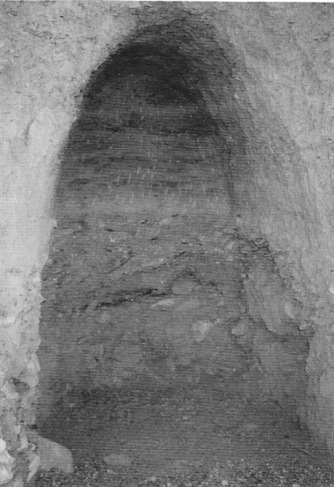

Close-up of Heart's miner's tunnel, dating from between 1909 and 1945, exposed by the mechanical dredge in Manhattan Wash. Note the tunnel's arched roof, which helped keep it from caving in. Miners' pick-marks are still visible in the tunnel's face. Photo taken in 1995. - Author's Collection

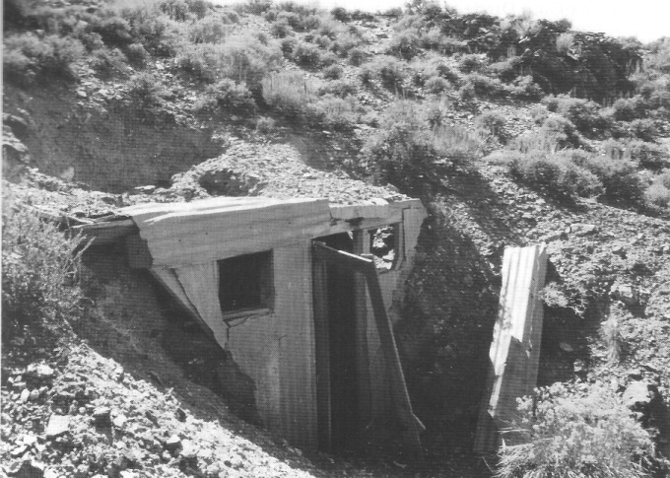

Remains of a miner's dugout dwelling located in Manhattan Wash dating from the 1930s. Photo taken in 1995. - Author's Collection

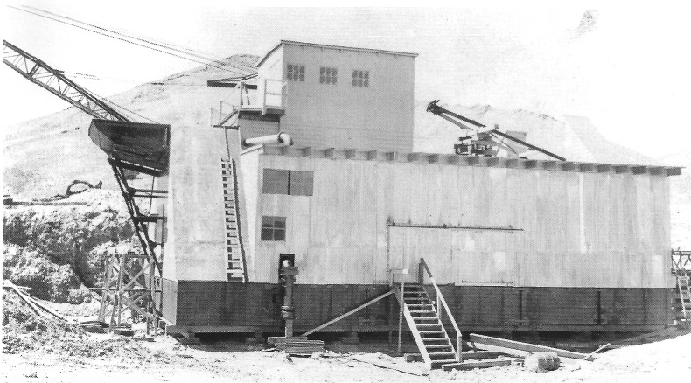

A photograph of the Manhattan dredge being assembled, late 1930s. - Central Nevada Historical Society

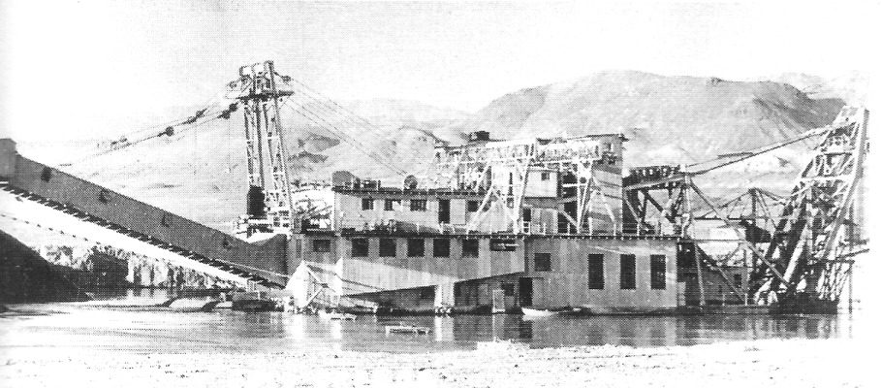

Manhattan gold dredge, pictured soon after being assembled. Photo taken in 1939. A portion of the town of Jamestown can be seen on the right. The "boat" floated on a man-made pond filled with water obtained from wells across Smoky Valley at Peavine The dredge dug its way up Manhattan Gulch, removing gold from the gravel as it dug, filling in the pond with processed gravel as it moved. - Central Nevada Historical Society

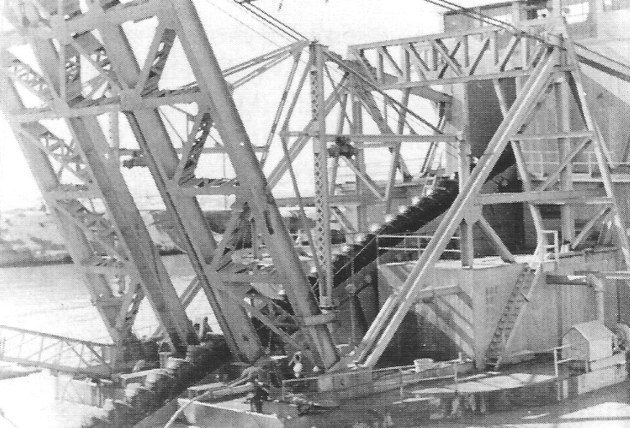

The bow of the Manhattan gold dredge, showing the base of the boom and the line of buckets that carried gravel from the bottom of the pond to the deck, where the gravel was processed. Photo taken in 1939. - Central Nevada Historical Society

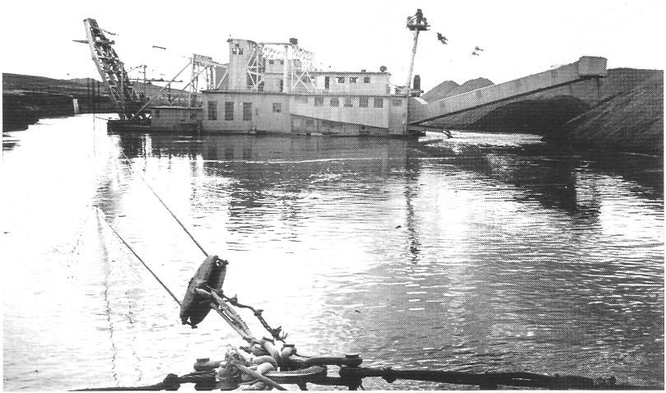

Side view of the Manhattan gold dredge floating on its man-made pond. Gold-bearing gravel was lifted from the bottom of the pond with the boom (left) equipped with buckets. The gravel was processed for gold and then disposed of by means of two booms, or stackers, at the rear of the dredge, seen on the right. Photo taken in 1940. - Central Nevada Historical Society

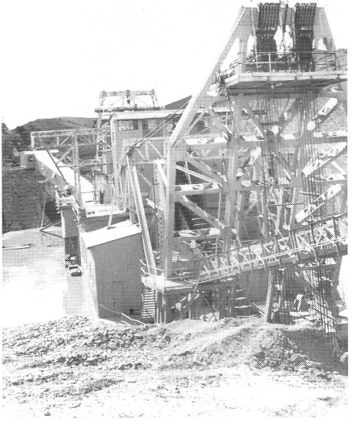

Bow of the Manhattan dredge. Photo taken in 1945. - Central Nevada Historical Society

Although the dredge recovered considerable quantities of gold from Manhattan Gulch, it was not, as it turned out, as efficient as had been initially hoped (or feared). Because of hills and ridges in the wash, there were places in the gulch where the dredge could not go, and the boom could not reach all the way up to the banks of the gulch where gold-bearing gravel could be found. Moreover, plans originally called for the dredge to make three passes through the gulch, once up in the middle and once along each side. As it turned out, the dredge cut so deeply into bedrock on its first trip up the gulch that bedrock would no longer hold water, so a pond could not be maintained on which to float the dredge. The dredge also failed to recover much of the gold in the gravel it did process. Consequently, gold-bearing gravels can still be found in Manhattan Gulch along the sides of the main channel and at various sites within the channel itself. Bob Bottom, a leading authority on Manhattan placer, estimates that more than 50 percent of the gold originally deposited in Manhattan Gulch still remains there. In 2007, placer miners were still extracting gold from the gulch where "Dry Wash" Wilson had worked more than 100 years earlier. One hardrock mining and milling property was operating. Thus, often four-generation gold production in Manhattan Gulch continues to be a source of income for the community.
In sum, as of 1949, the Manhattan Mining District had officially produced $10,363,289, exclusive of gold that was high-graded. Of this total, hardrock mines produced $5,765,862 from 402,300 tons of ore. The Natomas dredge, with its production total of $4,597,427, was the largest producer in the district, with the White Caps Mining Company coming in a distant second, producing $2,635,008 from 144,043 tons between 1918 and 1940. The Reliance Company produced $1,077,939 from 59,108 tons between 1935 and 1941. Bob Bottom and other knowledgeable observers, however, estimate that perhaps 50 percent or more of the gold extracted by the dredge was high-graded by the dredge's employees, and thus was never included in the official tally. High-grading was not only committed by the miners. John L. James, the manager, served time in prison for high-grading while he was in charge.

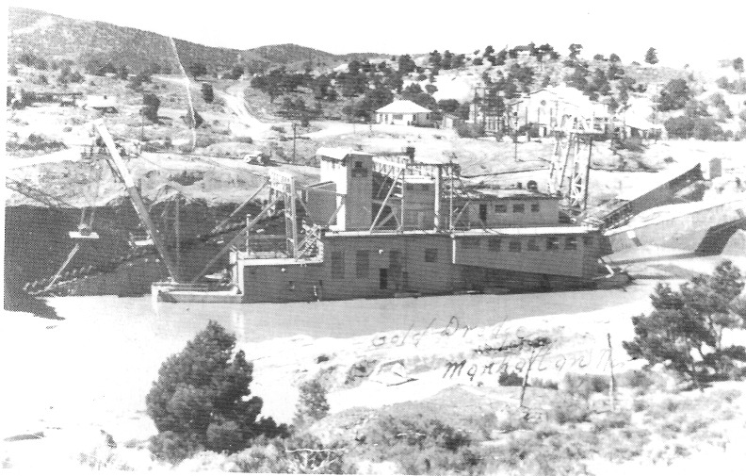

The Manhattan dredge opposite the power station just west of Manhattan, circa 1946. The dredge had just about completed its 7-year journey, digging its way up Manhattan Gulch, extracting the gold from the gravel as it went. - Central Nevada Historical Society

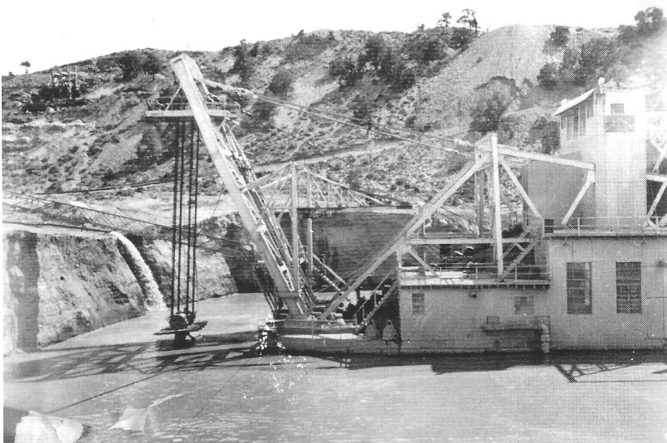

Manhattan Gulch gold dredge at work in 1946, shortly before it was dismantled. Smaller photo below shows the same perspective in 1988, with the pond filled with gravel tailings. - Central Nevada Historical Society

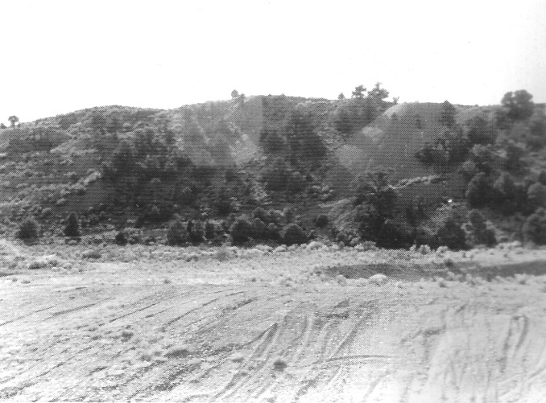

The pond shown above has been filled in with gravel tailings. Photo taken in 1988. - Central Nevada Historical Society

Keeping the Tradition Alive

One gold miner is keeping the tradition of the small placer miner in the American West alive in Manhattan. Although the gulch no longer echoes with the sounds of 100 or more miners tenaciously following the pay streaks of fabulous glitter, as of 2007 Bob Bottom has been digging in Manhattan Wash's placer gravel for 25 years. This way of life dates back nearly 150 years to the California gold-fields: the small independent producer working his claims, beholden to few, his own man, doing his own work, producing what has always been civilization's most basic standard of value, gold!
Bottom's placer claims are located at the upper end of Manhattan Gulch. Working alone, or perhaps with a hired hand or two, Bottom first determines where on his claims in the wash his chances are good for finding gold. Bottom knows the gravel in Manhattan Wash the way a wine connoisseur knows vintages or a diamond cutter knows crystals. He is keenly aware of the conditions that indicate where gold is likely to be found in the wash and where it is not. Large boulders in the gravel and a layer of coarse gravel near bedrock, for example, tend to predict the presence of gold. By panning a gravel sample, Bottom can estimate how much gold the gravel at a site will contain with an accuracy of a few cents per yard. It is this skill, as much as anything, that keeps his operation going. Overestimating the gravel's gold content means wasted time and effort, and lost opportunity.
Once he has selected a good spot to dig, Bottom must first strip off the barren overburden above the gold-bearing gravels. Once the overburden has been stripped away with a dozer, he loads the gravel containing gold into his dump truck and hauls it a short distance to his small placer mill, where he dumps the load on the ground. He tries to process ore that contains at least one-twentieth of an ounce of gold per cubic yard of gravel. On a good day, when everything goes smoothly and his equipment does not break down, he can haul and process about 80 yards of gravel.
At the placer mill, the gravel is loaded into a hopper with a front-end loader and from there it is fed automatically to a trommel screen. Oversized material that will not pass through the screen goes to the dump. Later, he will go over the dump with a metal detector to make sure no nuggets too large to pass through the screen have gotten away. Undersized material goes to a shaking sluice box. A sluice box is a three-sided trough open on top with riffles spaced cross-wise along the bottom. Water carries gold-bearing gravel along the trough's length. Because the gold is heavier, it sinks to the bottom and is trapped behind riffles in the sluice and the waste goes out the end. Both oversize and undersize tailings are periodically moved back to the gulch. Water to operate the mill comes from a nearby well, and the discharge from the mill goes to a pond where it can be recycled, or it drains back into the gulch. Because the water used in the process never comes into contact with anything but the gravel and steel in the machinery, once the silt has settled, it is clean enough to drink when it comes out of the mill. The mill can be operated only in warm weather—from late spring to early winter—when water and gravel will not freeze.
Bottom, a native of Tonopah, learned much of what he knows about mining from two other Tonopah miners, Norman Coombs and Louie Meyer. Although Bottom is about as free as a man who is not rich can be in this day, his biggest source of problems and anxieties involves challenges earlier miners would never have dreamed of, even in their worst nightmares. Mining in Nevada—even a very small operation like Bottom's—is highly regulated by the federal government. His operation is constantly monitored by many officials from a variety of agencies, despite the fact that he is digging on ground that was first disturbed and dug up—with few negative environmental consequences-100 years ago.

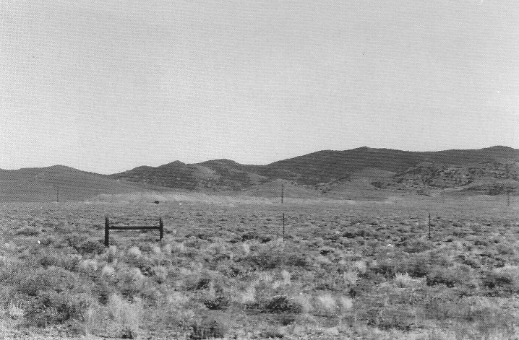

Looking east up Manhattan Gulch from State Highway 376, toward the mountains at the south end of the Toquima Range. Tailings from the Manhattan dredge are visible at the center of the photo. Photo taken in 1995. - Author's Collection

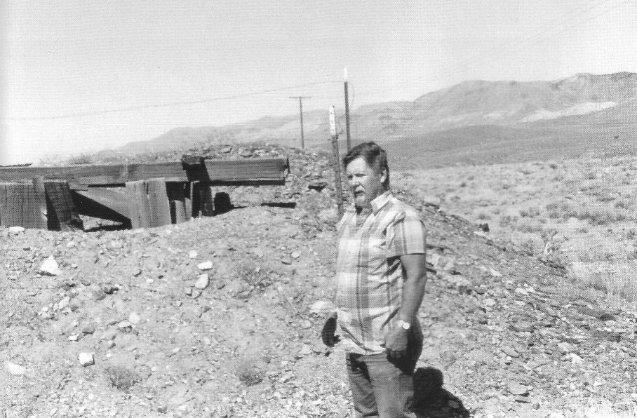

Placer miner Bob Bottom beside one of the old placer shafts in Manhattan Gulch, 1995. - Author's Collection

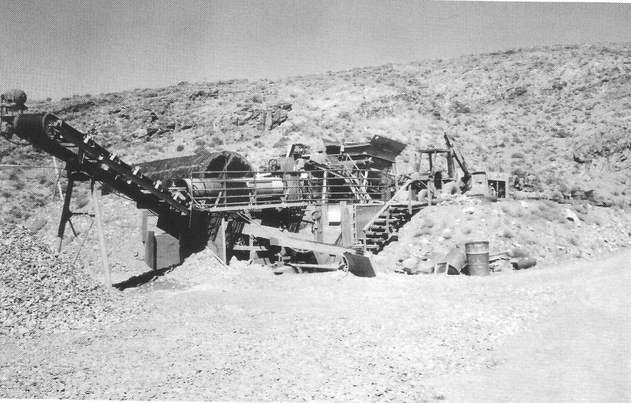

Gold placer mill operated by Bob Bottom in Manhattan, 1995. Gold-bearing gravel is loaded into the hopper at upper right, where it is fed into a trommel screen in the center. Gravel that passes through the screen travels down the shaking sluice box at lower right where the gold is captured. - Author's Collection

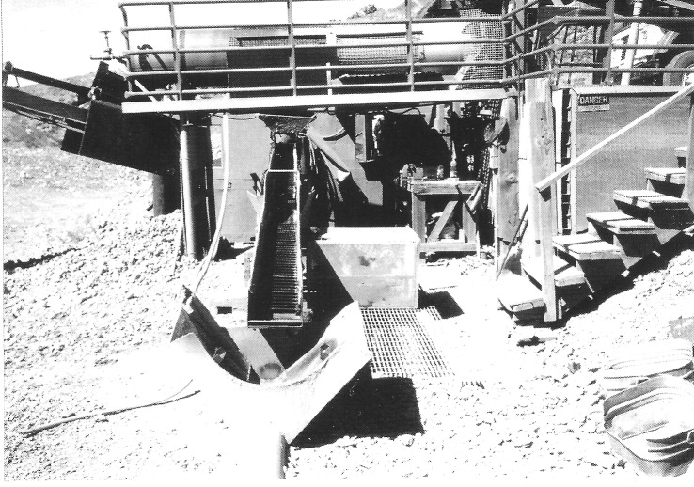

Close-up of trommel screen and sluice box, Bottom's Manhattan Gold Mill, 1995. - Author's Collection

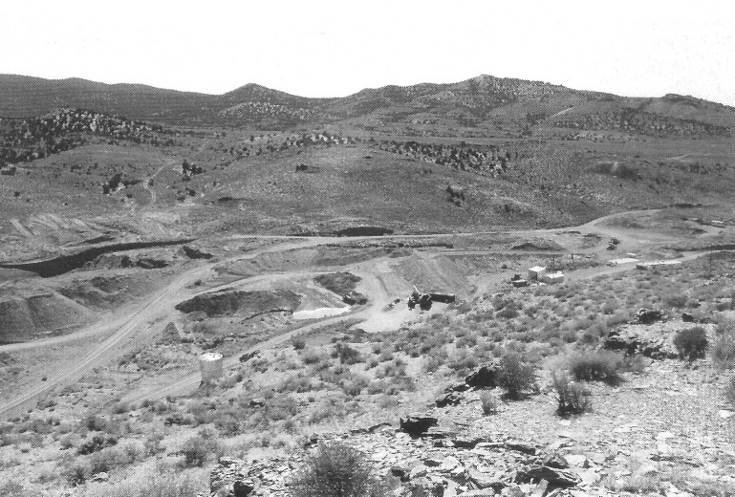

Looking south across Manhattan Wash with Bob Bottom's placer plant visible, 1995. - Author's Collection

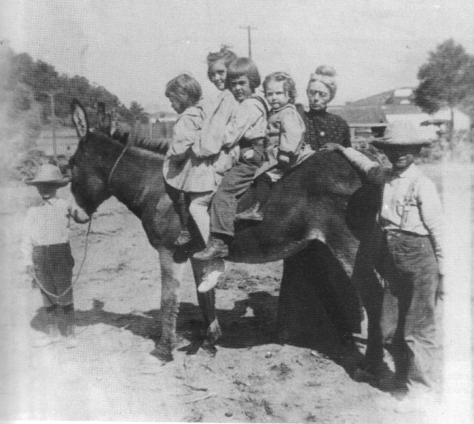

Children "on board" a burro, Manhattan, circa 1906. Unclaimed burros were ubiquitous in central Nevada mining communities; most seemed to enjoy the children's attention as much as the youngsters enjoyed playing with them. - Central Nevada Historical Society

CHAPTER SEVEN
Life in Manhattan
in the Early Year6

From its first days, Manhattan was a friendly, socially minded community. One reason for this atmosphere was that Manhattan did not have rich, high-producing mines like those found in Tonopah and Goldfield. The small town therefore lacked the wealth that often leads to the formation of clearly defined social classes. Few people were making big money—a crucible of social class formation. For the most part, the population of Manhattan was composed of miners, small merchants, and their families. Levels of educational achievement differed widely among the community's residents, but most people in Manhattan did not see this disparity as cause for social ranking.

The Toiyabe Literary Club

The most important social organization in the community was the Toiyabe Literary Club, a women's organization. The club was founded during the early days in Manhattan and gradually faded away, disappearing altogether in the 1960s. The Toiyabe Literary Club aimed to improve the educational level of the community. Initially, club members met once a month to discuss topics ranging from local issues to those of national and international interest. Each meeting focused on a preset topic.
At first, the members took turns hosting the meetings in their homes, but shortly after its inception, the club purchased a building in which meetings were held. When that building burned down, club members purchased a two-story office building on Main Street. They financed their purchase with funds raised from several sources, including club dues, promotional activities held in the community, and donations from local businesses and mining companies. The club rooms, which were upstairs, were nicely decorated with carpets and paintings. Meetings and discussions were held in these rooms, and members often played bridge after club dinners there as well. The ground floor, remodeled to accommodate a dance floor and a stage, also served as a town hall and as an auditorium for the school. School dances were held in the new Toiyabe Literary Club facility.
The club also strongly promoted education and culture in Manhattan as well as in the Manhattan school, supporting numerous school activities designed to raise money for the school and enrich the lives of students, teachers, and townspeople.
The Toiyabe Literary Club building was equipped with a kitchen, banquet table, fine china, and silver service, which enabled club members to host an annual banquet for eighth-grade graduates and graduating seniors. After the banquet, which included speeches, there was a dance with live music. It was the only opportunity many of the students had to dress up and attend a formally served dinner.
The literary club belonged to the National Women's Club Association. Most members were miners' wives, but membership was open to any woman in town at least 18 years old. Some young women joined as soon as they were eligible; others who moved away and later returned to Manhattan joined the club. There were a few women in town who refused to join because they believed club members were putting on airs.
The Toiyabe Literary Club was quite active until World War II. The decline in population in Manhattan caused by the government's closing of the mines began to affect the club's membership. In time, the only two members were Merle Abernathy and Ella May Humphrey, with only Humphrey residing in town. After Humphrey died, people began to break into the old building, vandalize it, and steal the club's belongings. Finally, Abernathy sold the building for $1300 and donated the money to the Tonopah Scholarship Fund. With this final gesture toward the education of the area's children, the Toiyabe Literary Club faded into the pages of history, along with the many other groups and people who had once had dreams for the booming town.

An Investment in the Future: Education

Residents of frontier Nevada recognized the importance of literacy. Education was almost always one of the first public services provided for in a mining boomtown. The presence of a school in a turn-of-the-century mining community was a good gauge of a camp's expectations of permanence. If a town had a school, it meant that the population included more than just prospectors and slick promoters intent on getting rich; it meant there were women, children, and family men living there. A school indicated a desire among the residents for the arts of civilization; it was proof that community members were investing in the town's future—its children.
In 1906, the first school in Manhattan was located in a small building on upper Main Street. The class photograph shows 16 children. In 1908, the school was housed at a site on Erie Street across from the Presbyterian church. In that year, the class photograph shows 24 schoolchildren.
In 1912, a special election was held in the Manhattan School District to decide whether to issue $5000 in bonds in $100 denominations to construct a new schoolhouse on Dexter Street. On Monday, June 2, 1912, the polls were open from 1:00 to 5:00 p.m.; on Saturday, June 22, it was announced that the vote had been unanimous: 137-0 for issuing the bonds. It was "the most decisive election ever held in Nye County" ("Manhattan School: Its History, Students, Personalities," 1977:10). The new school was frame construction covered with stamped tin. The building proved to be too cold and was later stuccoed. To celebrate its opening on September 2, 1913, a "Grand Benefit Entertainment" was held, featuring a skit as well as music by the Manhattan Orchestra, the Manhattan Male Quartet, and solo violinists. A dance was held following the program.
During the 1920s and 1930s, one teacher taught grades 1 through 4 in one room, a second teacher taught grades 5 through 8 in the second room, and in the third room, another teacher, who was also the principal, taught grades 9 through 12. Economic prospects in the town affected the number of students in the school as families came and went with the rise and fall of the mines. Finally, in spring 1955, there were only three children in Manhattan's school and it was closed. The building still stands and today houses the Manhattan Library.

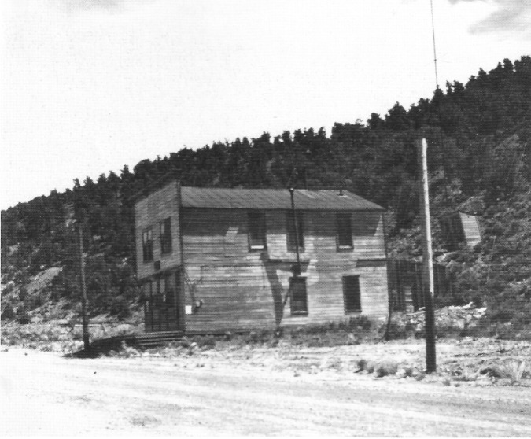

The Toiyabe Literary Club building, as it appeared in 1965. - Central Nevada Historical Society

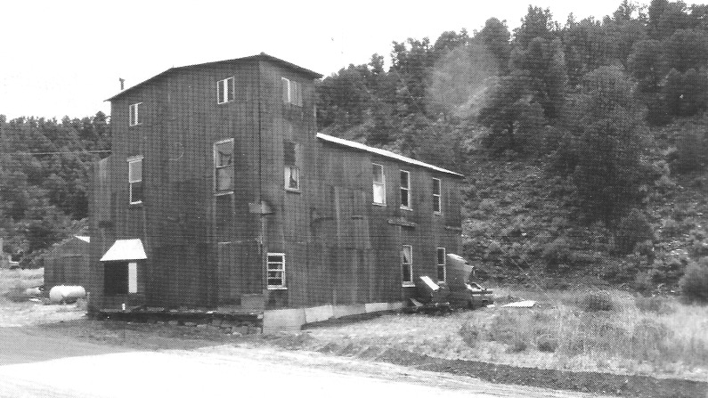

The Toiyabe Literary Club building, 1995, after an addition had been built on the front. - Author's Collection

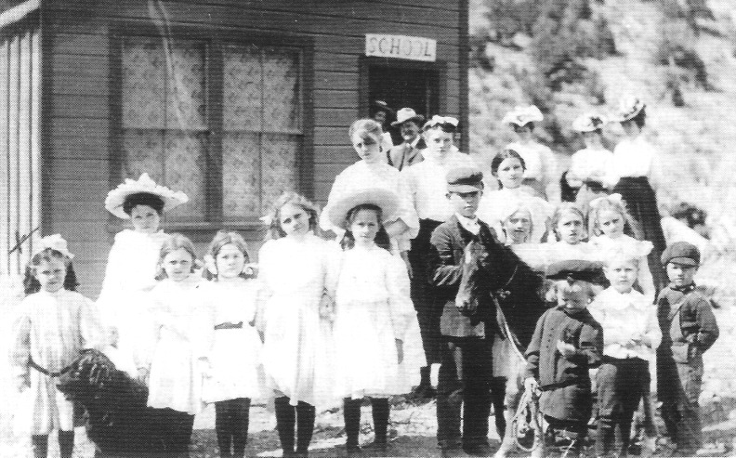

Manhattan's first school and its pupils, 1906. We do not know why the majority of the students pictured are girls. The school was located on upper Main Street. - Central Nevada Historical Society

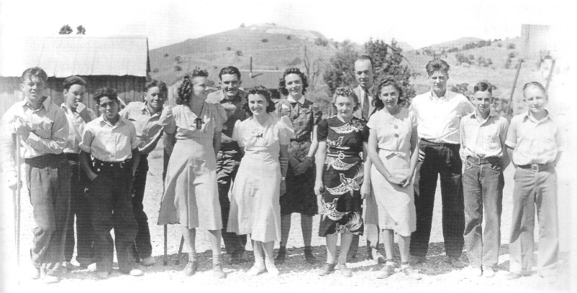

High school students, Manhattan, 1940. - Central Nevada Historical Society

A Church for Manhattan

With building materials in short supply, the frugal people in early mining camps recycled whatever they could, often moving entire buildings from one camp to another. The picturesque little church in Manhattan, which sits on a hill above Main Street, began life as a Catholic church in the neighboring town of Belmont. Belmont flourished during the 1860s and 1870s, and there was a need to minister to the growing flock in a real church building rather than meeting in other town structures. In January 1872, when Father Monteverde came from Austin to say Mass, he decided that it was time for Belmont to have its own church. Robert Mullen was appointed treasurer of a building fund committee, and the Catholics in Belmont agreed to pay $2.50 or $5.00 a month for three or four months until enough money had been raised. St. Stephens Church was originally erected in Belmont on East Belmont Summit in 1874 at a cost of $3000. The structure was built by Reverend William Maloney and members of the Catholic parish. By 1901, the building had been abandoned because of Belmont's decline.
In 1908, the building—complete with belfry, bell, and cross—was moved to Manhattan and renamed the Sacred Heart Mission. The steeple bell had been made in New York by Meneelys-Troy, the same company that made the bell that was installed in 1868 in the historic church in Virginia City, Nevada. Over the years, the pews and altar disappeared from the Manhattan church. In 1956, the bell was moved to Beatty. Then in 1971, a group of citizens undertook some restoration of the building. With donated funds and volunteer labor, they overhauled the church, repairing windows, doors, steps, and handrails. Today the church is a central Nevada landmark. During the national bicentennial celebration in 1976, a photograph of it was published in European newspapers. In that same year, the Catholic Church turned over its ownership of the Manhattan church to Nye County, which still owned it as of 2007.

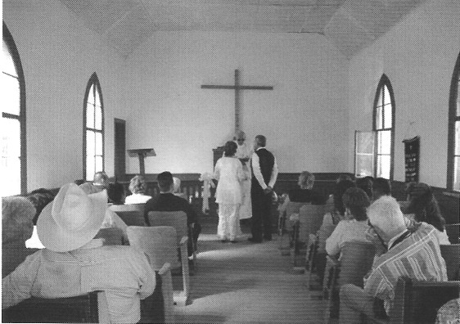

In 2005, a great-granddaughter of Barney McCann, one of the original figures behind the construction of St. Stephens Church in Belmont, was married in the church at its present location in Manhattan. - Photo by Felipa Lopez

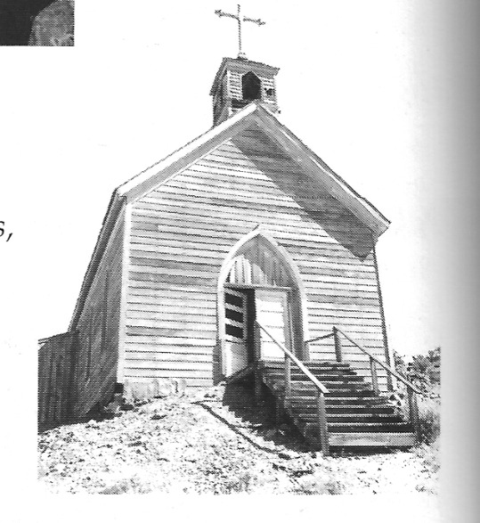

The front of the Catholic church in Manhattan. This picture was taken in the 1950's, prior to the building's restoration. - Nye County Town History Project - Boni Collection

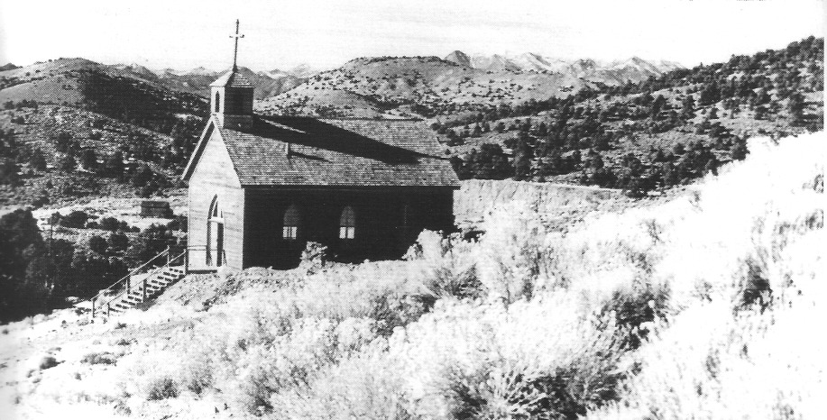

The Catholic church in Manhattan, photographed in 1980. The church was restored in 1971, and in 1976 it was turned over to Nye County, which still owns the building. - Central Nevada Historical Society

The Shooting of Sheriff Thomas W. Logan

On April 6, 1906, Thomas W. Logan, the highly regarded and much-loved sheriff of Nye County, Nevada, was shot and killed in an altercation in the Jewell Saloon, a Manhattan brothel. Logan's assailant, William A. Barieau, also known as Walter Barieau, was immediately apprehended and charged with murder. Three months later, on July 9, Barieau was placed on trial in Tonopah for the crime. The story of Sheriff Logan's murder is one of the most interesting in Nye County history, and it provides an unmatched view of life and the law in turn-of-the-century central Nevada.
Thomas W. Logan was a native Nevadan. He was born in the Washoe Valley in 1861 and had lived on the Muddy River in Lincoln County and at Duckwater. In 1899, Logan, by then the father of eight children, ran for Nye County sheriff and won. Logan was highly respected and admired throughout the county. At the time of his death, Nye County commissioner W. Cuddy is quoted in the Tonopah Daily Sun as saying, "Tom Logan was a man in a thousand. He was an ideal sheriff, and we will not see his like again. The man was absolutely fearless, and his only fault was that he was too kind hearted for his own good" ("Sheriff Thomas Logan Is Shot and Killed by Walter Barieau," 1906).
Barieau was born in 1869 in Nova Scotia. He left home at 14 and at about age 16, began a career as a gambler, eventually playing all the roles in the trade, as customer, dealer, operator, and proprietor.
In April 1906, Barieau had recently moved to Manhattan, where he was in charge of the craps table at the Monarch Saloon. His wife, Margaret, and 12-year-old daughter, Edith, had stayed in Goldfield, although Barieau had just written telling them to come to Manhattan.
The only witness to the shooting of Sheriff Logan was May Briggs, owner of the Jewell Saloon. At the preliminary hearing, Briggs contended that Barieau had been in the brothel and had become drunk and obnoxious. She asked him to leave, but he refused, grasping her wrist and giving it a painful wrench, whereupon she screamed for help. Her screams, she claimed, attracted the attention of Sheriff Logan, who rushed to assist her. Logan, who was said to be unarmed, prevailed upon Barieau to leave, which he did peaceably enough, but by the time Barieau reached the street, he had apparently become enraged. He then turned, pulled out his revolver, and fired at Logan through the glass in the building's front door. Logan, who was standing in the hallway, ran out of the house, intending to disarm Barieau. Once Logan was outside, Barieau opened fire on him, hitting him four times, once in the right cheek, once in the groin, and twice in the right leg. Although mortally wounded and bleeding profusely, Logan, who outweighed Barieau by 50 pounds, pounced upon Barieau. As the two began to struggle, neighbors and others rushed to the scene. Logan tried to disarm his assailant. A musician employed at the Jewell rushed inside and got Logan's gun. Logan used the gun to beat Barieau insensible, after which a bystander separated the men. With blood spurting from his wounds, Logan was finally persuaded to re-enter the Jewell, where he fainted on a bed. He lay there for several hours and died before medical help arrived.
Funeral services for the slain sheriff were held in Tonopah at the opera house on April 11. Major mines in Tonopah closed the afternoon of the funeral out of respect. A fire truck draped in black carried Logan's remains to the opera house, followed by a cortege of Eagles and Odd Fellows. At the services, the theater was filled to overflowing, and hundreds packed the entrance and the street. The ser-vices paid tribute to Logan's bravery, and the procession to the cemetery was the "longest ever held in Tonopah or Nye County" ("Thomas Logan Laid to Rest," 1906; "Tom Logan at Rest," 1906).
Perhaps the luckiest thing that ever happened to the gambler Barieau was that Attorney Patrick A. McCarran assisted senior counsel S. P. Flynn in Barieau's defense. McCarran was one of the several young attorneys who had moved to the central Nevada desert with the great Tonopah boom. Key Pittman, a veteran of the Klondike, was another. McCarran, noted for his eloquence, sarcasm, and brilliant defenses, had an engaging personal style. The prosecutor of Sheriff Logan's murderer was William B. Pittman, Key Pittman's brother.
The Barieau case posed a great challenge for McCarran. There was no doubt that Barieau had killed Logan, and McCarran's defense was made doubly difficult by the heavy weight of public opinion against his client. The strategy McCarran chose involved undermining Sheriff Logan's reputation and making the murder seem justified. And this he did with the greatest of skill.
Walter Barieau's trial began in Tonopah on July 9, 1906, and it provided him with the first real opportunity to state his version of events. Barieau testified that he had been pressured by Judge Hoggott and two friends to join a party of men who went to the Jewell the morning of the murder. When asked how he happened to be carrying a gun, Barieau said the judge had been concerned about the considerable amount of money and jewelry he was carrying and asked if anyone else had a gun. On Hoggott's behalf, Barieau put a gun in his pocket before they left. At the Jewell, the men were served wine. Barieau, for some reason, became ill from the wine, lay down on the lounge, and went to sleep. About two hours later, May Briggs came in and told him to go home. Because he still did not feel well, he asked to stay. Briggs told him again to go. Barieau headed for the door but was overcome by dizziness. He went back to the lounge to lie down again.
Briggs seized him by the arm and told him to get out. Barieau again pleaded with her to let him remain. She refused, and he rose to go. Apparently he was not moving fast enough, and she started to shove him along. Barieau objected and hit back with his elbow, striking Briggs on the arm.
Briggs screamed. Suddenly a man dressed in a nightshirt came to the door. He did not say a word, but punched Barieau in the eye, knocking him to the floor. Barieau struggled to his feet and was then struck on the head several times with a heavy instrument. As Barieau tried to get out of the house, he saw his assailant had a gun, and so he drew his revolver and fired. But the man with the gun was still coming on, and he fired four more shots. Barieau fell over backward off the porch and the man jumped on top of him.
According to Barieau, he did not know that the man was Thomas Logan, the sheriff of Nye County. Barieau contended that he had acted in self-defense throughout the episode.
District Attorney Pittman cast aspersions on Barieau's character for the jury's benefit, but the prosecution's cross-examination could not shake the gambler from his story. The prosecution admitted that Sheriff Logan had been wrong to visit the Jewell but pointed out that so had Barieau.
The defense went on to show that Sheriff Logan had been intimately involved with May Briggs. One witness, who knew May Briggs, testified that Logan frequently purchased expensive gifts for Briggs, among them two vases that cost $250, a pair of diamond earrings worth $600, a turquoise ring set with diamonds, a lovely wooden box with solid silver trimmings, and many other gifts of lesser value; but perhaps most symbolically, he had bought her two bedsteads and mattresses.
Those present in the courtroom agreed unanimously that no more eloquent and logical delivery had ever been made in the Tonopah Courthouse than that by Defense Attorney Pat McCarran in his closing argument. McCarran had no equal in the use of sarcasm and invective at the local bar. His assaults on the character and testimony of the prosecution witnesses were especially memorable. He presented Sheriff Thomas Logan as having been a decent married man with eight children, a victim of May Briggs, an "enchantress who had wound herself into the life of a man inclined to do right and making him a slave to her every will and wish" (Barieau, 1971:16; "Fate of Logan's Slayer. . ," 1906).
When jury members began their deliberations, they were evenly split: six for conviction, and six for acquittal. Ballot after ballot was taken as the margin shift-ed. On July 14 at 5:30 a.m., after 17 hours of deliberation, the jury, worn out with its all-night struggle to reach an agreement, rendered its verdict. Barieau was brought into the courtroom by the sheriff; his wife and child and a few spectators were present. Mrs. Barieau broke down when her husband arrived, but Barieau spoke encouragingly and attempted to appear unconcerned. However, his fingers twitched nervously and he shuffled his feet. The clerk read the verdict: "not guilty."
After beating the hangman's noose in his Manhattan encounter, Barieau lived a long life. He died in San Diego, California, in 1953 at age 83. Young Pat McCarran established his legal reputation during the trial. He was appointed Nye County district attorney a short time later and eventually moved up to the state supreme court. In 1932, he was elected to the U.S. Senate, where he served until his death in 1954.

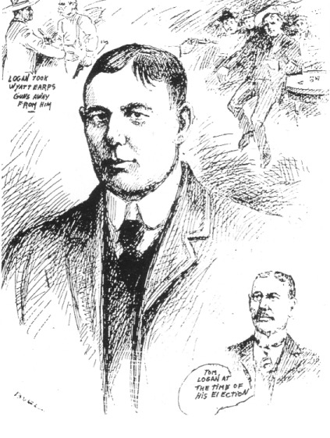
This sketch of Nye County Sheriff Thomas Logan appeared in the Tonopah Daily Sun on Saturday, April 7, 1906. Logan was depicted as a heroic and respected man.

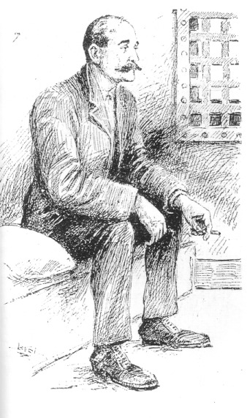

Walter Barieau in his jail cell. Artist sketch appeared in the Tuesday, April 10, 1906, edition of the Tonopah Daily Sun.

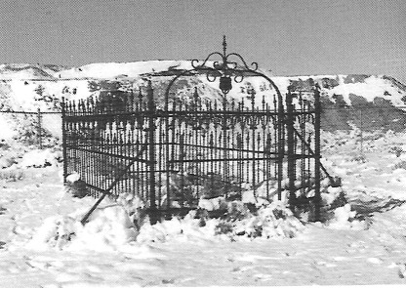

The grave of Nye County Sheriff Thomas W. Logan in the old Tonopah Cemetery has a beautiful wrought iron fence (Stewart Iron Works Company, Cincinnati, Ohio). The inscription on his grave reads: "Tom Logan, Nye County Sheriff and businessman, shot to death in front of the Jewell Saloon lower Main Street, Manhattan, Nevada. Left a widow and eight children!" - Central Nevada Historical Society

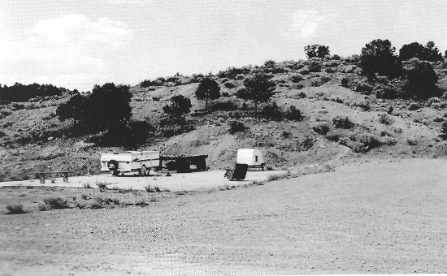

Site of the Jewell Saloon, where the shooting took place, located on lower Main Street, at the base of Chipmunk Hill, 2007 - Author's Collection.

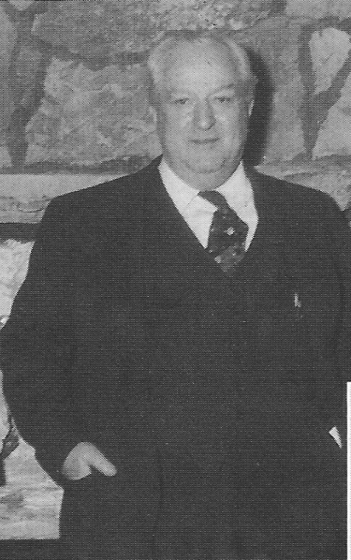

Senator Pat McCarran, who defended Walter Barieau in the murder of Sheriff Logan in 1906. Photo circa 1944. - Central Nevada Historical Society

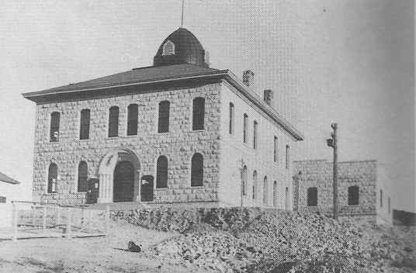

Nye County Courthouse, tonopah, Nevada, 1906. - Central Nevada Historical Society

Fires Ravage Manhattan

Fire was the scourge of the mining camps of the West. Most boomtowns used wood construction in homes and stores. A spark could set off a conflagration that could destroy all or part of a town, and fire protection was crude or nonexistent. The only communities that were relatively safe from fire were those that used adobe or brick construction.
For more than the first three years of its existence, Manhattan was quite lucky. With virtually no fire protection, the town experienced no disastrous fires. Then the town's luck changed. On Thursday, March 11, 1909, at 1:30 a.m., fire broke out on the second story of the Nevada Hotel on Erie Street. Firefighters were powerless to save the building. Then the fire spread to the Wilson Building 50 feet to the south. The flames took two homes to the north; then a carpenter shop burned. Loss of property was estimated at eight buildings, for a total of $25,000; none of the buildings were insured.
"Dry Wash" Wilson was a heroic figure that day. The Manhattan Mail (March 17) reported, "Wilson, with a damp blanket about his head and shoulders, and resembling a Comanche Indian, braved the thickest of the fray and saved considerable property" ("Fire Destroys Eight Buildings," 1909).
The Manhattan Mail noted the following humorous incident associated with the March 1909 fire.

"It is reported that a certain married man was so much perturbed and so anxious to escape from his house, which he believed to be on fire, that he unconsciously put on his wife's skirt and rushed out into the street. His wife, slower to grasp the situation, did not notice her husband's get-away with her wearing apparel until after he had gone, and was then forced to don his trousers. The couple created some amusement in the crowd when the change of garments was noticed."

The day after the fire, a meeting was held at the Athletic Hall. The Manhattan Volunteer Fire Department was organized at the meeting and 43 citizens signed up, 23 of whom paid one dollar for the first month's dues.
On December 23, 1920, another fire ravaged Manhattan. Those responding to the alarm at 2:15 a.m. found the business district, in the principal block on the north side of Main Street, ablaze. The fire had originated in either the Pinetree Garage or the Bank Saloon. Within an hour the entire block was destroyed. The fire jumped the alley behind the block and burned seven residences.
Most losses were not covered by insurance. Arson was the suspected cause ("Flame Razes Entire Business Block," 1920). Apparently, the original building housing the Toiyabe Club was destroyed by this fire.
Another big fire on May 20, 1922, burned half of the business section on the south side of Main Street. Loss was estimated at between $75,000 and $100,000; and again, there was no insurance coverage. Arson was suspected. The building that housed the post office and telephone office was lost and the fire burned homes on Nob Hill. The Manhattan Magnet proclaimed defiantly, regarding the fire, "But you cannot crush the spirits of those who develop the mines of Nevada and the people of Manhattan will not be downed. They have the mines still and the gold is not burned" ("Manhattan Scourged by Fire," 1922).
Exactly one week later, on May 27, Manhattan suffered another serious fire. Although it was held to the south side of Main Street, many businesses and two houses burned. None of the property owners who suffered loss had insurance, because of the high rates. A headline in the Manhattan Magnet read "Implacable Fire Bug Completes Destruction of Entire South Side of Main Street in Business District—Two Homes Burned" ("One More Block Is Laid in Ashes," 1922).

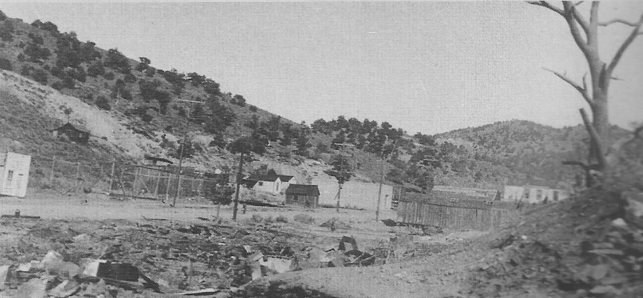

Results of one of the 1920s fires in Manhattan. - Central Nevada Historical Society

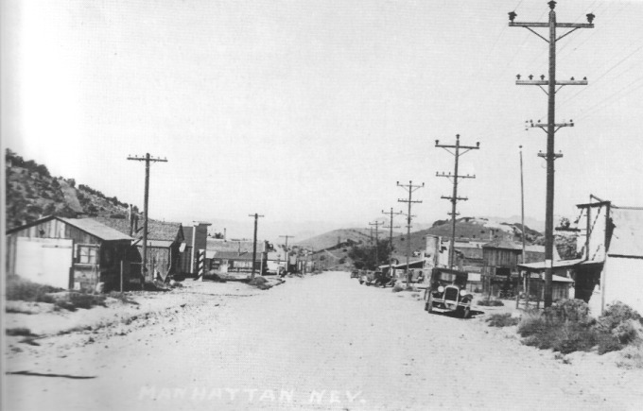

Looking northwest down Main Street, Manhattan, mid- to late 1930s. This is how Manhattan would have appeared when George "Monty" and Virginia Stewart moved there in 1936 seeking their fortune and what they would have seen in 1938 as they bid a sad farewell to the town and people they loved. - Central Nevada Historical Society

CHAPTER EIGHT
A Heap of Living -
Manhattan Reminiscence

In the mid-1930s, George "Monty" and Virginia Stewart had been married for two years and were living in Ohio, where they had met. "Monty" could not find work because of the Great Depression. In 1936, he had occasion to drive his mother to Manhattan, where he looked for a job. He secured a position at the Reliance Mill and sent for Virginia. She took the bus from Ohio to Tonopah, where "Monty" met her at the bus stop in front of the Mizpah Hotel.
"Monty" and Virginia rented a house in Manhattan that had been vacant for some time, fixed it up, and moved in. During the two years they lived there, they became accustomed to life in the small town on the remote desert. They made many friends, and their first child was born while they lived there.

The Gold Bug Bites

While living in Manhattan, they got the gold bug. Stewart's wages from working in the Reliance Mill enabled the couple to meet their bills, but there was nothing left over. An unexpected gift of $1000 from an uncle was enough to start their own placer mine. They learned firsthand the joys and sorrows of the tough life of the placer leasers. There were unceasing difficulties with mining machinery. Electric motors burned out. The sluice box and ore bins needed repairs. More rails for the dolly were needed as they dug deeper tunnels. Timber for the tunnels was expensive. They ran low on money; they charged their groceries at Coleman's store in Tonopah.
As the venture progressed, irregular shipments of dore (a kind of gold clinker) to the U.S. Mint at San Francisco enabled them to pay bills and stay about even, but they never saved much. Virginia's description of the results of their first gold shipment—the receipt of a check from the U.S. Mint—summarized much of their frustration: "After the necessary payments and royalties were deducted from the total amount of the check, I did not think it was enough money for the months of back-breaking labor involved" (Stewart, 1992:103).

Close Calls and Bad News

Twice, there were serious cave-ins at the mine. The first almost completely buried "Monty," but Ed, his partner, dug him out. On another occasion toward the end of the venture, the whole workings caved in, including the shaft, which collapsed, leaving only a saucer-shaped depression in the gulch. Luckily, no one was there at the time.
In 1937, "Monty" and Virginia began to hear rumors that a dredge was going to be constructed in Manhattan Gulch to mine the placer gold mechanically. In February 1938, rumor became reality and the leasers were told that the land in the gulch had been sold and, as of March 1 that year, they had six months to vacate their lease.
"Monty" foresaw that he could probably get a job on the dredge that would last for several years (until the dredge reached the head of Manhattan Gulch), but then what? With one month still left on the lease, they became discouraged, and using all their financial resources, "Monty" and Virginia paid their bills and returned to Ohio in early December 1938.

A Farewell to Manhattan

Many years later, Virginia Stewart wrote movingly of their departure from Manhattan and of the last moments she spent in the home she had shared with her husband and daughter in the old boomtown. Friends were taking them to Tonopah to catch the afternoon bus to Las Vegas. The car was waiting outside.

Now it was time to go. I walked slowly through the still rooms of our little brown house, checking the stoves one last time, assured the fires in them had been reduced to faintly glowing ashes and that everything else was in order. The curtains I had left at the window billowed slightly and I thought of the past winters, when we had taped all around the window frames to keep the cold air out. A heap of living had been crowded into the few short years we had lived in this house, I mused. The memories of all the happy and sad times floated into my mind, then brought tears to my eyes. I silently said Good-bye to this part of our lives, a part I'd never forget. I'll come back someday, I promised myself quietly, shut and locked the door for the last time (Stewart, 1992:146-147).

Of their drive down Main Street in Manhattan one last time, Virginia wrote:

I looked back once more as we pulled into Main Street and saw a faint wisp of smoke rise out of the kitchen smokestack into the blue sky above, a farewell salute from the old behemoth kitchen stove (Stewart, 1992:147).

As they drove toward Tonopah, in a final act, Virginia Stewart symbolically said good-bye to her life on the desert:

"Look, Monty," I said a little later, digging into my coin purse and showing him the post office receipts for each of our gold shipments. "I've kept them all, and added up they come to a good sized sum."
"That's past now," "Monty" said. "Throw them away."
I slowly tore them across, then opened the car window, watching as the wind snatched them from my hand and set them fluttering in the air, then gently scattering them over the desert, little white ghosts of our dreams of fortune. But we did go away rich—in friendship and experience (Stewart, 1992:147).

During the next 30 years, the Stewarts made four visits back to Manhattan. Each time they returned, there was less of the town, and there were fewer people they knew. Old familiar faces had passed on; once-sturdy buildings had fallen into disrepair or had been hauled off or dismantled. In the epilogue to her book on her life in Manhattan, Virginia Stewart concluded, "As long as there are people who care, I don't think Manhattan will ever be an old forgotten ghost town. To me, it will always be very much alive" (Stewart, 1992:150).

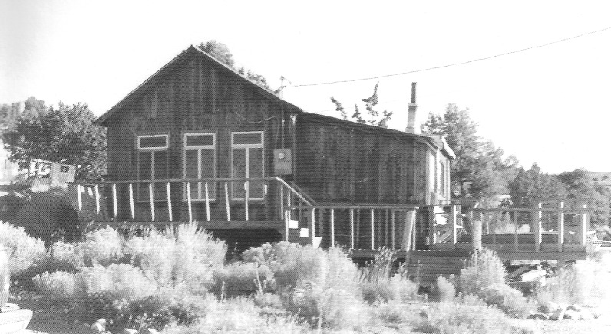

Now remodeled, this building is thought to be the home in Manhattan once occupied by George "Monty" and Virginia Stewart. Photo taken in 1995. - Author's Collection

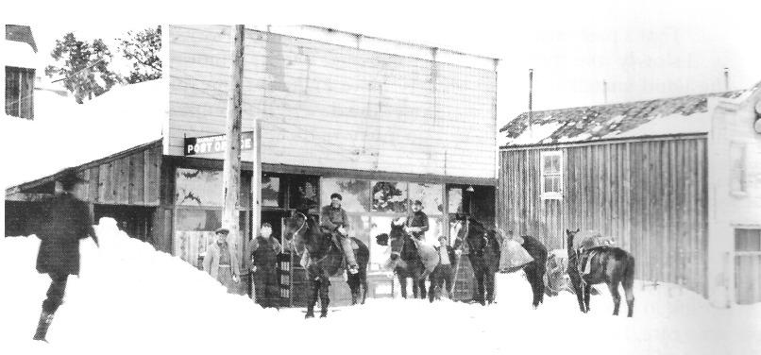

The post office on Main Street about the time "Monty" and Virginia Stewart lived in Manhattan. - University of Nevada, Las Vegas—Dickinson Library Special Collections

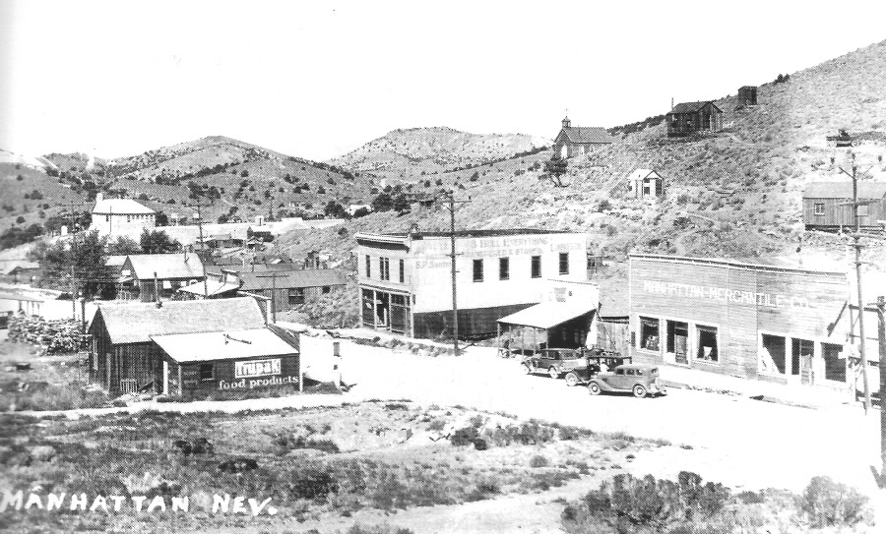

View of Manhattan looking northwest, with Catholic church and school in the background, a few years prior to Virginia and "Monty" Stewart's moving there. Probably early 1930s. - Nye County Town History Project—Zaval Collection

Tour of Manhattan

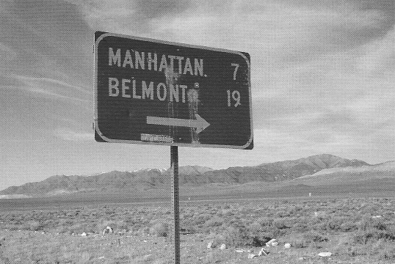

Photographic tour of Manhattan, Nevada, beginning in Smoky Valley at the junction of State Highways 376 and 377. All photos taken in 2007.

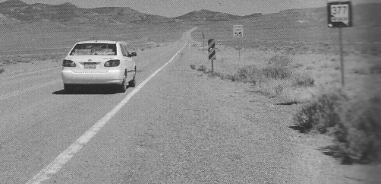

Looking east up State Highway 377 toward Manhattan - Jeanne Sharp Howerton

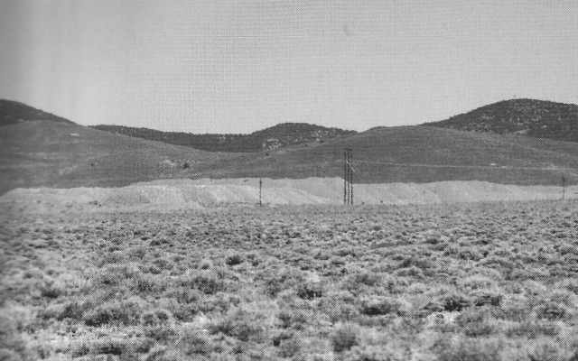

Dredge tailings in Manhattan Gulch looking south - Charles Rodewald

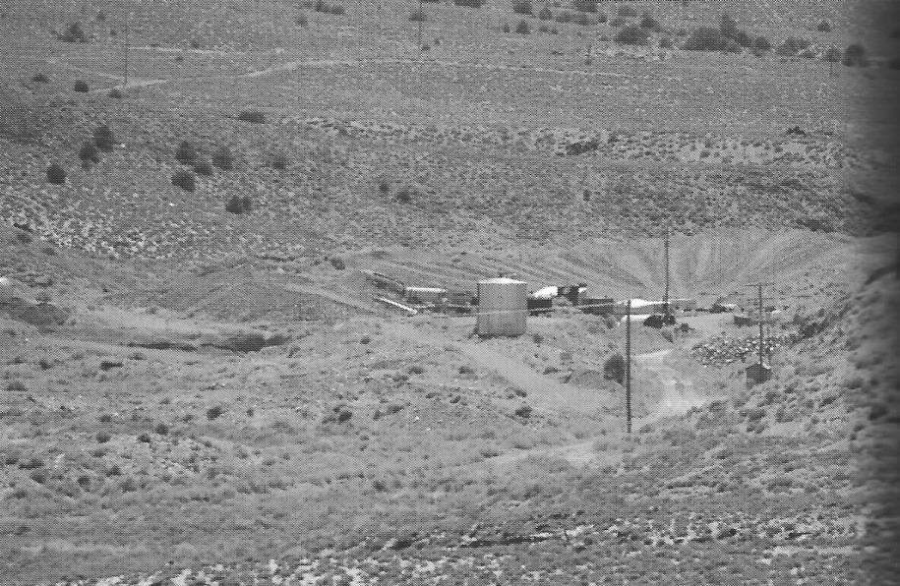

Bob Bottom's placer plant, Manhattan Gulch. - Charles Rodewald

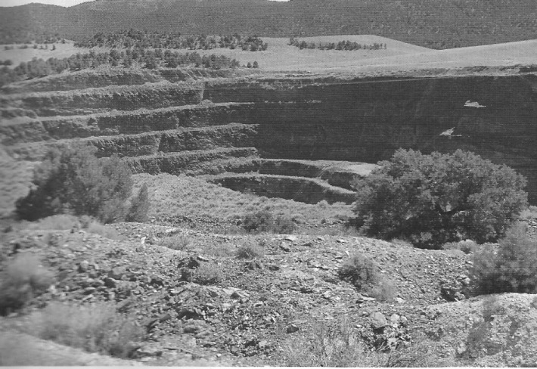

Round Mountain Gold Corporation's West Pit, located next to State Highway 377 on the west side of Manhattan. The pit is 300 feet deep. Round Mountain Gold Corporation was owned by Echo Bay Mining Company and two other companies. - Jeanne Sharp Howerton

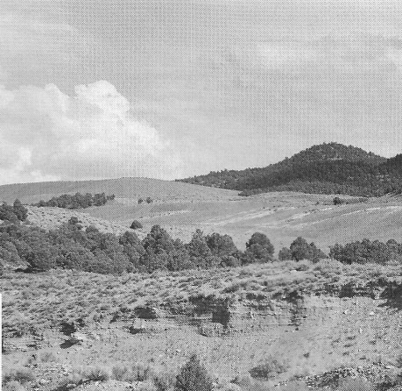

Looking east at the outstanding job of reclamation at the site of Echo Bay Mining Company's operations by Bob Bottom and Dick Carver following termination of the company's mill and heap leaching effort in Manhattan - Author's Collection

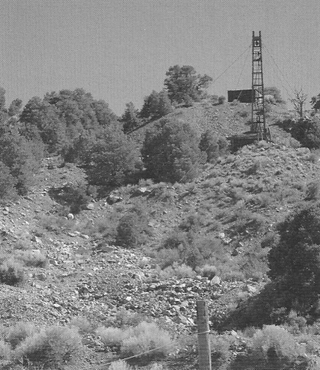

Dragline used to work gold-bearing gravels on Gold Hill (also known as Big four Hill) on the south side of town - Jeanne Sharp Howerton

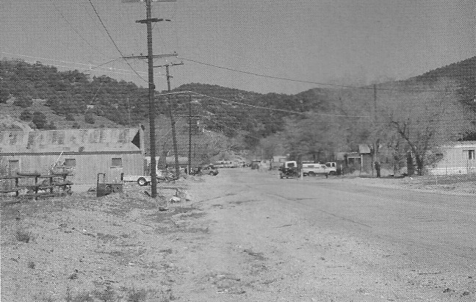

Manhattan, looking east. Val Boni's Garage is on the left in the distance. - Jeanne Sharp Howerton

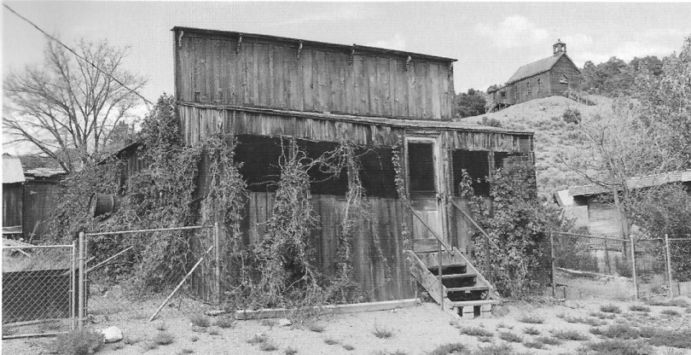

Former home of Pietro and Dominica Boni. Pietro immigrated to the United States in 1906 and came to Manhattan when he heard of its placer. Earlier he had sent for Dominica. They raised their nine children in this house and an adjoining structure to the left that served as a bunkhouse for the Boni boys. - Author's Collection

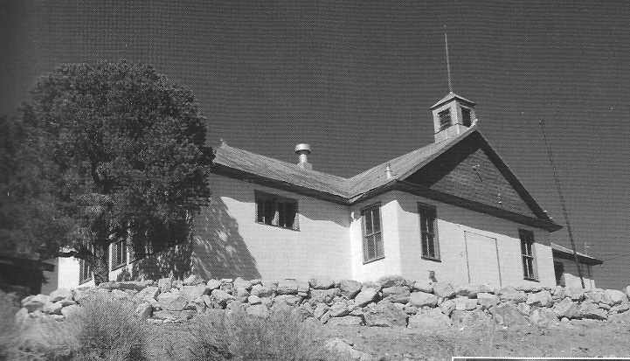

Manhattan School, built in 1912, currently houses a library and museum - Jeanne Sharp Howerton

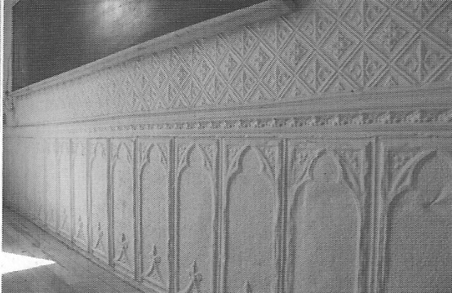

Pressed tin wall covering used in Manhattan School - Jeanne Sharp Howerton

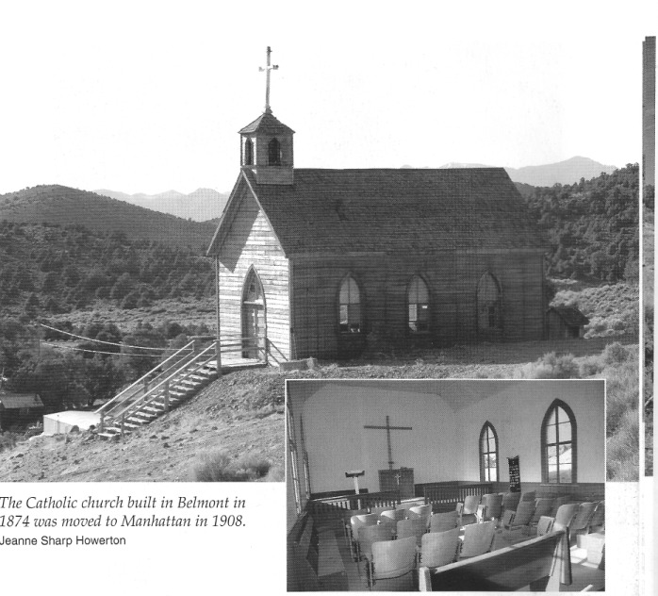

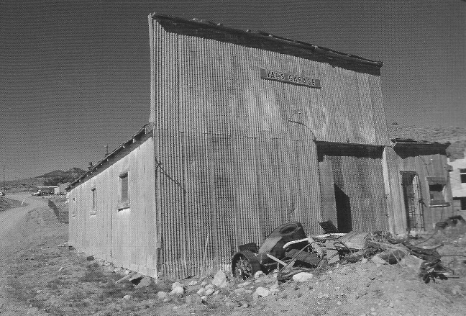

Val's Garage, circa 1933. Val Boni (the owner as of 2007) built the structure from lumber from the Presbyterian church in Belmont and metal siding from the Monitor Mining Company building in Belmont. - Jeanne Sharp Howerton

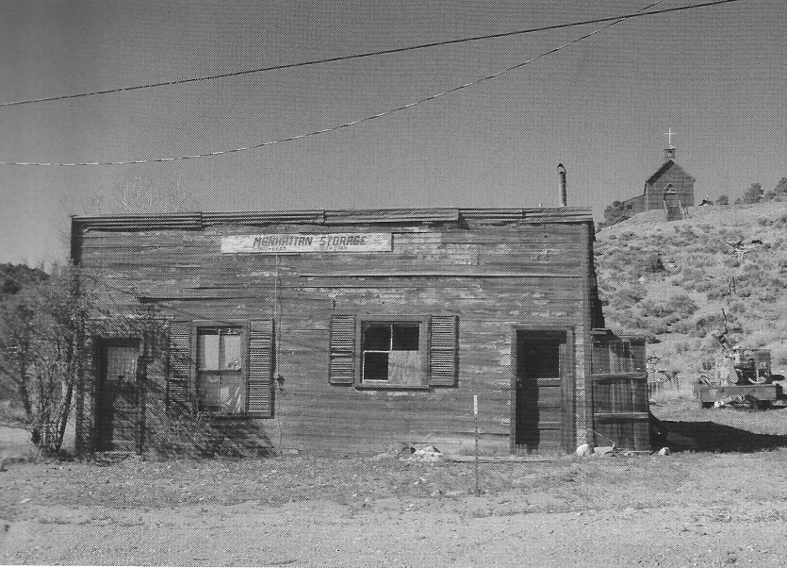

This building, circa 1910, had several functions. It was a residence, a bar, a grocery store, and the Manhattan Storage. - Jeanne Sharp Howerton

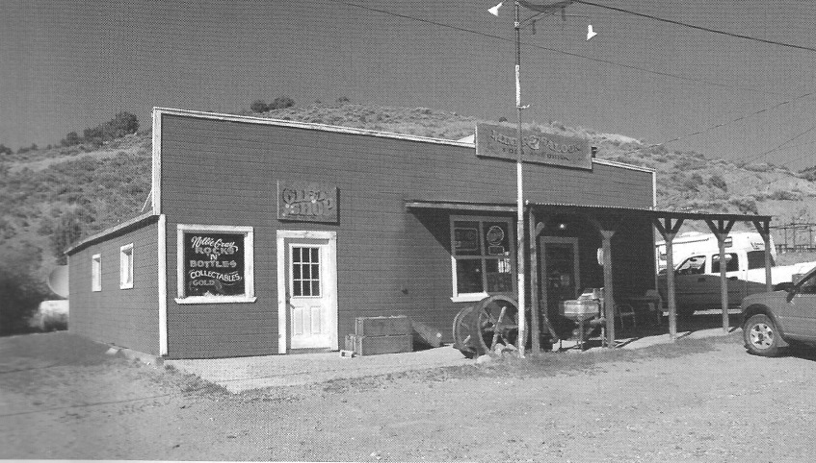

This building, constructed after 1930, is now a bar and gift shop. - Jeanne Sharp Howerton

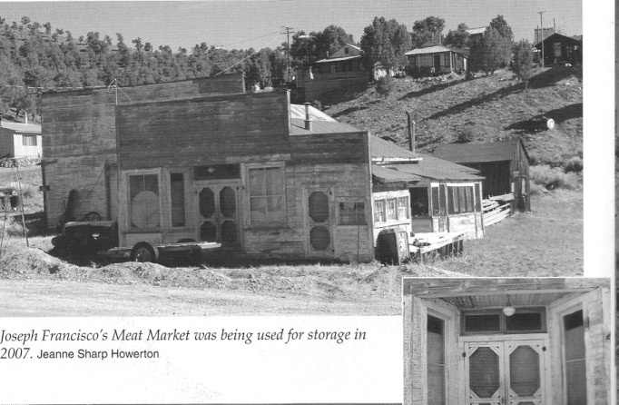

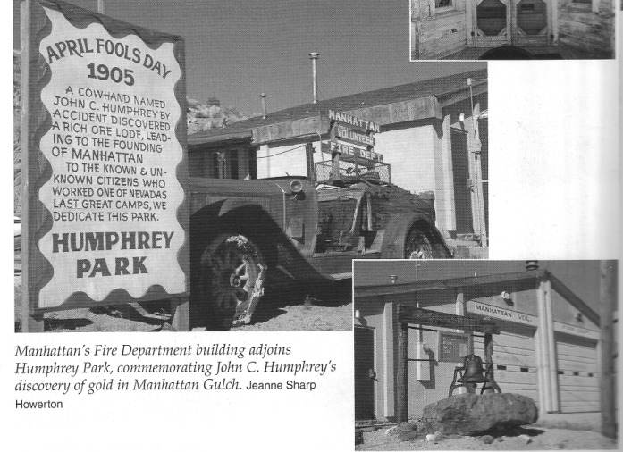

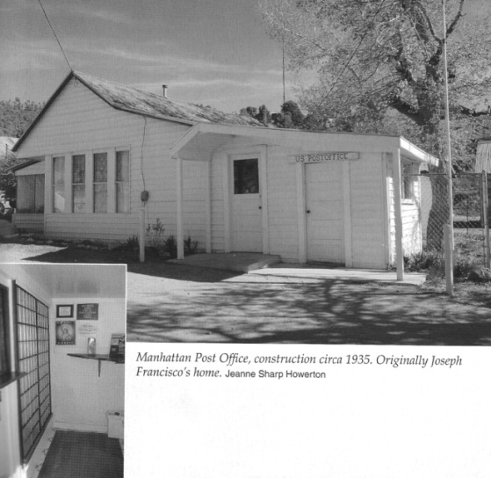

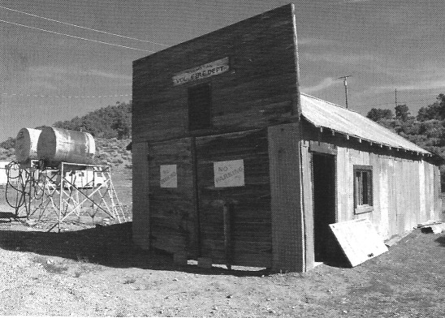

This structure, circa 1935, originally housed the Manhattan Volunteer Fire Department. In 2007, it was used to house the snowplow - Jeanne Sharp Howerton

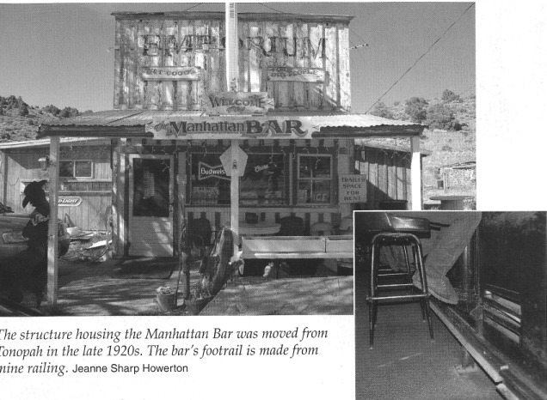

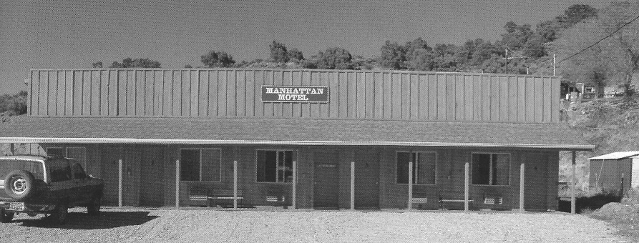

Manhattan Motel, construction circa 2005 - Jeanne Sharp Howerton

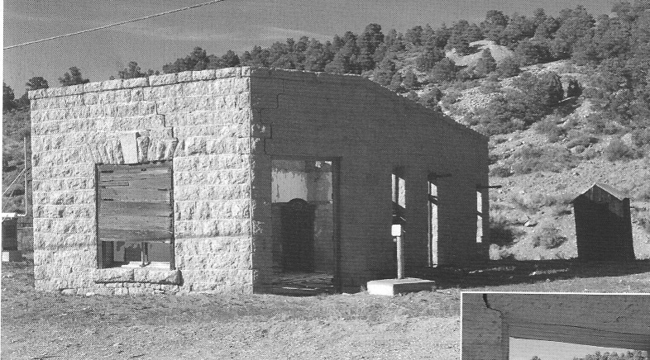

The Nye and Ormsby County Bank, circa 1906, was closed down during the Panic of 1907 and never reopened. The first stone building constructed in Manhattan, it was later used as a post office until 1940 - Jeanne Sharp Howerton

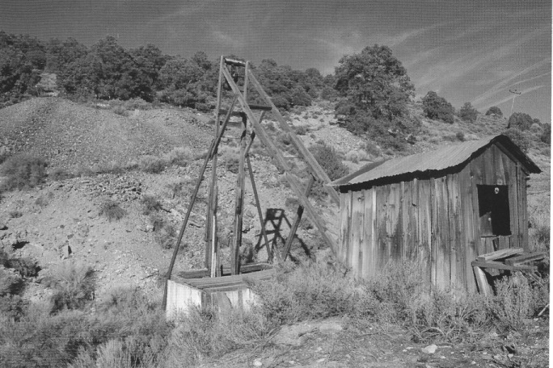

One of the original mines on April Fool Hill is very near the site where gold was discovered in Manhattan in 1905. - Jeanne Sharp Howerton

REFERENCES

Barieau, William G. "The Shooting of Sheriff Thomas Logan by Walter Barieau in Manhattan, Nevada, on April 6, 1906." Unpublished manuscript, on file at the Central Nevada Museum, Tonopah. 1971.

Beebe, Lucius, and Charles Clegg. The Saga of Wells Fargo. New York: E. P. Dutton and Co. 1949.

Berg, Lucile Rae. A History of the Tonopah Area and Adjacent Region of Central Nevada, 1827-1941. M.A. thesis, University of Nevada, Reno. 1942.

Boni, Jim. An Interview with Jim Boni. Tonopah, NV: Nye County Town History Project. 1990.

Brooks, George R., ed. The Southwest Expedition of Jedediah Smith: His Personal Account of the Journey to California, 1826-1827. Glendale, CA: Arthur H. Clark Company. 1977.

"Bucket of Gravel . . ." Manhattan Mail. February 17, 1909.

Clark, Addison N. "Nevada's Manhattan Gold Dredge." Mining Journal, Vol. 29, No. 3, pp. 2-4. April 30, 1946.

DeWolf, W. P. "Vivid Word Picture of People and Their Activities, All of Which Make up the Mosaic of Existence in the Gold Mountains." Manhattan Mail. June 30, 1906.

Earl, Phillip I. "Defending a Sheriff's Killer Made McCarran's Name." Pahrump Valley Times. February 1, 1981.

"Manhattan: A Cultural/Historical Overview." In Nye County Historic Property Survey, Appendix B. Tempe, AZ: Janus Associates. November 1980.

"Sheriff's Checkered Life Ended in Pool of Blood." Reno Gazette-Journal. May 31, 1987.

"Stray Dog the Luckiest Miner of All." Newspaper column, on file at the Central Nevada Museum, Tonopah. N.d.

"Fate of Logan's Slayer with the Jury." Tonopah Daily Sun. July 13, 1906.

Ferguson, Henry G. "Geology and Ore Deposits of Manhattan District, Nevada." U.S. Geological Survey. Bulletin 723. 1924.

"Fire Destroys Eight Buildings." Manhattan Mail. March 17, 1909.

"Flame Razes Entire Business Block." Manhattan Magnet. December 25, 1920.

Halloran, A. H. "Manhattan." Mining and Scientific Press, pp. 380-381. June 19, 1906.

"Headed for Great Manhattan." Tonopah Bonanza. January 6, 1906. "The Land of Heart's Desire." Goldfield News. January 19, 1906.

Larson, Jim. An Interview with Jim Larson. Tonopah, NV: Nye County Town History Project. 1990.

"Manhattan." Goldfield News. December 7, 1905. "Manhattan." Goldfield News. December 22, 1905.

"Manhattan Building Three Stamp Mills." Bullfrog Miner. October 1908.

"Manhattan Has First Wireless Telegraphy in State of Nevada." Tonopah Daily Bonanza. May 21, 1909.

"Manhattan Has the Richest Placer Ground in the Known World." Tonopah Daily Bonanza. May 21, 1909.

"Manhattan Leasers into the Money." Tonopah Daily Sun. December 26, 1905.

"Manhattan Miners Declare War Against Claim Jumpers." Tonopah Daily Sun. December 7, 1905.

"Manhattan Mining District." Goldfield News. September 22, 1905.

"Manhattan Placers Promise Great Gold Production." Rhyolite Herald. June 2, 1909.

"Manhattan School: Its History, Students, Personalities." Manhattan School Ob-server Supplement, Tonopah Times-Bonanza and Goldfield News. May 13, 1977.

"Manhattan Scourged by Fire." Manhattan Magnet. May 20, 1922.

Morgan, Dale L. Jedediah Smith and the Opening of the West. Lincoln: University of Nebraska Press. 1953, reprinted 1964.

"One More Block Is Laid in Ashes." Manhattan Magnet. May 27, 1922. "Placer and Quartz at Manhattan." Tonopah Daily Sun. August 6, 1905. "Placer Gold Runs $10 a Pan at Manhattan." Rhyolite Herald. 1909.

Rounsevell, Nelson. The Life of "N. R." Or, Forty Years of Gambling, Rambling, and Publishing. Panama City, Republic of Panama: Panama American Publishing Co. 1933.

"Sheriff Thomas Logan Is Shot and Killed by Walter Barieau." Tonopah Daily Sun. April 7, 1906.

Steward, Julian H. Basin-Plateau Aboriginal Sociopolitical Groups. Smithsonian Institution, Bureau of American Ethnology Bulletin 120. Washington, DC. 1938. Reprint, Salt Lake City: University of Utah Press. 1970.

Stewart, Virginia M. Golden Gravel: Manhattan, Nevada, in the 1930s. Morongo Valley, CA: Sagebrush Press. 1992.

"Straight Talk on Manhattan." Tonopah Daily Sun. September 1, 1905.

"Thomas Logan Laid to Rest." Tonopah Daily Sun. April 12, 1906.

"Tom Logan at Rest." Tonopah Miner. April 14, 1906.

"Town of Manhattan Located." Tonopah Daily Sun. August 9, 1905.

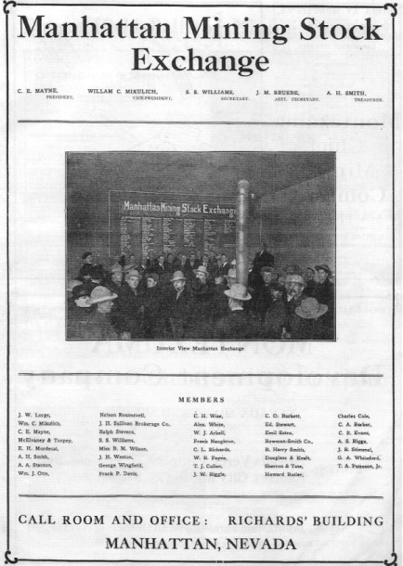
Goldfield News, Second Annual Edition. 1906-1907

About the Author

Robert D. McCracken is a descendant of three generations of hardrock miners. His love for Nevada and its people began in the early 1950s when he and his brother helped their father operate mines at several sites in Nye County, including Reveille Valley and Silver Bow. He earned his Ph.D. in cultural anthropology from the University of Colorado and has taught at Colorado Women's College, California State University at Long Beach, and UCLA. He is the author, coauthor or editor of numerous scientific reports and articles, a play, and more than 25 books-14 on the history of Nye County.

